Selenium-Modified Microgels: Novel Catalysts for Cross-Phase Oxidation of Aromatic Aldehydes
Anastasiia Pavliuk¹, Oliver Fiukowski², Volodymyr Ivasiv³, Roman Nebesnyi⁴, Andrij Pich⁵
1. Department of Technology of organic products, Lviv Polytechnic National University, UKRAINE, Lviv, S. Bandery street 12, E-mail: anastasiia.s.pavliuk@lpnu.ua
2. DWI - Leibniz Institute for Interactive Materials, GERMANY, Aachen, Forckenbeckstraße 50, E-mail: fiukowski@dwi.rwth-aachen.de
3. Department of Technology of organic products, Lviv Polytechnic National University, UKRAINE, Lviv, S. Bandery street 12, E-mail: volodymyr.v.ivasiv@lpnu.ua
4. Department of Technology of organic products, Lviv Polytechnic National University, UKRAINE, Lviv, S. Bandery street 12, E-mail: roman.v.nebesnyi@lpnu.ua
5. DWI - Leibniz Institute for Interactive Materials, GERMANY, Aachen, Forckenbeckstraße 50, E-mail: pich@dwi.rwth-aachen.de

Abstract. This paper explores selenium-modified microgels as interfacial catalysts for the environmentally friendly oxidation of aromatic aldehydes. Using mild reaction conditions and hydrogen peroxide as a green oxidant, microgels demonstrate versatility across various aldehydes and solvent systems while offering excellent reusability, positioning these microgels as promising candidates for sustainable oxidation processes.
Кеуwords: microgels, selenium, interfacial catalysis, oxidation, aromatic aldehydes, heterophase reaction, green chemistry, sustainable synthesis.
Introduction
Oxidation reactions are crucial in various chemical processes, from industrial synthesis to environmental remediation. The development of efficient and sustainable catalytic systems remains a significant challenge. Heterogeneous catalysts offer numerous advantages over homogeneous catalysts, including separation, recovery, and recycling capabilities, which make them more environmentally friendly as they produce fewer pollutants. However, homogeneous catalysts typically offer better accessibility to catalytic sites and higher product selectivity.
Performing reactions under biphasic ("water-oil") conditions can facilitate product separation and purification, especially when the starting material and product reside in different phases. The growing interest in these systems stems from their environmentally friendly conditions, particularly when reactions occur in aqueous media. However, the poor water solubility of many organic reactants presents a challenge. While surfactants can facilitate such reactions, separating them from products and catalysts for reuse can be difficult. An ideal solution would be a heterogeneous catalyst with surfactant properties.
Here, we explore the performance of these Se-modified microgels in emulsion stabilization and investigate their catalytic activity in the oxidation of aromatic aldehydes in oil/water biphasic systems. Oxidation of aromatic aldehydes, such as benzaldehyde, anisaldehyde and cinnamaldehyde, to the corresponding acids represents an important pathway in chemical valorisation for synthesis of valuable products and intermediates. Aromatic aldehydes generally are not soluble in water, so, to facilitate their oxidation with hydrogen peroxide, performing the reaction in heterophase conditions using interfacial catalyst should be beneficial.

Results and Discussion
The hydrodynamic radii of Se-modified microgels can affect their catalytic performance. In water, PVCL-based microgels are swollen below the Volume Phase Transition Temperature (VPTT, ~32°C). Above the VPTT, the microgels transform into a collapsed state. In contrast, in toluene solution, microgels remain swollen regardless of temperature (Fig. 1a).
The microgel caused a dramatic reduction of the interfacial tension (up to 42 times) compared to the reference (Fig. 1b). With increasing temperature, a slight increase in interfacial tension was observed, which has been attributed to the slowdown of surface tension decay due to the aggregation of polymer chains.
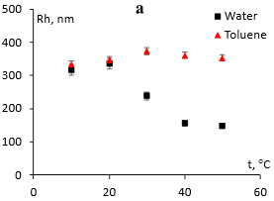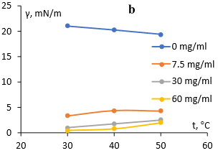
Fig. 1. a) Hydrodynamic radii of Se-modified microgel in toluene and water. b) Dependence of interfacial tension (γ) in toluene-water on temperature and concentration of Selenium-modified microgel

The catalytic activity of Se-modified microgels was evaluated in a model reaction of benzaldehyde oxidation with hydrogen peroxide under biphasic (toluene/water) reaction conditions. The oxidation occurs at the interface between the toluene phase (containing benzaldehyde) and the water phase (containing hydrogen peroxide), with the selenium-containing microgel acting as an interfacial catalyst due to its surfactant properties and catalytic seleninic groups. Phenol was the sole by-product in the benzaldehyde oxidation at all reaction conditions.
The catalytic activity of the Se-modified microgel increases with reaction temperature up to 50°C (Fig. 2a). A further increase in temperature results in a lower benzoic acid yield, correlating with the thermal responsiveness of the microgel in water. At temperatures higher than 40°C, the hydrodynamic radius of the microgel in water is 2 times smaller than at 20°C, which may cause difficulties in reagent diffusion inside the microgel particles.
When the reaction was performed in media with a large excess of water, the yield of benzoic acid and the reaction rate were quite low. As the amount of water in the reaction mixture was reduced from 80% (T1W4) to 20% (T4W1), both the reaction rate and the benzoic acid yield increased significantly. For the reaction performed with a T:W ratio of 4:1, the Se-microgel proved to be a highly active colloidal catalyst, achieving a yield of 95.6% of benzoic acid at 50°C.
The yield of benzoic acid increases rapidly with the reaction time up to 88.8% at 5 hours (Fig. 2b). Further increase of the reaction time to 8 hours leads to a relatively smaller increase in yield to 95.6%, which is not very efficient in terms of productivity, but has the additional benefit of increasing the selectivity from 91.2% to 96.6%, which is much more valuable. Therefore 8 hours was chosen as the optimal reaction time.
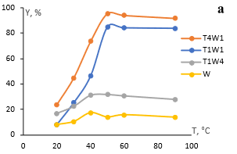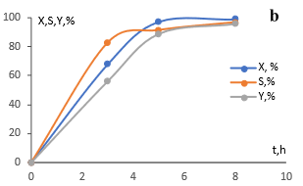
Fig. 2. a) Effect of toluene:water ratio and reaction temperature on the yield of benzoic acid (Y). b) Effect of reaction time on the yield of benzoic acid (Y). Catalyst – B1.5Se2.0.

Besides toluene, the microgel catalyst was tested in chloroform, ethyl acetate, and 1-octanol in water emulsions with a solvent:water ratio of 4:1 (Fig. 3). All of these provided lower yields of benzoic acid compared to the toluene/water system: 70.9% in chloroform/water, 53.6% in ethyl acetate/water, and 25.5% in 1-octanol/water. Interestingly, in the 1-octanol/water system, octyl benzoate (23.3%) was obtained alongside benzoic acid, suggesting either oxidative alkoxylation of benzaldehyde or subsequent esterification of benzoic acid, with a total oxidation yield of 48.8%.
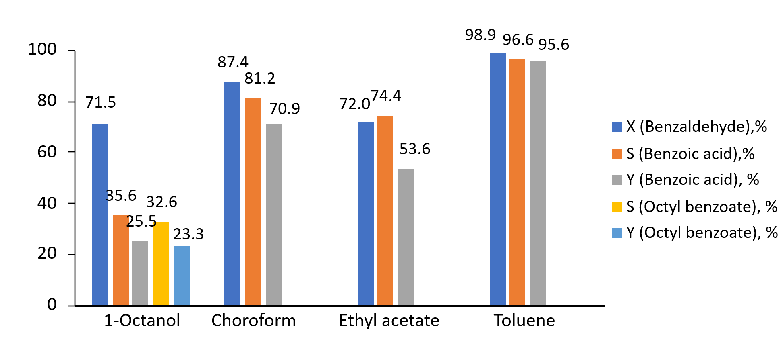
Fig. 3. Effect of solvent nature on the yield of benzoic acid (Y). Solvent:water ratio=4:1. Reaction temperature – 50 °C. Reaction time – 8 h.

In addition to benzaldehyde, cinnamaldehyde, anisaldehyde, and veratraldehyde were investigated in the toluene/water (4:1) system (Fig. 4). The Se-microgel catalyst proved active in oxidizing these aldehydes too, but with lower selectivity for the corresponding acids. Cinnamaldehyde oxidation produced 29.8% cinnamic acid, 9.8% hydrocoumarin, and 17.1% benzoic acid. Anisaldehyde oxidation yielded 28.5% anisic acid and 35.2% mequinol. Veratraldehyde oxidation produced only 1.7% veratric acid, with the main product being 3,4-dimethoxyphenol (39.0%).
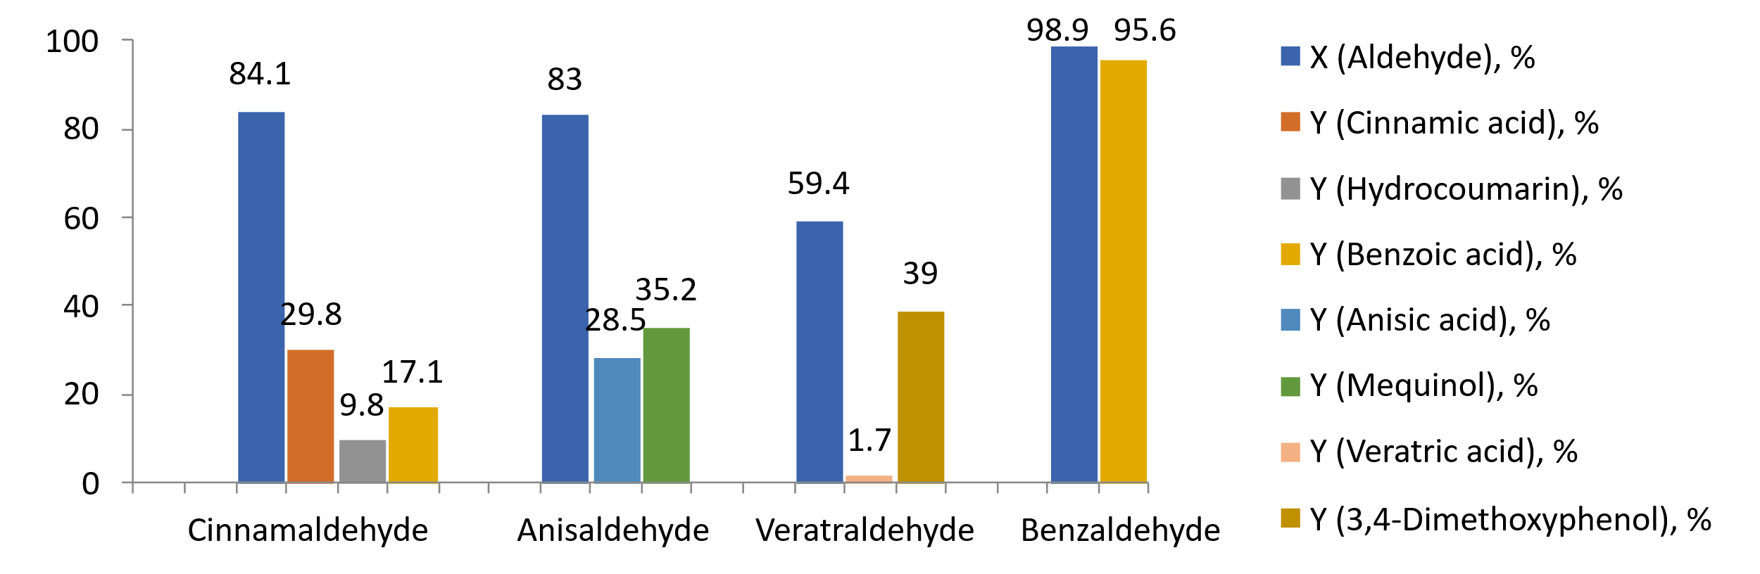
Fig. 4. Effect of catalyst activity on the oxidation reaction of a number of aromatic aldehydes. Toluene:water ratio=4:1. Reaction temperature – 50 °C. h. Reaction time – 8 h.

The reusability of the catalyst was explored after separating the microgel from the reaction medium through precipitation using hexane. The catalytic performance remained largely unchanged, with less than a 3% reduction in benzoic acid yield even after the third cycle (Fig. 5a). FT-IR spectra of the used microgel demonstrated its chemical stability, showing no structural changes after three catalytic cycles (Fig. 5b).
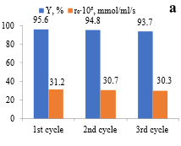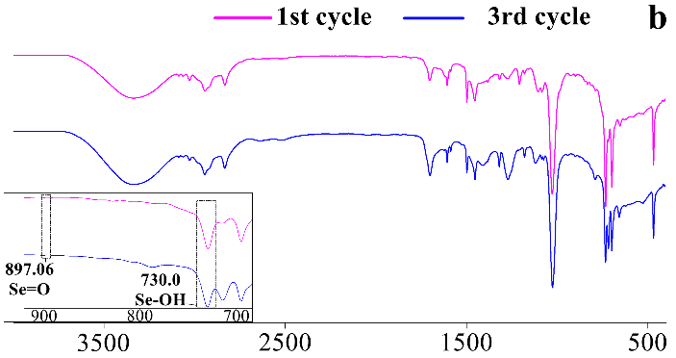
Fig. 9. a) Dependence of the benzoic acid yield (Y) and benzoic acid initial formation rate (r0) on the reusability of the catalyst, solvent – toluene/water 4:1, catalyst – Se 2.0 microgel, reaction time – 8 h. b) FT-IR spectra of the microgel after first and third use of the catalyst in the oxidation reaction.

Conclusions
Se-containing microgel demonstrated high activity and selectivity as a low-temperature interfacial catalyst in the heterophase oxidation of benzaldehyde to benzoic acid by hydrogen peroxide. The highest yield of benzoic acid (95.6% with 96.6% selectivity) was achieved in the toluene/water (4:1) system at 50°C and 8 h reaction time. Reusing the catalyst over multiple cycles showed no significant change in its activity.
The catalyst also proved effective in the oxidation of other aromatic aldehydes, although with lower selectivity for the corresponding acids. High efficiency at the interface and mild working conditions make Se-microgel catalysts promising candidates for green oxidation processes using hydrogen peroxide as an environmentally safe oxidant.
Acknowledgments
Funded by the Deutsche Forschungsgemeinschaft (DFG, German Research Foundation) – 492353574.

