Pyrolysis of Waste Tires: Product Characteristics and Industrial Applications
Bohdan Korchak¹, Serhiy Pyshyev², Yurii Lypko²
- Department of Civil Safety, Lviv Polytechnic National University, UKRAINE, Lviv, S. Bandery street 12, E-mail: bohdan.o.korchak@lpnu.ua
2. Department of Chemical Technology of Oil and Gas Processing, Lviv Polytechnic National University, UKRAINE, Lviv, S. Bandery street 12, E-mail: serhii.v.pyshiev@lpnu.ua
3. Department of Chemical Technology of Oil and Gas Processing, Lviv Polytechnic National University, UKRAINE, Lviv, S. Bandery street 12, E-mail: yurii.v.lypko@lpnu.ua
Abstract. The issue of waste tire accumulation and utilization is analyzed. Pyrolysis is identified as a promising recycling method, yielding gaseous, liquid, and solid products. These require further purification before use. The characteristics, processing methods, and potential applications of pyrolysis products have been briefly reviewed.
Кеуwords: pyrolysis oil, pyrolysis gas, waste tires, alternative fuel, pyrolysis of tires, carbon black.
Introduction
Given the depletion of global oil reserves, the search for alternative energy sources has become increasingly urgent. As light, high-quality crude oil availability declines, the oil refining industry is progressively shifting toward cheaper and heavier feedstocks. This transition drives the exploration of unconventional raw materials, including waste hydrocarbon-based materials and biomass.
Industrial waste has emerged as one of the most critical environmental challenges, threatening ecological stability. The growing volumes of industrial and municipal waste pose a substantial risk to society and natural ecosystems. Consequently, the rational utilization of industrial waste has become a highly relevant issue that demands prompt and effective solutions due to its profound impact on environmental quality and public health.
Notably, reusing industrial waste – such as used tires, waste oils, and plastics – for producing energy resources offers a viable strategy for mitigating environmental harm [1, 2].
Among the various categories of waste contributing to environmental pollution, used (waste) tires (WAT) occupy a particularly critical position, posing a significant threat to ecosystem diversity and human health. Their substantial volume and disposal complexity renders them a key environmental concern.
Tires are essential consumables in operating all types of motor vehicles. According to the European Tyre & Rubber Manufacturers Association (ETRMA), approximately 289 million tires are sold annually within the European Union, accounting for only 20% of the global tire market, totaling around 1.5 billion units annually [1]. According to Eurostat data, the average number of passenger vehicles in the EU is 560 per 1,000 inhabitants [1]. In Ukraine, used car tires are classified as hazardous waste (Class IV) under the Law of Ukraine “On Waste” and require specialized disposal at certified facilities [1]. As of 2020, Ukraine had approximately 245 passenger cars per 1,000 inhabitants – excluding freight and specialized vehicles – which is steadily increasing [1]. Figure 1 presents comparative data on WAT generation across various countries as of 2021 [1].
Waste tires are non-biodegradable and, due to their complex thermomechanical structure, are difficult to reuse or recycle without prior mechanical or thermal treatment [2]. The continuous accumulation of used tires presents a serious environmental and public health hazard. Improper disposal, including illegal dumping and accumulation, increases the risk of uncontrolled combustion, which releases toxic pollutants into the environment [1, 2]. Consequently, millions of WATs are required to be appropriately disposed of each year. However, Ukraine lacks a centralized system for WAT collection. Disposal and recycling operations are carried out only by a few private enterprises operating in select regions [2].
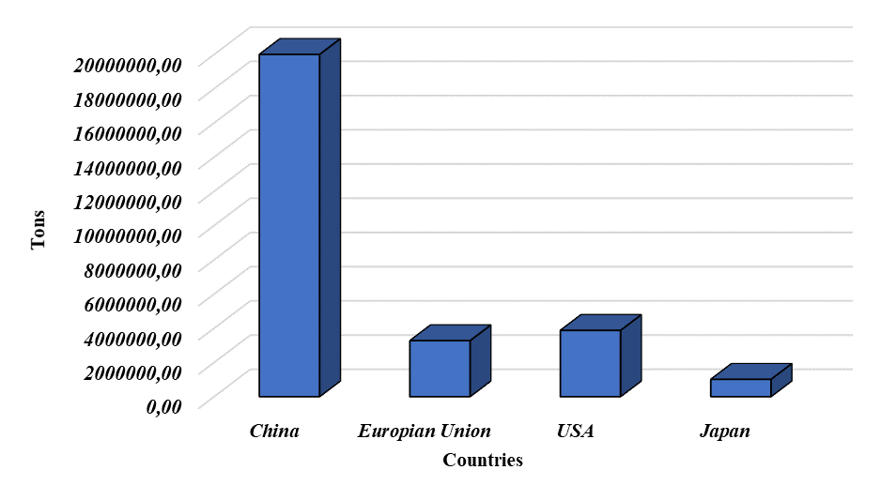
Fig. 1. The annual production of WAT in some countries.
Automobile tires are complex engineering products characterized by a multi-component structure and composition. A typical tire contains more than 200 individual substances. The primary constituents used in tire manufacturing include natural and synthetic rubber, carbon black, inert fillers (such as amorphous precipitated silica and alumina), steel, textile and fabric reinforcements (e.g., nylon, Kevlar), sulfur, zinc oxide, as well as various antioxidants and antiozonants [1].
Figure 2 illustrates the average qualitative composition of automobile tires, which varies depending on the vehicle type (passenger cars, trucks, buses, aircraft, etc.) and regional climatic conditions. Figure 3 provides a schematic representation of a passenger car tire, highlighting the key structural components that comprise the tire.
Fig. 2. Average composition of a passenger tire by weight | Fig. 3. Exploded view of a commercial passenger car tire
To fulfill their primary function and ensure long service life, tires are manufactured using materials resistant to biodegradation [1, 2]. The predominant component is rubber (approximately 45 – 47%), owing to its excellent elasticity and damping properties [1, 2]. Rubber compounds typically consist of blends of natural rubber (e.g., polyisoprene) and synthetic rubbers such as polybutadiene, styrene-butadiene rubber (SBR), and (halo)butyl rubber. The specific ratios of these rubbers vary depending on the intended application of the tire.
As illustrated in Figure 3, rubber materials are primarily concentrated in the tread (approximately 32.5 wt%) and sidewalls (about 22 wt%) [1, 2]. To enhance mechanical strength and wear resistance, reinforcing agents such as carbon black and silica (around 21 – 22.5% of tire mass) are added to the rubber compound [1, 2]. Carbon black is crucial in improving abrasion resistance and dissipating heat from the tread area, thereby preventing thermal degradation.
Steel components are incorporated to reinforce the tire structure and provide mechanical strength and durability [1, 2]. Sulfur is used as a vulcanizing agent, which improves the rubber matrix's elasticity, hardness, and structural integrity [1, 2], while zinc oxide acts as an activator, accelerating the vulcanization process [1, 2]. It is important to note that these components' exact composition and proportions may vary depending on performance requirements and tire design specifications.
The outer layer of the tire, responsible for traction through contact with the road surface, is known as the tread. It comprises a specific rubber compound and a patterned design to ensure optimal grip with minimal wear [1, 2]. Structurally, the tread is divided into three main zones: the cap (the uppermost layer in direct contact with the road), the base (located beneath the cap, designed to reduce rolling resistance), and the shoulder area (situated at the outer edges, forming a transitional zone between the tread and the sidewall).
To enhance stability, the tread is typically reinforced with two steel belts of steel cords arranged at opposing angles. Beneath the belts lies the carcass or carcass layer, which serves as the main structural framework of the tire. It usually comprises one or two plies made from polyester, rayon, or nylon cords embedded in rubber.
The inner liner on the inside of the tire comprises a thin layer of synthetic rubber – most commonly halogenated polyisobutylene designed to provide air impermeability and maintain internal pressure. The bead, formed by steel wires encased in a rubber matrix (bead filler), ensures an airtight and secure connection between the tire and the wheel rim [1, 2].
Due to this complex multilayered composition, tires cannot be directly reused once they end their service life. The heterogeneity of materials complicates selecting a practical and environmentally sound disposal or recycling method.
The primary waste automobile tires (WAT) disposal and recycling methods include landfilling, material reuse, incineration, pyrolysis, carbon black recovery, and their application in civil engineering projects [1, 2]. Additionally, a portion of WAT is utilized to produce modified bitumens, contributing to improving road construction materials [1, 2].
Due to their high calorific value, WATs are also considered a valuable energy resource, which has led to their reuse in various industrial sectors. Thermochemical processes such as pyrolysis [1, 2], gasification [1, 2], and combustion [1, 2] enable the efficient recovery of energy and valuable seco
The methods of disposal of WAT and their common areas of application are presented in Fig. 4.ndary products while simultaneously reducing reliance on conventional fossil fuels.
As can be seen from Fig. 4, the methods of WAT disposal can be divided into five groups [1, 2]:
- shredding into rubber crumb and use as a component of road coverings;
- recycling – restoration of the operational characteristics of car tires by physicochemical methods for a specific time;
- thermal methods – incineration (the simplest but the most non-ecological method), gasification (for the production of gases), and pyrolysis (one of the most promising methods);
- use as a building material;
- storage in landfills or on specialized sites.

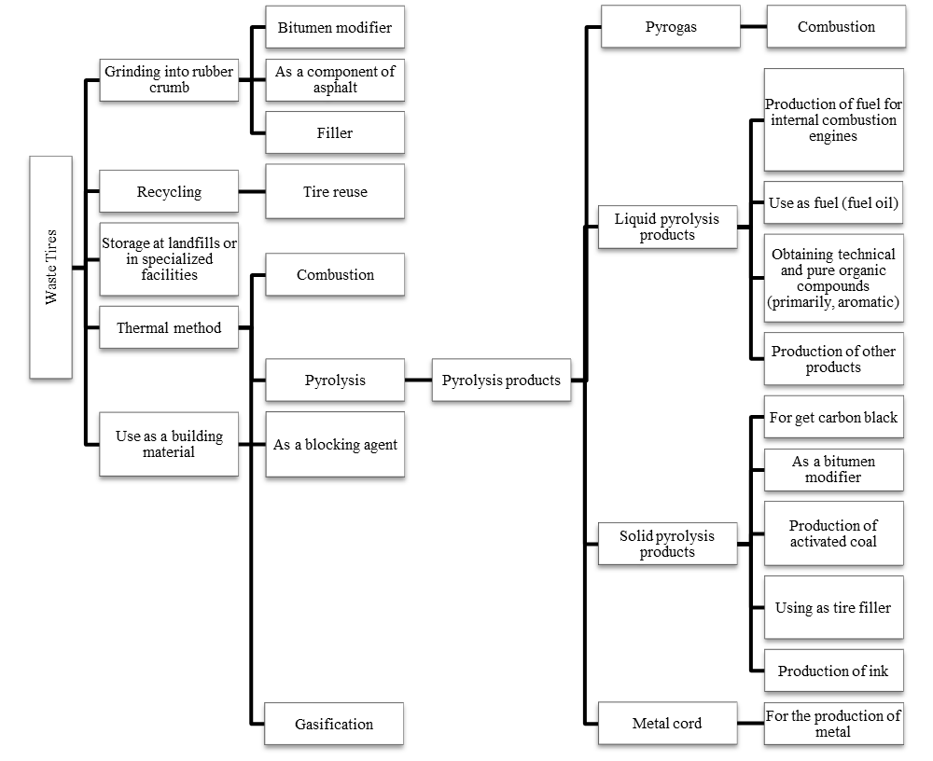
Fig. 4. Methods of disposal of WAT and their common application areas.
In light of the significant volume of waste automobile tires (WAT) generated globally, they represent a valuable secondary raw material for producing a wide range of products and new energy resources. However, due to their complex structure and composition, selecting an appropriate method for rational utilization presents a challenge. Among the various WAT disposal methods that yield diverse products, pyrolysis is an auspicious process enabling producing fuel and chemical raw materials. The following is a brief review of the pyrolysis process of used tires and an overview of the characteristics and potential applications of the products obtained through this method.
Conclusions
Considering the significant volume of global waste automobile tires (WAT) generated, their proper disposal and recycling present a critical ecological and economic challenge. Pyrolysis of waste tires emerges as one of the most promising methods for their utilization, as it allows for producing energy resources and chemical raw materials, which can be applied in various industries. However, the complex structure of WAT requires the selection of efficient technologies to ensure their effective processing and minimize environmental impact.
References
[1] Pyshyev, S., Lypko, Y., Demchuk, Y., Kukhar, O., Korchak, B., Pochapska, I., Zhytnetskyi, I. (2024). Characteristics and applications of waste tire pyrolysis products: A review. Chem Chem Tech., 18(2), 244–257. https://doi.org/10.23939/chcht18.02.244
[2] Pyshyev, S., Lypko, Y., Korchak, B., Poliuzhyn, I., Hubrii, Z., Pochapska, I., Rudnieva, K. (2024). Study on the composition of gasoline fractions obtained as a result of waste tires pyrolysis and production bitumen modifiers from it. J. Energy Inst., 114, 101598–101598-16. https://doi.org/10.1016/j.joei.2024.101598

