Diffusive Mass Transfer During Filtration Drying of Match Splints
Tetiana Kuzminchuk¹
1. Department of Chemical Engineering, Lviv Polytechnic National University, UKRAINE, Lviv, 12 S. Bandery Str., E-mail: tetiana.a.kuzminchuk@lpnu.ua
Abstract. Experimental and theoretical studies of internal diffusion during filtration drying of match splints are presented. The effective coefficient of internal moisture diffusion in a stationary layer of match splints has been determined. The influence of the heat agent temperature on internal diffusion has been investigated. A dependence for determining diffusion coefficients at different temperatures has been obtained.
Кеуwords: filtration drying, match splints, diffusive mass transfer, internal diffusion coefficient, stationary layer.
Introduction
Drying match splints is an important and energy-intensive process in match production. In industrial settings, match splints are dried in a belt dryer. A drawback of this method is that the heat agent flows over the surface of the material layer. Since moisture moves from the hotter surface to the cooler one, thermodiffusion occurs during such drying, which is directed opposite to the direction of moisture evaporation. As an alternative method, filtration drying in a stationary material layer has been proposed.
Filtration drying is one of the highly efficient and intensive methods of convective drying [1]. Its advantage lies in the high values of mass transfer coefficients. This is due to the large contact surface area between the phases, as the heat agent flows around all the particles. Filtration drying is conventionally divided into two periods: the period of complete saturation of the heat agent with moisture, during which the drying potential of the heat agent is the limiting stage, and the period of partial saturation of the heat agent with moisture, during which the drying rate is limited by the intensity of moisture diffusion from the inside of the material to the phase contact surface [2].
The moisture in match splints is mainly bound and located in the pores and microcapillaries. Therefore, the drying process strongly depends on the intensity of moisture diffusion from the inside of the material to the surface. To ensure the efficient use of the heat agent, the diffusion and mass transfer coefficients need to be approximately equal, which can be achieved by adjusting the velocity and temperature of the heat agent.
Therefore, an important part of the research on filtration drying of match splints is the determination of internal diffusion coefficients. The diffusion coefficient does not depend on the hydrodynamics of the heat agent but only on temperature. Thus, it is essential to investigate the influence of temperature on diffusion and to obtain dependencies for determining diffusion coefficients at different temperatures.
Materials and methods
Match splints are prismatic particles with equal width and height, and a significantly greater length.
The internal moisture diffusion in match splints was studied using an experimental setup, the operating principle of which is described in [3]. The research was conducted in a short layer. A batch of match splints with a moisture content of approximately 1.6 kg H₂O/kg of dry material was loaded into a cylindrical container.
The container was placed on the setup, and the drying agent was filtered through the layer of match splints at a constant velocity and temperatures of 313, 323, 333, 343, and 353 K. A constant temperature was maintained using a SESTOS DIS 10 electronic thermostat with an accuracy of ±0.5°C. The change in the mass of the match splints was measured using Axis AD3000 electronic scales with an accuracy of ±0.01 g. The experimental studies were carried out until the material reached a constant mass.
To describe the diffusion process, third-kind boundary conditions were used, according to which the moisture content is a function of four variables: the coordinates x, y, z, and time τ.:
${w^{c}\left(±R_{1}, y, z, τ\right)= w_{h.a}^{c} \atop \begin{aligned}w^{c}\left(x, ±R_{2}, z, τ\right)= w_{h.a}^{c} \\ w^{c}\left(x, y, ±R_{3}, τ\right)= w_{h.a}^{c}\end{aligned}}$ , (1)
where w^{c} – is the average moisture content in the material (kg H₂O/kg dry material) at time τ, R₁, R_{2,} R₃. – are characteristic dimensions in the coordinate system located at the center of the prismatic particle.
For prismatic particles, the differential equation of diffusion under third-kind boundary conditions takes the following form::
$\frac{∂W^{c}(x, y, z, τ)}{∂τ}=D_{w}^{*}\left[\frac{∂^{2}W^{c}(x, y, z, τ)}{∂x^{2}}+\frac{∂^{2}W^{c}(x, y, z, τ)}{∂y^{2}}+\frac{∂^{2}W^{c}(x, y, z, τ)}{∂z^{2}}\right]$ (2)
The solution of which can be represented as follows:
$-\frac{\ln\left(∆W^{c}\right)-\ln\left(B_{n}B_{m}B_{k}\right)}{μ^{2}\left(K_{1}^{2}+K_{2}^{2}+K_{3}^{2}\right)}=Fo$ (3)
Denote:
$A^{*}=-\frac{\ln\left(∆W^{c}\right)-\ln\left(B_{n}B_{m}B_{k}\right)}{μ^{2}\left(K_{1}^{2}+K_{2}^{2}+K_{3}^{2}\right)}$ (4)
Then, equation (4) will take the form:
$A^{*}=Fo=\frac{D_{w}^{*}∙τ}{R^{2}}$ (5)
The results of the experimental studies can be presented as a graphical dependence of A* = f(τ). By approximating the data with a linear function and using the tangent of the slope of the straight line, the internal diffusion coefficient can be determined.
Results and discussion
Based on the experimental data, a graphical dependence of moisture content on drying time w^{c} = 𝑓(τ) is plotted in Fig. 1.
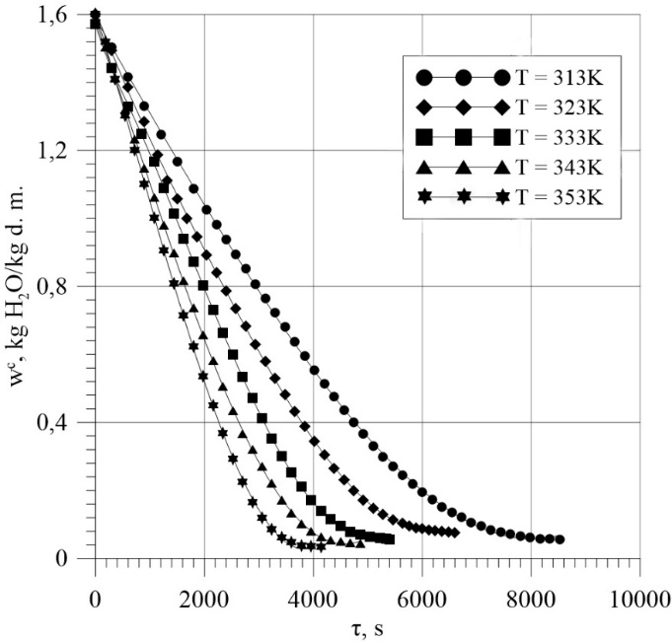
Fig.1. The graphical dependence of moisture content on drying time of match splints.
As shown by the analysis of Figure 1, with an increase in drying temperature, the drying process becomes more intensive, and the drying duration decreases. This is explained by the increase in the drying potential of the heat agent, which accelerates the drying process during the period of full moisture saturation, and the increase in the moisture diffusion rate within the material, which is important during the period of partial moisture saturation.
Based on the obtained moisture content values, the coefficient A* was determined, and the dependence A* = f(τ) was constructed, as shown in Fig. 2. The analysis of the figure reveals that the dependence is linear, meaning that the value of the internal diffusion coefficient can be determined by approximating the data with a linear function using the tangent of the slope angle of the straight line.
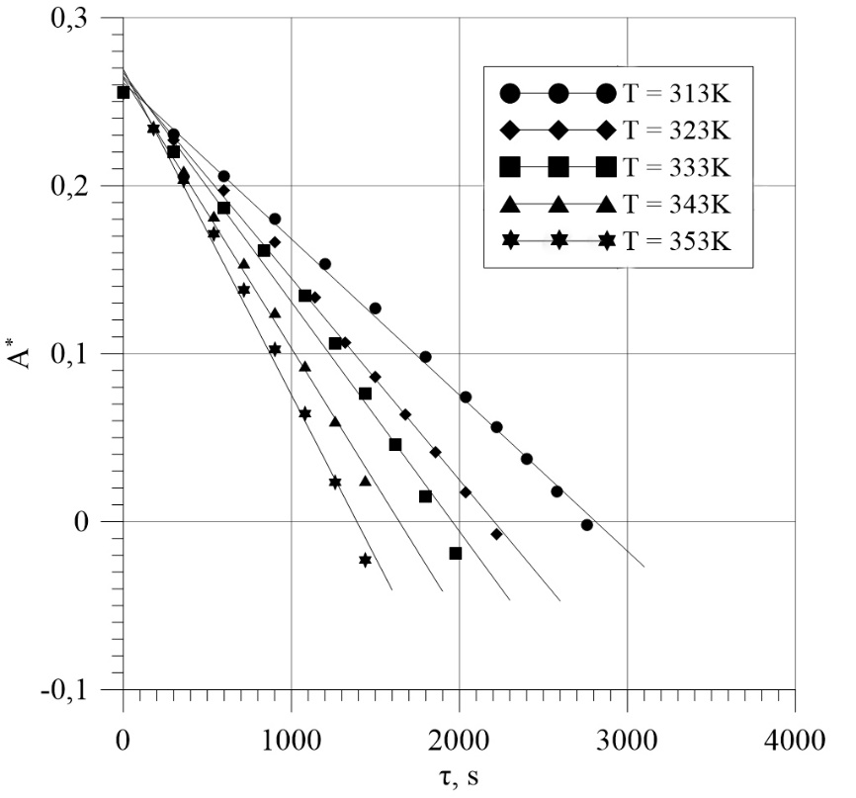
Fig.2. The graphical dependence of A* on the drying time of match splints.
Table 1 presents the values of the diffusion coefficient in match splints within the range of 313–353 K.
Table 1
Values of the diffusion coefficient for match splints at different temperatures
T, K | 293 | 313 | 323 | 333 | 343 | 353
D*_{w}ꞏ10¹¹, м²/с | 2.84 | 6.02 | 7.78 | 8.84 | 10.42 | 12.55
As seen in Table 1, with an increase in temperature, the internal diffusion coefficient increases. The rise in the temperature of the heat agent causes an increase in the temperature inside the match splints, which contributes to the increased movement of moisture molecules within the material. Figure 3 shows the graphical dependence of the internal diffusion coefficient on temperature.
As seen in Fig. 3, the dependence D_{w} = 𝑓(T) is linear, and therefore, it can be represented by the following calculated equation:
$D_{w}^{t}=D_{w}^{293}+1.55∙{10}^{-12}∙(T-293)$ (6)
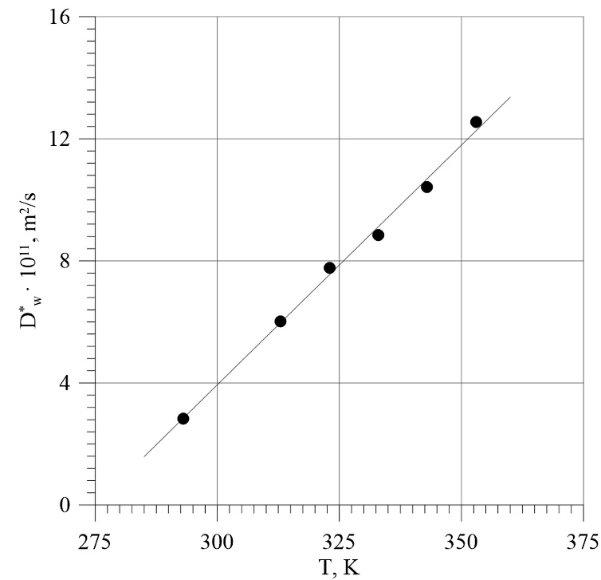
Fig.3. Graphical dependence of the internal diffusion coefficient on temperature for match splints.
The obtained analytical Eq. (6) allows for the theoretical determination of the internal diffusion coefficient for match splints within the temperature range of 293-353 K.
The maximum error between the experimental data and the theoretically calculated values of the internal diffusion coefficients for match splints does not exceed 3.8%.
Conclusions
The paper presents the results of experimental studies on internal moisture diffusion during the filtration drying of match splints. The internal diffusion coefficients at different temperatures were determined. It was shown that as the temperature increases, the diffusion coefficient also increases. A linear dependence was obtained, which allows for the determination of the diffusion coefficient during the filtration drying of match splints. The obtained dependence demonstrates high convergence with the experimental data within the temperature range of 313-353 K. The maximum error does not exceed 3.8%.
References
[1] Atamaniuk, V, & Humnytskyi, Ya. (2013). Naukovi osnovy filtratsiinoho sushinnia dyspersnykh materialiv. Lviv: Vyd-vo Lviv. politekhniky, 255.
[2] Khussanov, A. Ye., Atamanyuk, V. M., Kobeyeva, Z. C., Kaldybayeva, B. M., & Janabayev, D. Zh. (2021). Heat and Mass Transfer Patterns of Filtration Drying of Fibrous Material. Proceedings of Higher Education Institutions. Textile Industry Technology, 5, 162–168. DOI:10.47367/0021-3497_2021_5_162
[3] Kuzminchuk, T. A., Atamanyuk, V. M., Duleba V.P., & Janabayev, D. (2023). Kinetics of drying of match splints. Chemistry, Technology and Application of Substances, 2, 119-125. DOI: 10.23939/ctas2023.02.119
[4] Gnativ, Z. Ya., Ivashchuk, O. S., Hrynchuk, Yu. M., Reutskyy, V. V., Koval, I. K., & Vashkurak, Yu. Z. (2020). Modeling of internal diffusion mass transfer during filtration drying of capillary-porous material. Mathematical Modeling and Computing, 7 (1), 22–28. DOI: 10.23939/mmc2020.01.022

