Investigation of the Energy Characteristics of Sunflower Stalks and Their Separated Tissues as Lignocellulosic Raw Materials for Solid Biofuel Production
Diana Kindzera¹, Roman Hosovskyi², Viktoria Kochubei³
1. Department of Chemical Engineering, Lviv Polytechnic National University, UKRAINE, Lviv, Bandery Str. 12,
E-mail: diana.p.kindzera@lpnu.ua
2. Department of Chemical Engineering, Lviv Polytechnic National University, UKRAINE, Lviv, Bandery Str. 12, E-mail: roman.r.hosovskyi@lpnu.ua
3. Department of Chemical Engineering, Lviv Polytechnic National University, UKRAINE, Lviv, Bandery Str. 12, E-mail: viktoriia.v.kochubei@lpnu.ua

Abstract. The purpose of this research was to investigate the energy characteristics of sunflower stalks and their separated tissues, which differ in chemical composition. Due to their adequate calorific value but excessive ash content, the rind and whole sunflower stalks were recommended as components of solid composite fuel.
Кеуwords: sunflower; rind; pith; filtration drying method; differential thermal analysis (DTA); calorific value; ash content
Introduction
The search for new alternative energy sources remains a pressing global priority. Among various types of biomass, agricultural residues hold significant potential as a source of lignocellulosic material for solid fuel production due to their rapid renewability, environmental sustainability, and high calorific value. Furthermore, utilizing agricultural waste for energy production also helps address the issue of waste disposal in the agricultural sector.
Sunflower (Helianthus annuus L.) is a rapidly growing, high-yielding crop primarily cultivated for its seeds and oil. Currently, global sunflower seed production reaches 56.7 million metric tons (MMT), and sunflower cultivation covers over 27 million hectares worldwide [1, 2]. Additionally, the substantial above-ground biomass yield of 45–75 tons per hectare leads to considerable post-harvest residue accumulation [3, 4]. However, a large proportion of sunflower stalks is not managed sustainably.
Sunflower stalks, with considerable height (0.6–2.5 m) and stem diameter (2–7 cm), possess a complex, multi-layered anatomical structure unique to this crop. The inner part of the stalk is filled with spongy, thin-walled, large-celled parenchyma tissue known as pith. Thus, the idea emerged to separate sunflower stalks into individual components — the pith and outer tissues (rind) — and to investigate their fuel characteristics separately, comparing them with those of whole stalks.
This study aims to investigate the energy characteristics of sunflower stalk pith and rind as individual tissues, as well as of whole stalks, as potential raw materials for solid fuel production.
Results and Discussion
Sunflower (Helianthus annuus L.) stalks were collected after the seed harvesting period. The stalks were cut lengthwise to separate the pith from the outer rind tissues. To prepare sunflower stalk rind (SSR), sunflower stalk pith (SSP), and sunflower stalk general (SSG) test samples, the rind, pith, and entire stalks were ground separately in a jaw crusher to a particle size of 0.01–5 mm.
The average contents of lignin, cellulose, and hemicellulose in the SSR, SSP, and SSG samples are presented in Table 1. Notably, the composition of the SSP sample differs significantly from that of the other stalk samples, as it contains lower levels of hemicellulose and lignin but a high pectin content (approximately 23.2% [5]).
Table 1
Composition of sunflower stalk samples, along with their calorific values and ash content
Samples | Cellulose,  wt.% d.m. | Hemicellulose,  wt.% d.m. | Lignin,  wt.% d.m. | Calorific values, MJ/kg d.m. | Ash content, wt.% d.m.
SSR | 39.4 | 28.5 | 19.8 | 18.2 | 8.8
SSP | 34.2 | 6.3 | 3.8 | 7.4 | 16.1
SSG | 35.3 | 20.4 | 15.8 | 14.2 | 10.2
To reduce the moisture content of the SSR, SSP, and SSG samples, a filtration drying method was applied as an energy-efficient approach [6, 7]. Drying kinetic curves for the sunflower stalk samples are presented in Fig. 1.
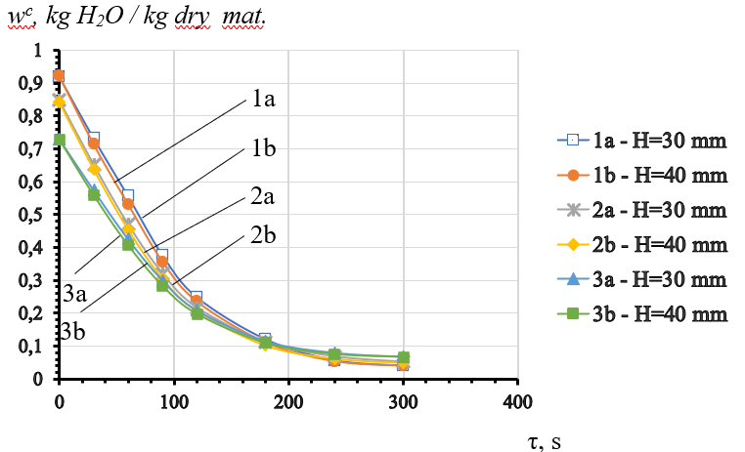
Fig.1. Drying kinetic curves for sunflower stalk samples: 1a, 1b – SSR; 2a, 2b – SSG;
3a, 3b – SSP.
To examine the dried SSR, SSP, and SSG samples under high-temperature conditions, differential thermal analysis (DTA) was conducted using a Q-1500 derivatograph of the Paulik–Paulik–Erdey system. To predict the calorific values of the samples, a comparison of the DTA curves is shown in Fig. 2.
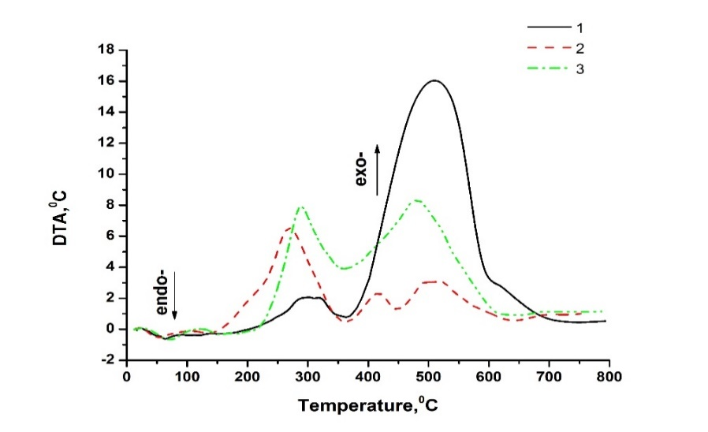
Fig. 2. DTA curves of sunflower stalk samples: 1 – SSR; 2 – SSP; 3 – SSG.
As shown by the DTA curves, the SSR sample exhibited the highest calorific value, with combustion of its pyrolytic residue in the temperature range of 377–750°C accompanied by the most pronounced exothermic effect. The SSP sample had the lowest calorific value, as evidenced by the presence of only minor exothermic effects during combustion of its pyrolytic residue at 360–750°C. The calorific value of the SSG sample was lower than that of the SSR sample but higher than that of the SSP sample.
Additionally, the calorific values of the SSR, SSP, and SSG samples were determined using a precision bomb calorimeter B-08-MA, and the results are shown in Table 1. The calorific values of the SSR and SSG samples were consistent with data for herbaceous and agricultural biomass, which typically show calorific values of approximately 14–18 MJ/kg dry matter.
To determine the ash content, 1 g of each sample was carbonized in an oven at 550°C for 3 hours. The SSP sample exhibited the highest ash content (Table 1) due to its high concentration of inorganic substances.
The chemical composition of the ash obtained after combustion of the SSR sample (SSR ash) was determined through X-ray fluorescence (XRF) analysis and is presented in Table 2. Similar information for the ash of the SSP sample is presented in Table 3.
Table 2
Chemical composition of the ash obtained after the combustion of the SSR sample
and XRF spectras
Chemical composition of the SSR ash, wt.% |  | XRF spectras of SSR ash sample
 |  | Light elements | Heavy elements
MgO | 6.1±0.1 | 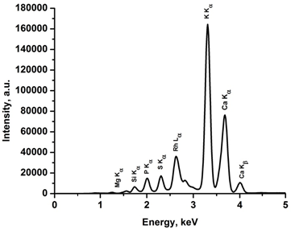 | 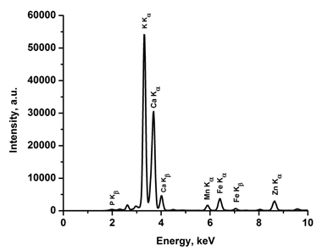
SiO₂ | 4.1±0.04
P₂O₅ | 3.8±0.02
SO₃ | 2.2±0.01
K₂O | 38.0±0.1
CaO | 44.5±0.3
Fe₂O₃ | 0.5±0.01
Other oxides | 0.8±0.01
Table 3
Chemical composition of the ash obtained after the combustion of the SSP sample
and XRF spectras
Chemical composition of the SSP ash, wt.% |  | XRF spectra of SSP ash sample
 |  | Light elements | Heavy elements
MgO | 2.7±0.1 | 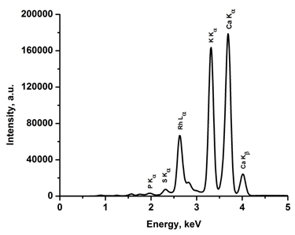 | 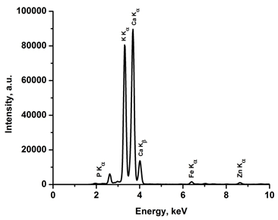
SiO₂ | 0.4±0.02
P₂O₅ | 0.2±0.01
SO₃ | 0.5±0.01
K₂O | 28.6±0.08
CaO | 67.2±0.1
Fe₂O₃ | 0.2±0.01
Other oxides | 0.2±0.01
The chemical compositions of the SSR and SSP ash samples differed slightly as shown by X-ray fluorescence (XRF) analysis.
Conclusions
To reduce the moisture content of the sunflower stalk samples (SSR, SSP, and SSG), a filtration drying method was applied as an energy-efficient approach, and the dried materials were subsequently used for further research. In general, the calorific values of the sunflower stalk samples were found to be directly influenced by their chemical composition, particularly the relative contents of cellulose, hemicellulose, and lignin. The calorific values determined using a bomb calorimeter were 18.2 MJ/kg for the SSR sample, 14.2 MJ/kg for the SSG sample, and 7.4 MJ/kg for the SSP sample. The calorific values of the SSR and SSG samples were consistent with data for herbaceous and agricultural biomass, which typically show calorific values of approximately 14–18 MJ/kg dry matter. The highest lignin content in the SSR sample resulted in its highest calorific value, whereas the low lignin content in the SSP sample led to its lowest calorific value. Additionally, the presence of inorganic compounds played a crucial role in ash formation. The experimentally determined ash contents were 8.8 wt.% for SSR, 10.2 wt.% for SSG, and 16.1 wt.% for SSP. The SSР sample showed the highest ash content caused by the highest content of inorganic substances. The chemical compositions of the SSR and SSP ash samples differed slightly as shown by X-ray fluorescence (XRF) analysis. Given their favorable calorific values but relatively high ash contents, sunflower stalk rind and whole sunflower stalks are recommended as potential components of solid composite fuel based on woody biomass. Conversely, due to its low calorific value and high ash content, sunflower stalk pith is not considered a viable option for solid biofuel production as a standalone material.
References
[1] Ma’ali, S., Cochrane, N., Makgoga, W., & Erasmus, J. (2024). The impact of planting dates and hybrid selection on sunflower seed yield and oil content. South African Journal of Plant and Soil, volume 41, no 1–3, 3–12. DOI: 10.1080/02571862.2024.2352174
[2] Grădinaru, C. M., Serbănoiu, A. A., & Serbănoiu, B. V. (2021). Sunflower stalks versus corn cobs as raw materials for sustainable concrete. Materials, volume 14, 5078. DOI: 10.3390/ma14175078
[3] Was, A., Sulewski, P., Gerasymchuk, N., Stepasyuk, L., Krupin, V., Titenko, Z., & Pogodzińska, K. (2022). The Potential of Ukrainian Agriculture’s Biomass to Generate Renewable Energy in the Context of Climate and Political Challenges — The Case of the Kyiv Region, Energies, volume 15, 6547. DOI: 10.3390/en15186547
[4] Ziebell, A. L., Barb, J. G., Sandhu, S., Moyers, B. T., Sykes, R.W., Doeppke, C., Gracom, K. L., Carlile, M., Marek, L.F., Davis, M.F., Knapp, S. J., & Burke, J.M. (2013). Sunflower as a biofuels crop: an analysis of lignocellulosic chemical properties. Biomass Bioenergy, volume 59, 208-217. DOI: 10.1016/j.biombioe.2013.06.009
[5] Zhang, L., Ren, W., Liu, F., Xia, L., Wu, X., Yang, R., Yu, Y., & Zhang, X. (2022). Comparative investigation on structural and chemical differences between the pith and rind of sunflower stalk and their influences on nanofibrillation efficiency. Polymers, volume 14, 930. DOI: 10.3390/polym14050930
[6] Kindzera, D., Hosovskyi, R., Atamanyuk, V., & Simak, D. (2021). Heat transfer process during drying of grinded biomass in a fixed bed dryer. Chemistry & Chemical Technology, volume 15, no 1, 118–124. DOI: 10.23939/chcht15.01.118
[7] Hosovkyi, R., Kindzera, D., & Atamanyuk, V. (2016). Diffusive mass transfer during drying of grinded sunflower stalks. Chemistry & Chemical Technology, volume 10, no 4, 459-463. DOI: 10.23939/chcht10.04.45

