Interrelation of quality indicators of coal charge and blast furnace coke
Illia Avdeiuk¹, Denys Miroshnychenko²
- Department of Oil, Gas and Solid Fuel Processing Technologies, National Technical University «Kharkiv Polytechnic Institute», UKRAINE, Kharkiv, Kyrpychova Street, 2. E-mail: illia.avdeiuk@ihti.khpi.edu.ua
- Department of Oil, Gas and Solid Fuel Processing Technologies, National Technical University «Kharkiv Polytechnic Institute», UKRAINE, Kharkiv, Kyrpychova Street, 2. E-mail: dvmir79@gmail.com
Abstract. The presented research is aimed at developing the scientific basis for the mechanism of bursting pressure, studying the influence of the nature of coal raw materials on the development of bursting pressure and developing optimal technologies for preparing blends to improve the quality characteristics of coke. The possibility of predicting the composition of coal blends using the data on the properties of coal concentrates is shown.
Keywords: charge, preparation, segregation, tamping, bursting pressure, compaction, mechanical strength, segregation.
Introduction
The need to produce high-quality metallurgical coke has led to the formation of a multi-basin raw material base at Ukrainian coke plants. To expand the raw material base of coking coal, it is necessary to introduce advanced technologies, such as modification of charges with additives; coking of rammed charges; and coking technology for thermally prepared charges. Inclusion of low-baking or non-baking coal in the composition of coal charges is possible with the introduction of partial briquetting of the charge.
The application of these methods directly affects the bulk density of the coal charge, sintering, and thus the quality of the coke produced and the production capacity of the coke chambers. However, all technological operations contribute to an increase in coking pressure (bursting pressure), which is an important criterion to consider when forming the composition of coal charges.
І Burst pressure
The influence of raw material factors of coal on the bursting pressure and properties of coke was studied [1]. 17 coal concentrates were used as the object of research: 6 are represented by the mark gas, 5 – mark fatty, 3 – mark coking, take one – marks long-flaming, gas fatty and lean caking.
The study of the qualitative characteristics of coke was carried out using physical, mechanical, and thermochemical methods for the study of standardized indicators: crushability (M₂₅), abrasion (M₁₀), reactivity (CRI), and post-reaction strength (CSR). Mathematical statistics methods were used to analyze the influence of raw material and technological factors on the value of the bursting pressure.
The determination of the bursting pressure was carried out in a unified laboratory installation of the SE “UKHIN” (Fig. 1). The method consists in bilateral heating in a retort at a given temperature of the tested coal (charge) load of a certain mass and subsequent measurement of the bursting pressure using a piezoelectric pressure sensor in the range from 1 kPa to 70 kPa.
The correlation coefficients between the bursting pressure and the technological characteristics of coal charges were determined. The mathematical dependencies were obtained and their statistical evaluation was carried out. The mechanism of influence of the bursting pressure on the strength characteristics of coke is confirmed. The possibility of predicting the composition of coal blends using the data on the properties of coal concentrates is shown.

Fig. 1. Installation for determining the bursting pressure of coal and charge. 1 - base; 2 - electric furnace; 3 - bracket; 4 - adjusting screw; 5 - pressure sensor;
6 - heat-insulating cover; 7 - gas outlet pipe; 8 – hole
Based on the study of the plastic-viscous properties of coal concentrates by the Giseler method, the connection between the peculiarities of the plastic state of coal of different degrees of metamorphism and the bursting pressure that it develops during coking was confirmed (Fig. 2).
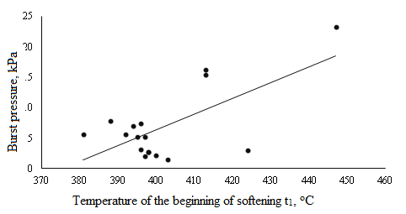
Figure 2. Dependence of tensile pressure on the temperature of the beginning
of coal softening
The interrelation of the bursting pressure and the component composition of the coal mixture, the yield of volatile substances of the charge, and the petrographic characteristics (vitrinite content) was confirmed.
Based on the processing of experimental data using the methods of mathematical statistics, regression equations were obtained that make it possible to predict the bursting pressure and optimize the composition of coal blends, which will allow controlling the indicator during re-blending and reducing the number of experimental measurements of bursting pressure in the conditions of a particular coke production [2].
The mechanism of influence of the bursting pressure on the strength characteristics of coke has been confirmed. Thus, an increase in the bursting pressure causes an increase in the amount of liquid products, deepening their interaction with softened coal grains, which improves the sinterability and coking properties of the charge and, as a result, increases the mechanical strength of coke [3].
The work of tamping, which must be applied to achieve the required density and stability of the coal cake, is investigated. The proportional dependencies of the tamping operation and the technological parameters and characteristics of coal charges were established. The tamping tests were carried out at the installation of SE “UKHIN” (Fig. 3).

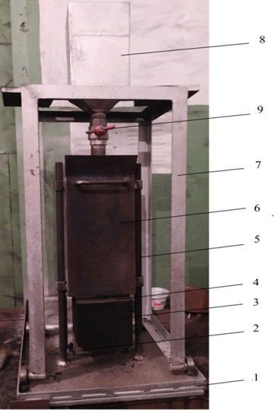
Fig. 3 Device for determining the shear strength of a rammed cake: 1 - base,
2 - table, 3 - test sample (briquette), 4 - metal plate, 5 - container guide, 6 - container,
7 - mobile hopper device, 8 - hopper with a fraction of lead, 9 - on/off valve
The prepared charges were coked in a 5-kg laboratory furnace developed by UHIN SE. The coke was quenched by drying. The coke was weighed and the gross dry coke yield was determined from the dry coal loading.
The resulting coke was subjected to destructive forces to realize cracks by dropping it 4 times from a height of 1 m on a metal plate, after which the coke was sieved (calibrated) on sieves with round holes with diameters of 70, 60, 50, 40, 25 and 10 mm. The sieving results were used to calculate the yield of individual size classes.
ІІ Coal segregation
The paper investigates the process of coal segregation in a real industrial coke plant, both in terms of size and the main parameters of coal quality [4]. The object of research was coal concentrates, which are part of the raw material base Coal Preparation Department-2 PJSC «Аvdiivka Coke Oven Plant». Batch composition: 4 gas, 4 fatty, 3 coking and 1 lean caking coal. The submitted samples of coal concentrates were analyzed by a set of standardized methods to determine the data of technical, petrographic and particle size analysis, including determination of ash content, volatile matter yield of the obtained size classes, as well as the Hardgrove grindability coefficient and Horne index.
The study was carried out at PJSC «Аvdiivka Coke Oven Plant», respectively, the injection, initial selection and analysis of the distribution of the charge were carried out in relation to the two-section coal tower built at this enterprise with a stationary reversible conveyor and charge distribution chutes, where the distribution of the charge into sections is carried out by a stationary reversible belt conveyor with valves (Fig. 4).
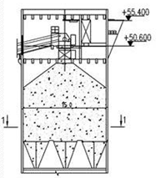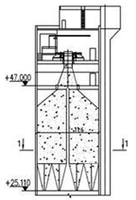
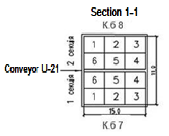
Fig. 4. Coal tower with charge chutes and valves
According to the results of this study, the ash content by coal size class is unevenly distributed; excessive grinding of coal with the formation of an increased number of classes less than 0.5 mm can lead to “self-lean caking” of the charge and, accordingly, deterioration of its quality. It is possible to state the relative stability of the technological properties and particle size distribution of the coal charge during its injection into the coal tower.
Conclusions
With an increase in the content of low-stage metamorphism coal in the charge from 37 to 49% and a decrease in the content of high-stage metamorphism coal from 57 to 45%, a gradual decrease in the compaction of the charge from 22.5 to 21.1 kPa, an increase in the bursting pressure from 6.8 to 5.9 kPa, as well as tamping work to achieve the specified density of the coal cake of 1.15 t/m³ per wet state of the charge from 8966 to 6822 J is observed.
The work and/or tamping time is inversely proportional to the content of low-stage coal in the charge, the content of the sum of fusinized components of the charge ΣFC and the content of volatile substances in the charge V^{daf}, while it is directly proportional to the average arbitrary reflectance of the vitrinite of the charge R₀ and the vitrinite content V_{t}.
An increase in the content of low-stage metamorphism coal in the blends leads to a decrease in the quality of the coke obtained from them. The mechanical strength of the studied cokes was close (91.0 - 91.5%), and the abrasion of cokes decreased from 7.3% to 7.8 and 8.0%.
The expediency of introducing technological measures to eliminate segregation and equalize the quality of the charge was shown, which should lead to stabilization of the quality of blast furnace coke produced at the enterprise.
Reference
[1] Miroshnychenko D.V., Shmeltser K.O., Kormer M.V., Sytnyk O.V., Avdeiuk I.M. (2024). Aspects of influence on the value of bursting pressure and metallurgical properties of coke. 1. Formation of bursting pressure depending on the properties of coal concentrates. Vuhlekhimichnyi zhurnal, 5
[2] Mahoney M. et al. (2010). The mechanism of coking pressure generation II: Effect of high volatile matter coking coal, semi-anthracite and coke breeze on coking pressure and contraction. Fuel. 89, 1557-1565
[3] Nomura S., Kato K. (2006). The effect of plastic size on coke quality and coking pressure in the co-carbonization of coal/plastic in coke oven. Fuel. 85. DOI:10.1016/j.fuel.2005.05.019
[4] Wang, Q., Yin, W., Zhao, B., Yang, H., Lu, J., Wei., L. (2014). The segregation behaviors of fine coal particles in a coal beneficiation fluidized bed. Fuel Processing Technology, 124, 28-34. https://doi.org/10.1016/j.fuproc.2014.02.015

