Formation of specific electrical resistance of blast furnace coke
under the influence of raw materials and technological factors
of its production
Yevhen Soloviov¹, Denys Miroshnychenko²
- Department of Oil, Gas and Solid Fuel Processing Technologies, National Technical University «Kharkiv Polytechnic Institute», UKRAINE, Kharkiv, Kyrpychova Street, 2. E-mail: yevhen.soloviov@ihti.khpi.edu.
- Department of Oil, Gas and Solid Fuel Processing Technologies, National Technical University «Kharkiv Polytechnic Institute», UKRAINE, Kharkiv, Kyrpychova Street, 2. E-mail: dvmir79@gmail.com
Abstract. The studies made it possible to establish the relationship between the specific electrical resistance and the reactivity, To obtain high-strength coke with low abrasiveness, it is necessary to have an appropriate component composition of the coal charge with a sufficient level of sintering, an optimal level of its grinding and an appropriate thermal regime of its coking.
Keywords: electrical resistance, coke powder, coal mixture, grade composition, structural strength, optimization.
Introduction

The quality of coke is a key factor for satisfactory operation of the furnace and can be evaluated in terms of physical characteristics (abrasion and crushing resistance, particle size distribution), chemical composition, coke reactivity index and post-reaction strength of the coke. The most important characteristics of coke used in electrothermal production are reactivity, electrical conductivity (specific electrical resistance), thermal stability, and technical analysis indicators (ash content, volatile matter yield). In electrothermal processes, coke acts as a reducing agent. Raw materials and coking process factors determine the carbon structure of blast furnace coke and its physical and mechanical properties. Deeper thermochemical transformations of coal matter also lead to an improvement in the coke structure.

І Determination of electrical resistivity

The degree of orderliness of the structure of coke and other carbonaceous materials can be controlled by the resistivity. Given that the resistivity is considered an indicator of the structural features of carbon materials, its value will be determined by both raw material factors and the impact of coking technology.

The aim of the work was to theoretically and experimentally substantiate the relationship between the resistivity and the orderliness of its structure [1]. A comprehensive assessment of the properties of the experimental cokes as lumpy material (П25, I10), porous coke body devoid of cracks (structural strength by Gryaznov, reactivity CRI and km, apparent density, porosity); as well as the substance of coke that forms the pore walls (abrasive hardness by Ginzburg and actual density) was given.
Coal charges of different component composition were used for the study.
The resistivity of coke was determined in accordance with DSTU 8831:2019 “Coke. Method for determination of the resistivity of coal coke powder”, which establishes a method for measuring the resistivity of coal coke powder in the range from 0.05 Ohm-cm to 0.5 Ohm-cm. The installation for measuring the resistivity of coke powder, according to DSTU 8831:2019, is shown in Fig. 1.

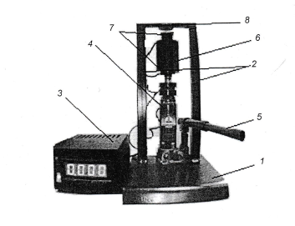
Fig. 1. Test setup for determining the electrical resistance of coke powder:
1 - frame; 2 - racks; 3 - digital measuring unit with a current stabilizer and a digital millivoltmeter; 4 - hydraulic jack, 2 kN; 5 - jack handle; 6 - two-probe measuring
matrix; 7 - upper and lower punches; 8 - crossbar.

The essence of this method is to measure the voltage drop when a direct current passes through a compressed column of coke with a particle size of less than 0.2 mm, enclosed in a matrix between two punches.
A scheme of the laboratory setup for experimental coking is shown in Fig. 2
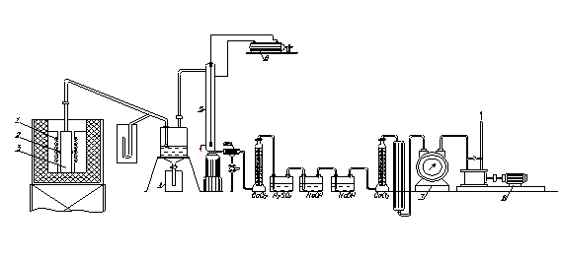
Figure 2. Scheme of the laboratory setup: 1 - carborundum heater; 2 - thermocouple covers; 3 - chamber; 4 - resin collector; 5 - electrostatic precipitator; 6 - transformer; 7 - gas meter; 8 - pump.

It has been established that an increase in the content of gas group coal is the dominant factor affecting the properties of coke, hence increasing the reactivity of coke and naturally increasing the resistivity of the resulting coke.

It has been found that the structure of blast furnace coke is significantly affected by the grade composition of the coal charge, sinterability, and coking properties of its components, which can be further evaluated using the resistivity.

According to the results of the study, the relationship between the resistivity of coke and the chemical properties of coke (reactivity and post-reaction strength) was established.

It was found that a change in the grade composition of the coal charge due to an increase in the content of low-metamorphosed coal (42-63 %), as a result, causes a decrease in the vitrinite reflection index and a shift in the plasticity interval towards lower temperatures, and also leads to a weakening of the coke structure and an increase in its resistivity [2].

Specific electrical resistance is an aggregate characteristic of coke properties, as evidenced by the mathematical dependence of the change in resistivity on ash content, sulfur content, volatile yield and petrographic composition and high correlation values (0,6-0,84).

The studies made it possible to establish the relationship between the resistivity and reactivity, which is reasonable, since both of these indicators characterize the structure of coke and the degree of its orderliness. The obtained regression equations will allow us to further assess the structure of coke and predict its behavior in the blast furnace process. They can also be recommended for optimizing the component composition and quality of production batches, given their significant impact on the resistivity of coke. This is especially relevant when using coke in electrothermal processes, since the resistivity of coke determines the productivity, electrical and thermal efficiency factor of the furnace.
ІІ Influence of organic and inorganic additives on the specific electrical resistance
of coke
The effect of organic (petroleum coke) and inorganic (boron carbide and silicon carbide (carborundum) nanopowders) additives on the quality of coke produced in a laboratory furnace and its electrical properties was evaluated.
The coal concentrates were studied by the following methods of express analysis (W^{r}_{t}, A^{d}, S^{d}_{t}, V^{daf}), plastometric (X, Y) and petrographic (R₀, petrographic composition).
After coking, the gross coke yield and technical analysis parameters were determined (A^{d}, S^{d}_{t}, V^{daf}), mechanical strength (М₂₅, М₁₀), structural strength (СМ), abrasive hardness (AТ) та specific electrical resistance of coke (ρ).
Coal charge with organic additive. Four variants of coal mixtures that are typical for coal blends of Ukrainian coke plants were studied Analyzing the results of determining the quality of the coke produced, it can be stated that the addition of 5% of petroleum coke to coal blends leads to an increase in the gross coke yield by 1.2-1.3%; a decrease in coke ash content by 0.2-0.3%; increase in total sulfur content in coke by 0.15-0.23%; deterioration of both mechanical (П25 - by 0.1-0.6%; I10 - by 0.1-0.2%) and post-reaction (CSR - by 0.6-1.0%) strength, coke reactivity (CRI - by 0.2-0.3%), as well as structural strength (SS - by 0.3-0.4%), abrasive hardness (AТ - by 0.7-1.0 mg) and specific electrical resistance (ρ - by 0.002-0.007 Ohm×cm)
Petroleum coke, as an inert material, significantly worsens the flowability of coal, but some interaction with coal can occur due to the release of volatile substances from petroleum coke, which smooths out this negative effect [3]. In addition, there was no significant effect of petroleum coke on the type of coke texture. All coke matrices (binder phase) were formed by ring texture components, the proportion of which decreased with increasing participation of petroleum coke.
Coal charge with inorganic additive. The additives were introduced into the production charge from the coal preparation shop of «PrAT Zaporozhkoks». The additives are crystalline nanopowders of boron carbide and silicon carbide (carborundum) produced by the Research Institute of Refractories, Fig. 3.
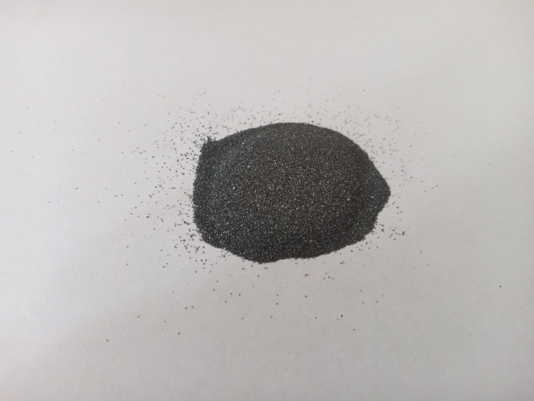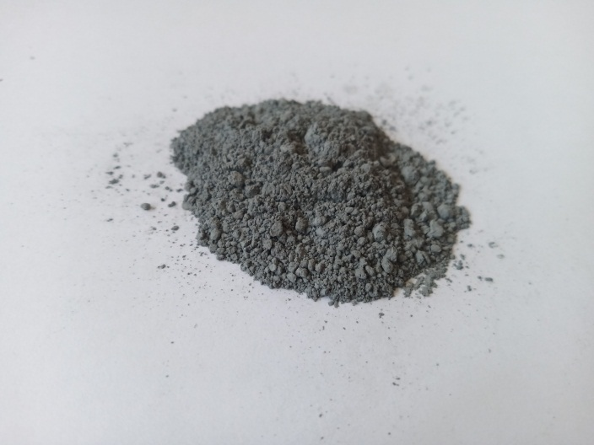
а) b)
Fig. 3 Nanopowder: a) boron carbide; b) silicon carbide

It has been shown that the introduction of a certain amount (0.25 wt. %) of non-sintering B₄C and SiC nanoparticles allows modifying the processes occurring during the plasticization of coal charge, with a subsequent increase in coke strength. The effect on coke properties of B₄C and SiC nanoparticles depends significantly on the rank composition of the charge. The proposed additives are especially effective in the charge with low coking properties.
The effect of adding inorganic nanoadditives to the charge is illustrated in Fig. 4
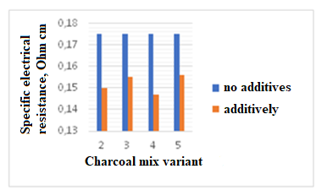
Fig. 4. Resistivity depending on the coal mixture variant
Conclusions.

The structure of blast furnace coke is significantly influenced by the grade composition of the coal charge, sinterability and coking properties of its components, which can be further evaluated using specific electrical resistance.

Increasing the degree of coke readiness and increasing the degree of orderliness of its structure leads to a decrease in the coke specific electrical resistance.

The specific electrical resistance is a measure of the temperature effect during the thermal destruction of coal and coking process. Depending on the final temperature of the process, the resistivity decreases the higher the temperature. Therefore, the specific electrical resistance can characterize the degree of coke readiness.

Reference
[1] Barsky V.; Vlasov G. Rudnitsky A. (2011) Composition and structure of coal organic mass. 3. Dinamics of coal chemical structure during metamorphism. Chem. Chem. Technol., 5 (3)
[2] Buryak, V., Vasil’chenko, G., Chirka, T., Konstantinov, S. Specific electrical resistance of carbon materials. (2013). Refract. Ind. Ceram., 54, 215–219. doi:10.1007/s11148-013-9577-8
[3] Gerrit Ralf Surup, Tommy Andre Pedersen, Annah Chaldien, Johan Paul Beukes, Merete Tangstad. Electrical Resistivity of Carbonaceous Bed Material at High Temperature. (2020). Processes, 8, 0933; doi:10.3390/pr8080933

