Temperature Influence on the Rheological Properties of C9 Hydrocarbon Resin Solutions
Roman Subtelnyy, Dariia Kichura, Bohdan Dzinyak
Department of Technology of organic products, Lviv Polytechnic National University, UKRAINE, Lviv, S. Bandery street 12, E-mail: roman.o.subtelnyi@lpnu.ua
The study examines the behavior of C9 resin solutions synthesized via different oligomerization methods, focusing on dynamic viscosity, shear stress, and shear rate as functions of temperature. Viscosity decreases with rising temperature, confirming pseudoplastic behavior. The ratio of density to viscosity increases, indicating molecular interactions.
Кеуwords: rheology, viscosity, shear rate, shear stress, C9 resin, solution.
Introduction
A primary method for producing gaseous olefins (ethylene and propylene) is the pyrolysis of petroleum feedstocks like gasoline and diesel. This process generates 30–35% liquid by-products, a complex mix of hydrocarbons, including dienes, olefins, and aromatics. Further processing yields light pyrolysis resin (pyrocondensate) with a boiling point up to 473 K, making up ~80% of liquid by-products. The C9 fraction (423–473 K), rich in unsaturated aromatics (~60 wt.%), serves as a raw material for hydrocarbon resins used in paints, coatings, adhesives, printing inks, and synthetic substitutes for vegetable oils and rosin [1, 2].
Oligomerization of the C9 fraction occurs via initiated or catalytic methods. Free-radical oligomerization, despite its industrial use, has drawbacks like high temperatures (453–493 K), long processing times, and high resin color index.
To reduce energy consumption and improve resin quality, a low-temperature (333–353 K) suspension and emulsion oligomerization method has been developed. Resins obtained by suspension oligomerization contain monomeric units of styrene and its derivatives. These products are characterized by a narrow molecular weight distribution and a lighter color. This technology reduces both the duration and energy consumption of the process compared to conventional methods [3].
Polymers and oligomers exhibit viscoelasticity, with viscosity influenced by temperature and pressure. Understanding resin viscosity under thermodynamic deformation aids in optimizing technical properties [4]. This study examines the temperature effect on the rheological properties of C9 hydrocarbon resin solutions obtained by different methods.
Experimental results and discussion
The dynamic viscosity of 10% resin solutions was measured using an Oswald viscometer with a 0.56 mm capillary. Flow time was recorded at six temperatures (293–343 K, in 10 K increments). The viscometer was placed in a constant-temperature water bath, and the solution was stabilized for 10 minutes before measurement. Flow time was measured with 0.1 s accuracy, with at least three measurements averaged for viscosity calculation.
The density of the resin solution and pure benzene was determined by the dilatometric method. Shear rate was calculated from the volumetric flow rate and capillary dimensions, while shear stress was derived from the pressure drop and capillary diameter [5].
The studied resins were obtained using different methods based on the C9 fraction of liquid by-products from diesel fuel pyrolysis. The synthesis method and properties of the resins are shown in Table 1.
Table 1
Production conditions and properties of hydrocarbon resin
Resin | Synthesis method | C9 resin structure | Molecular mass | Softening point, K
1 | Іnitiated oligomerization (initiator: di-tert-butyl peroxide, reaction temperature - 473 K, reaction time - 6 hours. | Styrene-cyclopentadiene  resin | 670 | 356
2 | Emulsion oligomerization (initiator: potassium persulfate, reaction temperature – 323 K, reaction time – 3 hours. | Styrene resin | 690 | 358
3 | Suspension oligomerization (initiator: benzoyl peroxide, added in 6 dosages, reaction temperature – 353 K, reaction time – 3 hours. | Styrene resin | 500 | 348
4 | Initiated oligomerization of the C9 fraction after suspension oligomerization (initiator: isopropyl benzene hydroperoxide, reaction temperature – 453 K, reaction time – 6 hours. | Cyclopentadiene resin | 650 | 354
The dynamic viscosity varies from 0.51 to 1.60 mPa·s (Fig. 1). The viscosity of the studied resins decreases with increasing temperature. These findings confirm the temperature dependence of viscosity, which is characteristic of pseudoplastic non-Newtonian fluids.
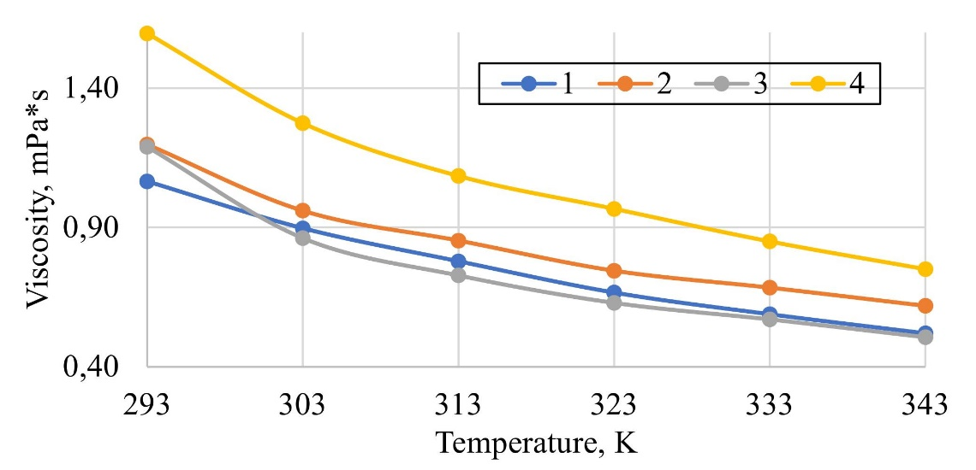
Fig. 1. Resin solution dynamic viscosity as a function of temperature
The most significant changes in viscosity were observed in resin (1). At 293 K, resin (1) exhibits an initial viscosity of 1.07 mPa·s, which decreases to 0.52 mPa·s at 343 K. The difference in dynamic viscosity values for the resin solutions ranges from 0.93 to 0.98 mPa·s. The correlation between temperature and dynamic viscosity for different resins ranges from -0.95 to -0.99.
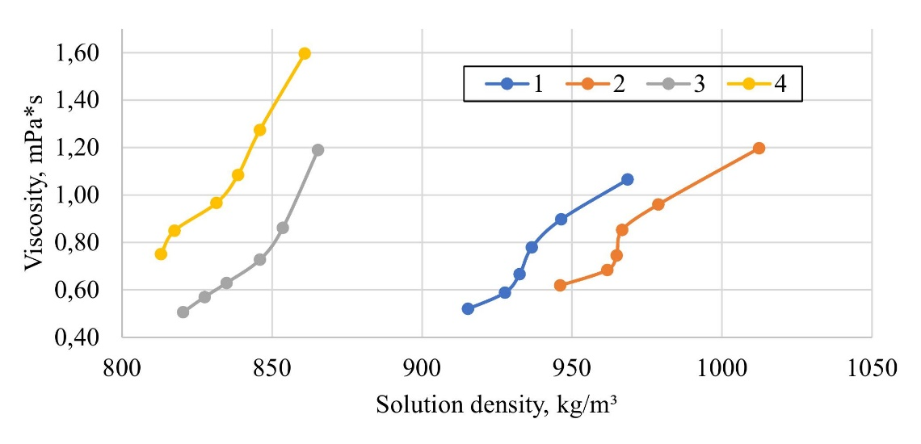
Fig. 2. Resin solution dynamic viscosity as a function of density
The density of 10% resin solutions in benzene in the temperature range of 293–343 K varies from 1012.4 to 812.5 kg/m³ (Fig. 2). In the temperature range under consideration, the greatest variation in density was observed in the case of a resin solution of (2) – 66.3 kg/m³, while the lowest value was recorded for resin (4) – 32.9 kg/m³.
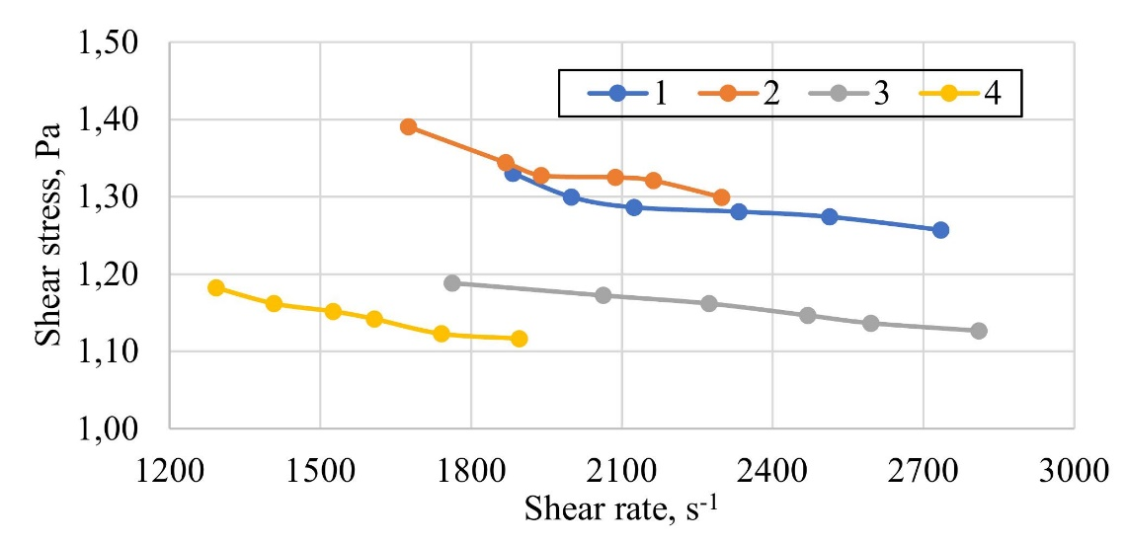
Fig. 3. Shear stress as a function of shear rate
The shear rate vs. shear stress relationship (Fig. 3) was nonlinear for all samples, confirming their non-Newtonian behavior. The observed decrease in shear stress with increasing shear rate indicates shear thinning, a characteristic of pseudoplastic fluids. At high shear rates (>2000 s⁻¹), the shear stress values for all samples converge, suggesting reduced viscosity and more uniform flow behavior. Thus, all samples can be classified as pseudoplastic non-Newtonian fluids that undergo shear-induced liquefaction.
The temperature corresponding to the largest change in viscosity (critical temperature) is 303 K in all cases. The values of the temperature coefficient for the temperature range of 293–343 K are presented in Table 2.
Temperature significantly influenceson the rheological properties of the resins under consideration. The temperature coefficient, which quantifies the degree to which dynamic viscosity undergoes a change when the temperature is elevated or depressed by 1 K, exhibits negative values for all resins. This finding indicates a decline in viscosity with an increase in temperature from 293 K to 343 K. With increasing temperature, the density-to-viscosity ratio rose for all resins, reflecting the general viscosity decrease upon heating. Resin (4) showed the highest stability in this parameter, confirming its suitability for industrial applications requiring consistent rheological properties.
Table 2
The rheological properties of hydrocarbon resin solutions
Property | Resin 1 | Resin 2 | Resin 3 | Resin 4
Temperature Coefficient (mPa·s/K) | –0.011 | –0.012 | –0.014 | –0.017
Density per Unit Viscosity (293 K), (m⁻¹·s⁻¹) | 909.1 | 845.4 | 727.6 | 539.3
Density per Unit Viscosity (343 K), (m⁻¹·s⁻¹) | 1760.0 | 1529.1 | 1620.9 | 1083.7
Flow Index (n) | –0.129 | –0.187 | –0.110 | –0.143
Consistency Constant (Pa·sⁿ) | 3.49 | 5.55 | 2.71 | 3.29
The flow index (n), which defines the shear stress dependence on shear rate, also varied with temperature. All tested resins had n values below 1, indicating pseudoplastic behavior. Cyclopentadiene resin (4), with significant viscosity changes under heating, emerged as a strong candidate for high-temperature paints and coatings. Meanwhile, styrene resin (2), demonstrating exceptional stability under high shear stress, is promising for applications involving heavy mechanical loads, such as rubber compounds and modified bitumen materials.
Conclusions
The dependence of the dynamic viscosity of hydrocarbon resin solutions on temperature, solution concentration, and synthesis method was studied. It was found that as the temperature increases, the rheological properties of the solutions approach those of non-Newtonian fluids, as confirmed by their pseudoplastic behavior. It was determined that the dynamic viscosity of resin solutions depends on both temperature and solution composition.
Acknowledgment
We are grateful to the brave people of Ukraine.
References
[1] Rahmatpour, A., & Ghasemi Meymandi, M. (2021). Large-Scale Production of C9 Aromatic Hydrocarbon Resin from the Cracked-Petroleum-Derived C9 Fraction: Chemistry, Scalability, and Techno-economic Analysis. Organic Process Research & Development, 25(1), 120–135. https://doi.org/10.1021/acs.oprd.0c00474
[2] Mildenberg, R., Zander, M., & Collin, G. (2008). Hydrocarbon resins. John Wiley & Sons.
[3] Subtelnyy, R., Zhuravskyi, Y., & Dzinyak, B. (2023). Preparation of hydrocarbon resins by suspension oligomerisation of the С9 fraction of gasoline pyrolysis initiated by amino peroxides. Eastern-European Journal of Enterprise Technologies, 6(6(126)), 23–30. https://doi.org/10.15587/1729-4061.2023.292527
[4] Ricarte, R. G., & Shanbhag, S. (2024). A tutorial review of linear rheology for polymer chemists: Basics and best practices for covalent adaptable networks. Polymer Chemistry, 15(9), 815–846. Scopus. https://doi.org/10.1039/d3py01367g
[5] Bhattad, A. (2023). Review on viscosity measurement: Devices, methods and models. Journal of Thermal Analysis and Calorimetry, 148(14), 6527–6543. https://doi.org/10.1007/s10973-023-12214-0

