Influence of dispersion medium parameters on suspension polymerization of methacrylic esters in presence of polyvinylpyrrolidone
Nataliya Semenyuk, Galyna Dudok, Volodymyr Malynovskyi, Nazar Shalata,
Volodymyr Skorokhoda
Department of Chemical Technology and Plastics Processing, Lviv Polytechnic National University, Ukraine, Lviv, 12 Bandery str. E-mail: nataliia.b.semeniuk@lpnu.ua; halyna.d.dudok@lpnu.ua; volodymyr.a.malynovskyi@lpnu.ua; nazar.t.shalata@lpnu.ua; vskorohoda@yahoo.com

Abstract. The influence of the solubility parameter on the regularities of obtaining hydrogel suspensions based on copolymers of 2-hydroxyethyl methacrylate and glycidyl methacrylate with polyvinylpyrrolidone has been investigated. The effect of the solvent nature on diffusion processes in suspension polymerization, the dispersive characteristics of hydrogel particles, and the polymerization kinetics has been established.
Keywords: polyvinylpirrolidone, 2-hydroxyethylmethacrylate, solubility parameter, suspension copolymerization, hydrogel.
Introduction
Polymeric suspensions with a narrow particle size distribution, predetermined chemical composition, and well-defined structure serve as a fundamental basis for developing drug delivery systems and biologically active substance carriers. From both a scientific and applied perspective, polymeric spherical particles obtained via suspension homopolymerization of methacrylic monomers – such as 2-hydroxyethyl methacrylate (HEMA) and glycidyl methacrylate (GMA) – or their graft copolymerization with polyvinylpyrrolidone (PVP) in the presence of crosslinking agents in inert solvent media [1,2] are particularly promising. It is known that such (co)polymers are biocompatible and are effectively used in medicine for the production of contact lenses, artificial intraocular lenses, (hemo)dialysis membranes, dental filling and impression materials, osteoplastic silver-containing composites for bone tissue replacement, and other applications [3-8].
A key challenge in the suspension polymerization of such compositions is the selection of a solvent that can dissolve water-soluble components (HEMA and PVP) while remaining immiscible with water or having limited solubility in it, thereby preventing the diffusion of monomer-polymer composition components into the aqueous phase. Consequently, research on the selection of an appropriate inert solvent to be added to the monomer phase, characterized by a partition coefficient significantly greater for the monomer than for water, is crucial. A critical parameter for evaluating the suitability of a solvent for the polymerization of a specific monomer is the solubility parameter, which reflects the polarity of the reaction medium and controls the critical molecular weight [2].
Results and discussion
During the suspension (co)polymerization of the investigated water-soluble polymer-monomer systems, the use of water as a dispersion medium is complicated by the possible dissolution of both the monomer (HEMA) and PVP. Therefore, to develop a suspension polymerization technology, studies were conducted to select the most effective solvents among higher alcohols, particularly cyclohexanol (CH), nonanol, decanol (DC), and their mixtures, suitable for ensuring the formation of spherical particles with sizes ranging from 0.1 to 2 mm.
Diffusion studies of water-soluble components from the organic (polymer-monomer) phase revealed a slight transfer of HEMA into the aqueous phase during the initial stages of polymer particle formation (Fig. 1), with diffusion virtually ceasing after 1–1.5 hours.
The dissolution of PVP in the monomer reduces the diffusion rate of HEMA into the aqueous phase. The highest monomer diffusion was observed when DC was used as the organic phase, whereas the lowest diffusion occurred with a CH-DC mixture. PVP also diffused from the dispersion phase into the dispersion medium during the initial stage but in significantly smaller amounts (1.6% per hour).
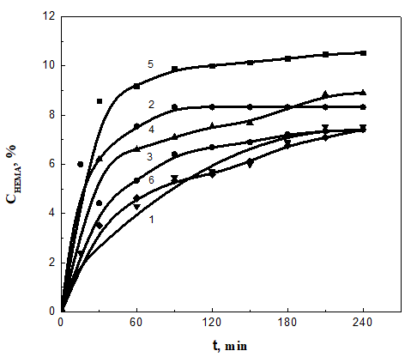 |  | 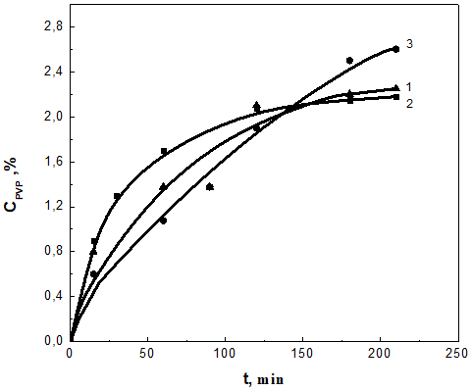
a) | b)
Fig. 1. Kinetics of diffusion of HEMA (a) and PVP (b) from the organic phase into
the aqueous phase. T=293 K.
а) [HEMA]=1.9 mol/l. Organic phase: 1– CH;  2 – DC; 3 – CH:DC = 1:1; 4…6 – 8% PVP solution in:  4 - CH; 5 – DC; 6 – CH:DC = 1:1. |  |  | b) Organic phase, wt. parts:  1– HEMA:PVP:CH = 8:2:15;  2 – HEMA:PVP:CH:DC = 8:2:7.5:7.5;  3 – HEMA:PVP:DC = 8:2:15.
An important factor determining the efficiency of suspension polymerization is the monomer distribution coefficient between the organic and aqueous phases. It is known that for successful dispersion polymerization, the monomer’s distribution coefficient should be as high as possible in the organic phase and as low as possible in the aqueous phase [9]. The determined distribution coefficients for the studied HEMA–PVP compositions were К_{distrib.1}=13,1; К_{distrib.2}=11,2; К_{distrib.3}=13,1; К_{distrib.4}=10,5; К_{distrib.5}=8,6; К_{distrib.6}=12,9. In view of these results, the compositions corresponding to organic phases 1, 3, and 6 (Fig. 1a) are the most suitable.
To confirm the appropriateness of the selected solvents for the polymerization of the HEMA/PVP composition, interfacial tension measurements at the organic phase–water interface were performed (Table 1), which demonstrated an increase in interfacial tension when DC was present in the organic phase.
Table 1.
Solubility parameters and interfacial tension of solvent and monomer mixtures
Composition of mixtures, vol. parts |  |  |  | Solubility parameter,  δ (MJ /m³)^{1/2} | Interfacial tension,  σ_{1/2}, N/m
HEMA | CH | DC | Н₂О | Solubility parameter,  δ (MJ /m³)^{1/2} | Interfacial tension,  σ_{1/2}, N/m
−  −  −  8  8  8 | 15  −  7,5  11,25  7,5  2,5 | −  15  7,5  11,25  7,5  2,5 | 50  50  50  42,5  50  60 | 43,48  43,15  43,31  39,29  41,59  44,48 | 10,24  14,39  15,59  −  −  −
Based on diffusion studies, interfacial tension, and calculated solubility parameters, the CH-DC mixture was selected as the inert solvent for the dispersed phase in the suspension polymerization of HEMA-PVP compositions.
For compositions containing another methacrylic ester (GMA), where the monomer is hydrophobic and PVP remains hydrophilic, solvent selection for the dispersion phase in the GMA–PVP system was investigated using various solvents: DC, CH, their mixtures, dioxane, benzene, and toluene (TL). Polymerization synthesis using TL as the solvent resulted in agglomerates, whereas employing DC produced non-spherical polymer particles. Both dioxane and CH proved unsuitable for conducting the granule copolymerization of GMA with PVP, as equilibrium was disturbed over time, leading to droplet coalescence and the formation of a homogeneous swollen polymer block. Analysis of the PVP content in the dispersion medium revealed significant diffusion of PVP (80 wt.% per hour) from the polymer–monomer phase containing these solvents into the aqueous phase. The addition of a TL/DC mixture to the GMA–PVP composition reduced the rate of PVP diffusion from the organic phase to the aqueous phase. The minimal diffusion was observed with a TL/DC volumetric ratio of 1:3. Conversely, an increase in the TL content in the organic phase resulted in an increased diffusion rate and higher limiting value of PVP diffusion (Fig. 2).
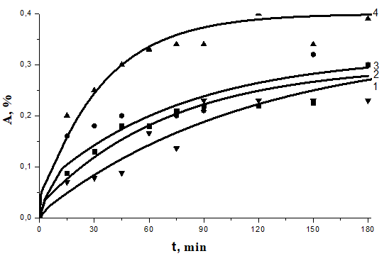 | 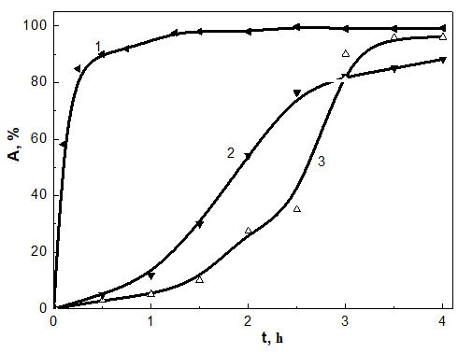
Fig. 2. Kinetics of diffusion of PVP from the organic phase containing GMA into the aqueous phase.  T=293 K, [GMA]=2.9 mol/l, [PVP]=5.6 wt.% .  Organic phase TL:DC, vol. parts:  1 – 1:3; 2 – 0:1; 3 – 1:1; 4 – 3:1. | Fig.3. The influence of the solubility parameter δ on the kinetics of suspension polymerization of compositions.  [org. phase]:[Н₂О] = 1:2.5 wt. parts  δ, (MJ/m³)^{1/2}:  1 – 42.300 (GMA:PVP = 8:2 wt. parts);  2 – 42.670 (HEMA:PVP = 8:2 wt. parts);  3 – 42.275 (HEMA:PVP = 10:0 wt. parts).
The nature of the monomer significantly influences both the solubility parameter of the compositions and the polymerization rate. It was established that the polymerization rate of compositions containing GMA is substantially higher than that for those with HEMA (Fig. 3). Considering the similar reactivity of HEMA and GMA in the homogeneous copolymerization with PVP [6], we attribute the marked differences observed in the dispersion systems to interphase interactions and the interaction parameters between the monomer and the solvent. Compositions containing GMA exhibit lower solubility parameter values (δ_{GМА}=19,36 (MJ/m³)^{1/2}) compared to HEMA compositions (δ_{HЕМА}=23,30 (MJ/m³)^{1/2}), which is one of the primary reasons for their enhanced reactivity in suspension polymerization (Fig. 3).
The calculated distribution coefficients for the GMA–PVP compositions are presented in Table 2. Based on these findings, the use of a TL/DC mixture as the organic solvent for the dispersion phase in the suspension polymerization of GMA–PVP compositions is justified.
A critical aspect in suspension polymerization is the controlled regulation of the granule size distribution of the polymers. The solubility parameter is one of the factors that undoubtedly affects both the size and shape of the polymer suspensions. Therefore, investigating the particle sizes and the polydispersity index as functions of the solubility parameter is of significant technological importance.
The most uniform particles, having the smallest diameter (and consequently the highest specific surface area), were formed at δ = 42.300 (MJ/m³)^{1/2}, corresponding to an organic phase solvent ratio of DC:TL = 1:1 vol. parts.
Table 2.
Distribution coefficients of composition components in organic and aqueous phases
Composition of mixtures, vol. parts |  |  |  | Distribution coefficient
GMA | PVP | TL | DC | in organic phase | in aqueous phase
4 | 1 | – | 5,6 | 32,80/31,85 | 0,03/0,031
4 | 1 | 1,4 | 4,2 | 43,78/35,83 | 0,022/0,028
4 | 1 | 4,2 | 1,4 | 82,57/24,57 | 0,012/0,041
4 | 1 | 5,6 | 5,6 | 170,9/34,40 | 0,006/0,029
4 | - | – | 5,6 | 24,08 | 0,040
4 | - | 5,6 | 5,6 | 31,86 | 0,031
* numerator – for GMA; denominator – for PVP
Our studies revealed that the influence of the solubility parameter on the average particle size in the suspension polymerization of GMA–PVP compositions exhibits a pronounced extremum, with a minimum particle diameter observed at δ = 42.300 (MJ/m³)¹/² (Table 3).
Table 3.
Influence of the solubility parameter δ on the dispersion characteristics of granular copolymers of PVP–polyGMA. (GMA:PVP = 8:2 wt.parts; T = 348 K; ω_{rotation} = 270 rpm; С_{stab} = 1 wt.%; [PB]=1 wt.%)
Composition of mixtures, vol. parts |  |  |  | Solubility parameter,  δ (MJ /m³)^{1/2} | d_{n},  mm | d_{w},  mm | PDI | Maximum fraction content, %
GМА | DC | TL | Н₂О
8  8  8  8  8 | 11,2  8,4  7,4  5,6  3,8 | 0  2,8  3,8  5,6  7,4 | 53  53  53  53  53 | 42,381  42,341  42,326  42,300  42,274 | 0,925  0,760  0,626  0,467  1,336 | 1,241  1,164  0,910  0,584  1,728 | 1,342  1,531  1,451  1,251  1,294 | 19  21  26  35  12
8 | 0 | 11,2 | 53 | 42,220 | agglomerates |  |  | –
If the solubility parameter falls below this value as a result of an increased TL content in the organic phase, a sharp increase in particle diameter occurs, eventually leading to agglomeration. When TL alone was used as the organic phase solvent (without DC), the formation of granular particles was unsuccessful.
Studies on the influence of the solubility parameter of compositions containing hydrophilic HEMA and PVP on the average particle diameter and polydispersity index demonstrated a similar effect. This dependency was observed both for varying solvent concentrations at a constant ratio and for a constant solvent content at different ratios. With an increase in the solubility parameter, i.e., with an increase in the concentration of CH in the organic phase, the size of the polymer particles decreases. The effect of the solubility parameter on the particle polydispersity also shows an extremal behavior. The most uniform particles were obtained with a CH content of 20–30 wt.% in the composition. For HEMA compositions, a decrease in the concentration of the inert solvents CH and DC in the organic phase leads to an increase in the solubility parameter, resulting in suspensions with smaller particle sizes and a narrow size distribution. The most uniform particles were achieved at an inert solvent (CH + DC) content of 10 wt.% in the organic phase.
Conclusion
In summary, the performed investigations demonstrate that the solubility parameter is a crucial and effective factor influencing both the kinetics of suspension copolymerization of methacrylic esters, such as HEMA and GMA, with PVP and the particle diameter and granule size distribution, which in turn determine the potential applications of the resultant polymers.
The diffusion of water-soluble components from the organic (polymer-monomer) phase was studied, and a slight transition of HEMA and PVP into the aqueous phase was observed at the initial stages of polymer particle formation. However, after 1–1.5 hours, diffusion practically ceased. The dissolution of PVP in the monomer reduced the diffusion rate of HEMA into the aqueous phase. The lowest monomer diffusion was observed when a mixture of CH and DC was used as the organic phase.
The interfacial tension was investigated, and the solubility parameter of HEMA–PVP compositions was calculated. Based on the results, a mixture of DC and CH was selected as an inert solvent for the dispersed phase. The use of an organic solvent mixture of TL and DC for the dispersed phase in the suspension polymerization of GMA–PVP compositions was substantiated.
It was established that the polymerization rate of compositions containing GMA was significantly higher than that of HEMA. The influence of the solubility parameter on the average particle size in the suspension polymerization of GMA–PVP compositions exhibited a distinctly extreme nature. The most uniform and smallest-diameter particles were formed at a solvent ratio in the organic phase of DC:TL = 1:1 vol. parts. For HEMA-based compositions, a decrease in the concentration of inert solvents CH and DC in the organic phase led to an increase in the solubility parameter, resulting in the formation of smaller suspensions with a narrow size distribution.
References
[1] Semenyuk, N., Skorokhoda, V., & Dudok, G. (2024). Hydrogels in biomedicine: Granular controlled release systems based on 2-hydroxyethyl methacrylate copolymers. A review. Chemistry and Chemical Technology, 18(2), 143-156. https://doi.org/10.23939/chcht18.02.143
[2] Horak, D., Semenyuk, N., & Lednicky, F. (2003). Effect of the reaction parameters on the particle size in the dispersion polymerization of 2-hydroxyethyl and glycidyl methacrylate in the presence of a ferrofluid. Journal of Polymer Science Part A: Polymer Chemistry, 41, 1848-1863. https://doi.org/10.1002/pola.10728
[3] Suberlyak, O., & Skorokhoda, V. (2018). Hydrogels based on polyvinylpyrrolidone copolymers. In S. Haider & A. Haider (Eds.), Hydrogels (pp. 136-214). IntechOpen. https://doi.org/10.5772/intechopen.72082
[4] Skorokhoda, V. Y., Semenyuk, N. B., Melnyk, Y. Y., Dziaman, I. Z., & Suberlyak, O. V. (2016). The bactericidal hydrogel materials and soft contact lenses on their bases. Visnyk of the National University “Lviv Polytechnic”: Chemistry, Technology of Substances and Their Application, 841, 428-432.
[5] Semenyuk, N., Dudok, G., Skorokhoda, T., Bratychak, M., Sadova, U., & Skorokhoda, V. (2022). Regularities of obtaining silver nanoparticles in the presence of polyvinylpyrrolidone and their application for osteoplastic composites. Chemistry and Chemical Technology, 16(3), 404-410. https://doi.org/10.23939/chcht16.03.404
[6] Skorokhoda, V. J., Semenyuk, N. B., Dudok, G. D., & Kysil, H. V. (2022). Silver-containing osteoplastic nanocomposites based on polyvinylpyrrolidone copolymers. Voprosy Khimii i Khimicheskoi Tekhnologii, 3(142), 67-73. https://doi.org/10.32434/0321-4095-2022-142-3-67-73
[7] Melnyk, Y., Stetsyshyn, Y., Skorokhoda, V., & Nastishin, Y. (2020). Polyvinylpyrrolidone-graft-poly (2-hydroxyethylmethacrylate) hydrogel membranes for encapsulated forms of drugs. Journal of Polymer Research, 27(11), Article 354.
[8] Melnyk, Y. Y., Ivanyukh, O. O., Semenyuk, N. B., Kostenko, M. B., & Skorokhoda, V. Y. (2023). Hydrogel membranes based on 2-hydroxyethyl methacrylate copolymers with polyvinylpyrrolidone, modified with montmorillonite and silver nanoparticles. Chemistry, Technology and Application of Substances, 6(2), 139-144. https://doi.org/10.23939/ctas2023.02.139
[9] Arshady, R., & Ledwith, A. (1993). Suspension polymerization and its application to the preparation of polymer supports. Reactive Polymers, 1, 159-174.

