Assessment of the impact of transverse section damage on the strength and deformability of structures
V. Kravchuk,¹ P. Vegera,² R. Khmil ³
1. Department of Building Construction and Bridges, Lviv Polytechnic National University,
UKRAINE, Lviv, Zelena str., 204, e-mail: volodymyr.s.kravchuk@lpnu.ua
2. Department of Building Construction and Bridges, Lviv Polytechnic National University,
UKRAINE, Lviv, Karpinskoho str., 6, e-mail: pavlo.i.vehera@lpnu.ua

3. Department of Building Construction and Bridges, Lviv Polytechnic National University,
UKRAINE, Lviv, Karpinskoho str., 6, e-mail: roman.y.khmil@lpnu.ua

Abstract - Reinforced concrete elements are subjected to various types of damage that significantly reduce their strength and operational characteristics. This study examines the main types of defects, i and their impact on the load-bearing capacity of structures. It also involves structural modeling and emphasizes the need for further research

Keywords - reinforced concrete beams; defects; corrosion; stress-strain state; strength.

Introduction

Reinforced concrete is one of the most widely used materials in construction due to its high strength, durability, and ability to withstand significant loads. These properties make it indispensable for the creation of both large-scale residential and public buildings, as well as complex engineering structures. However, despite its reliability, reinforced concrete structures can suffer from various types of damage caused by external and internal factors. These factors include aggressive environmental conditions, mechanical damage, and the consequences of warfare. Photos of such damage are shown in Fig. 1.

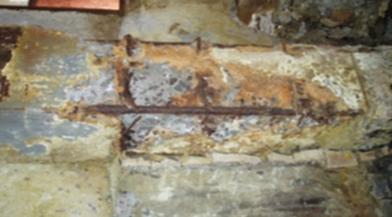
Fig. 1. Photo of a damaged building structure caused by the impact of the environment

All these factors can significantly reduce the reliability and operational characteristics of structures, as well as substantially limit their service life.
Damage to reinforced concrete elements can occur at various stages of their life cycle, ranging from the construction process to the long-term operation of the facility. Such damage may be caused not only by external factors, such as mechanical impacts or accidents, but also by natural processes, including reinforcement corrosion or a decrease in concrete quality due to the influence of moisture, temperature fluctuations, or chemical reactions. This leads to changes in the stress-strain state of the structures, which can result in further deformations or even failures.
An especially important task in the construction industry is the study of the residual load-bearing capacity of reinforced concrete structures. Reinforced concrete is a primary material used in many infrastructure projects in Ukraine, so timely diagnostics and assessment of the residual strength of such structures are crucial to ensure the safety of building operations. Damage, such as cracks, corrosion of reinforcement, reduced concrete strength, or surface spalling, significantly reduces the load-bearing capacity of structures and complicates their further use.
In this context, the consideration and application of various methods for modeling, calculating, and analyzing the stress-strain state of damaged reinforced concrete beams is highly relevant today. The use of software packages for modeling and analysis allows for a more accurate assessment of the impact of damage on structures and determination of their residual load-bearing capacity. This is a critical step in developing recommendations for the repair and restoration of damaged structures, which, in turn, ensures their continued safe operation.
Research and Methods

The main goal of this work is to review and analyze scientific publications dedicated to the damages and defects of reinforced concrete structures, as well as to develop a detailed classification of these defects based on various parameters and conduct modeling of damaged structures using software complexes. To accurately determine the causes of the reduced load-bearing capacity and serviceability of such structures, it is necessary not only to describe the nature of the damages but also to clearly systematize them, taking into account the various factors that can lead to their occurrence. These factors include mechanical, chemical, and physical damages, as well as the influence of external conditions such as temperature, humidity, or aggressive chemical environments.
A detailed classification of defects is a key step in assessing the residual strength of structures, as it allows for precise identification of the type and degree of damage, which in turn aids in the development of effective diagnostic and reconstruction methods. This issue is particularly important because damages to reinforced concrete structures can have different natures and occur at various stages of their operation.
Given the variety of factors that affect the strength and reliability of structures, the classification of damages is an essential tool for effectively assessing their condition and determining the next steps for ensuring the safe operation and restoration of damaged elements. This issue is actively discussed in numerous previous studies, highlighting the importance of a thorough analysis of reinforced concrete structure defects to maintain their functionality and safety under real loading conditions.
In their paper [1], the authors classify the causes of damages to reinforced concrete structures into three main groups: physical, biological, and chemical. Physical damages occur due to temperature fluctuations, cyclic loading, and mechanical impacts. Biological damages are caused by the growth of plants and microorganisms that damage the material structure, while chemical damages are related to corrosion and interaction with chemical substances.
The authors [2] note that building codes in different countries and scientific studies propose various classification systems for damages; however, all of them allow for the assessment of the technical condition of structures and decision-making regarding their further operation. The assessment of the condition is based on identifying and analyzing defects, which simplifies the diagnostics and calculation of structures.
Reinforced concrete structures undergo a complex process of deterioration that requires reliable methods for detecting defects. One such method is the analysis of the deformation of structures, which can indicate a decline in their condition. Changes in the mechanism of destruction and the accumulation of internal stresses also point to the possibility of wear. As noted in study [3], evaluating changes in the dynamic characteristics of structures helps determine their ability to withstand loads. A comprehensive approach to studying wear allows for an accurate assessment of the technical condition of objects and determining the need for their repair or maintenance.
Modeling damaged reinforced concrete structures and evaluating their damage under various factors has become an important area of modern scientific research. Understanding the effects of damage on structures, particularly in the context of war-damaged buildings, is an urgent task [4]. Existing methods partially address the issue, as the impact of damage is complex and depends on numerous factors. The lack of calculation methods for the residual load-bearing capacity of reinforced concrete elements in current standards complicates the assessment. Current research using software packages focuses on studying the mechanisms of damage and their impact on load-bearing capacity.
In article [5], experimental data on the stress-strain state of damaged inclined sections of reinforced concrete beams are presented. The results showed that as the angle of damage increases, the deformations grow, and the position of the neutral axis shifts, rotating towards the damage and becoming almost parallel to the damage front. These results were confirmed by beam modeling in software packages "LIRA – SAPR" and FEMAP in studies [6-8]. The research demonstrated that an increase in the area of damage reduces the residual load-bearing capacity of the element. Specifically, each centimeter of damage decreases the effective height of the beam and its load-bearing capacity.
In study [9], the effects of damage on reinforced concrete bending elements are considered, particularly concrete spalling, reinforcement corrosion, and mechanical damage. This leads to changes in the geometric characteristics of the cross-sections and a reduction in the load-bearing capacity of the structures. The research confirmed that a beam with defects operates under oblique bending, as reflected in the results of strain gauge measurements.
In our research, we modeled damaged beams in the "LIRA – SAPR" software, which allowed us to assess the impact of continuous damage to the cross-sectional area of the beams. The dimensions of the test beams and their reinforcement are shown in Fig. 2.

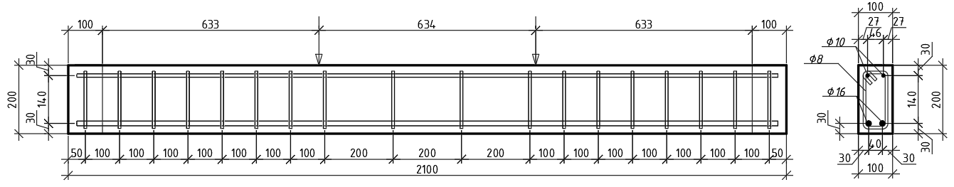
Fig. 2. General view of the beam reinforcement

The type of beam damage is shown in Fig. 3, where a complete cross-sectional damage of the beam with a width of 80 mm and a depth of 20 mm is depicted. Such damage may occur due to the corrosion of the beam caused by potential water ingress. The study investigated how the load-bearing capacity of both the undamaged and damaged beams changed, as well as the nature and concentration of stresses in the damaged beam. To construct the model, volumetric finite elements (FE) No. 236 were used, and for modeling the reinforcement, finite elements No. 210—physically nonlinear universal spatial FE—were applied.

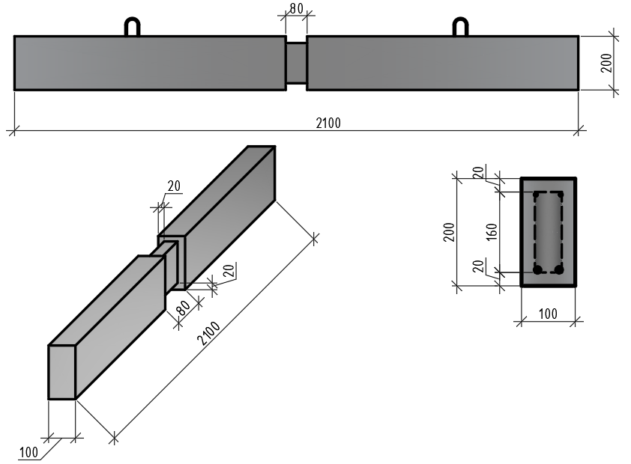
Fig. 3. View of the damaged beam

Results and discussions

As a result of the modeling and static calculation using the "LIRA-SAPR" software, models and isolines of reinforced concrete beams with damage were obtained. For example, the overall model of the damaged beam in "LIRA-SAPR" is shown in Fig. 4, the forces in the reinforcement cage of the damaged beam are shown in Fig. 5, and the mosaic stress diagram is presented in Fig. 6.

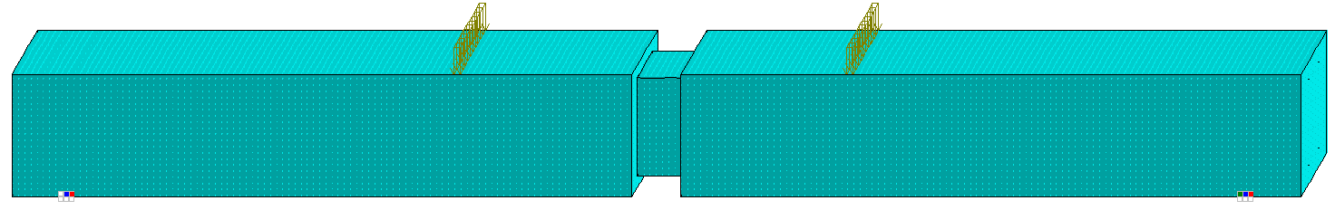

Fig. 4. Overall model of the damaged beam in the "LIRA – SAPR" software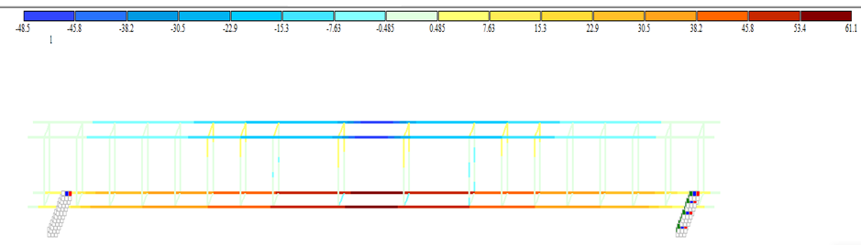
Fig. 5. Forces in the reinforcement frame of the damaged beam 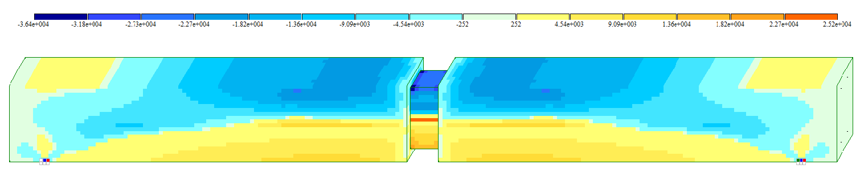
Fig. 6. Mosaic stress map of the damaged beam

As a result of the simulation of damaged reinforced concrete beams using the "LIRA – SAPR" software, the impact of complete damage to the cross-section on their bearing capacity was evaluated. The analysis showed that damage to beams with a cross-section of 80 mm in width and 20 mm in depth significantly reduces their operational characteristics. The bearing capacity of the damaged beams decreased by 25%, which emphasizes the importance of timely diagnostics and restoration of structures to ensure their safety during operation.
The simulation also revealed changes in the stress distribution: in the damaged beams, the stresses were redistributed, with maximum concentration in the damaged zone. This confirms the theory that every centimeter of damage reduces the effective working height of the beam and alters its stress-strain state. As a result, the stresses in the reinforcement increased significantly (from 25.7 kN to 50.1 kN), and the deflections increased from 0.05 mm to 4.65 mm. The stresses in the concrete of the damaged beams compared to the undamaged ones also increased from 40.7 MPa to 72 MPa, indicating a reduction in their residual strength.
The simulation demonstrated the importance of accurately considering the depth and nature of the damage to properly assess the technical condition of structures. The lack of unified methods for calculating the residual bearing capacity of damaged reinforced concrete elements in current standards complicates the decision-making process regarding the restoration of damaged structures.

Conclusion

The finite element method is an effective tool for evaluating the impact of damage on the bearing capacity of reinforced concrete structures. The results of the simulation in the "LIRA – SAPR" software allow for the precise determination of changes in the mechanisms of stresses and deformations that occur due to damage.
Damage caused by corrosion or mechanical defects has a significant impact on the reduction of the load-bearing capacity of structures, which confirms the need for timely detection and repair of defects.
Modeling damaged structures is an important tool for predicting their behavior under load, which is essential for ensuring the safety of buildings and structures.
For the development of more effective methods of diagnosing and reconstructing damaged structures, it is important to consider the types of damage and their depth, as well as the influence of various factors on the reduction of load-bearing capacity.
The results of this study highlight the need for further development and improvement of regulatory documents governing the assessment of the residual load-bearing capacity of damaged reinforced concrete elements, as well as increasing the accuracy of the models used for these purposes.
For further improvement of the methods for evaluating the technical condition of damaged reinforced concrete structures, additional studies are required with other types of damage, particularly with varying widths of damage, damage to the upper compressed reinforcement, as well as experimental studies to confirm the simulation results and refine the obtained data.

References

[1] Mykhalevskyi, N. A., Vegera, P. І., & Blikharskyi, Z. Y. (2023). The influence of damage to reinforced concrete beams on strength and deformability: the review. Theory and Building Practice, 5(1), 112-119. https://doi.org/10.23939/jtbp2023.01.112
[2] Klymenko, Ye. V., & Oreshkovych, М. (2013). On the Study of the Compressed Damaged Reinforced Concrete Elements of Circular Cross-Section. Theory and building practice, 755, 173-178. https://science.lpnu.ua/sctp/all-volumes-and-issues/volume-755-2013-1/do-pitannya-vivchennya-roboti-stisnutih-poshkodzhenih
[3] Hait, P., Arjun, S., & Satyabrata, Ch. (2018). Quantification of damage to RC structures: A comprehensive review. Disaster Advances, 11(12), 41-59. https://www.academia.edu/39813716/Quantification_of_damage_to_RC_Structures_A_Comprehensive_review
[4] Krasnitskyi, P., Lobodanov, M., & Blikharskyy Z. (2024). Аnalysis of software packages applying in the investigation of the damage effect to reinforced concrete beams on strength and deformability: the review. Theory and Building Practice, 6(1), 61-68. https://doi.org/10.23939/jtbp2024.01.061
[5] Klymenko, Ye. V., & Polianskyi, K. V. (2019). Experimental investigation of the stress-strain state of damaged reinforced concrete beams. Bulletin of the Odessa State Academy of Civil Engineering and Architecture, 76, 24-30. https://doi.org/10.31650/2415-377X-2019-76-24-30
[6] Pavlikov, A.M., Harkava, O.V., Hasenko, A.V., & Andriiets, K.I. (2019). Comparative analysis of numerical simulation results of work of biaxially bended reinforced concrete beams with experimental data. Building construction: Bulletin of the Odessa State Academy of Civil Engineering and Architecture, 77, 84-92. https://doi.org/10.31650/2415-377X-2019-77-84-92
[7] Mykhalevskyi, N.A., Vegera, P.І., & Blikharskyy, Z.Y. (2023). Analysis of the effect of uneven damage of reinforced concrete beam using the FEMAP software package. Modern construction and architecture, 6, 54-61. http://visnyk-odaba.org.ua/2023-06/6-6.pdf
[8] Deineka, V., Vegera, P., & Blikharskyy, Z. (2024). Simulation influence of uneven damage of reinforced concrete beam in LIRA-FEM. Theory and Building Practice, 6(1), 130-140. https://doi.org/10.23939/jtbp2024.01.130
[9] Voskobiinyk, O.P, Kitaiev O.O., Makarenko Ya.V., & Buhaienko Ye.S. (2011). Experimental investigation of reinforced concrete beams with defects and damages that cause the skew bending. Academic journal. Industrial Machine Building, Civil Engineering, 1(29), 87-92. https://reposit.nupp.edu.ua/handle/PoltNTU/8074

