Improvement of the experimental separation-condensation unit for drying compressed air using throttle devices
Dmytro Bondar^{1,2}, Oleksandr Mandryka^{1,3}, Oleksandr Liaposhchenko¹
1. Faculty of Technical Systems and Energy Efficient Technologies, Sumy State University, UKRAINE, Sumy, 116, Kharkivska Str, E-mail: d.bondar@pohnp.sumdu.edu.ua (D.B.), E-mail: mandryka.o@ms.sumdu.edu.ua (O.M.), o.liaposhchenko@pohnp.sumdu.edu.ua (O.L.)
2. LLC Pnevmotechnika, UKRAINE, Sumy, 4, Cherkaska Str, E-mail: pnevmotechnika@ukr.net
3. LLC Progresstech-Ukraine, UKRAINE, Kyiv, 3, Sholudenka Str, E-mail: ukr@progresstech.ua
Abstract – The paper proposes the improvement of an experimental installation for drying compressed air based on throttle devices. The goal is to achieve a stable mode of heat exchange between two heat carriers and to achieve the dew point of the compressed air quality to the level of the 4th class according to ISO 8573-1:2010.
Кеуwords – energy efficiency; air system; coolant; compressed air; process innovation; vortex tube.
Introduction
In modern industrial production, the most common source of energy for powering pneumatic equipment and tools is compressed air [1]. Compressed air is also very often part of the technological process of transporting loose materials, abrasive surface treatment, cooling of cutting tools and cutting zones on metalworking machines, blowing and cooling of various types of semi-finished products. Compressed air is produced using various types of compressor equipment, which is considered a relatively simple and safe process compared to other types of energy sources. The ability to accumulate, store in high-pressure tanks and transport with the help of pipeline systems over considerable distances also give compressed air significant advantages in industrial applications [2].
The compressed air after the compressor is warm and contains a significant amount of moisture, the level of which depends on the temperature and relative humidity of the surrounding air. In pneumatic pipelines, compressed air gradually cools, which is accompanied by the release of a large amount of condensate, which is harmful to the technical condition of pneumatic equipment, and also spoils or changes the chemical state of products/raw materials with which it comes in contact [3]. Therefore, in addition to basic parameters such as volume flow and pressure, compressed air must meet the established standards that are defined for certain types of equipment or technological process.
The quality of compressed air is usually classified according to the international standard ISO 8573-1:2010 [4]. This standard provides for 6 quality classes corresponding to a certain level of compressed air humidity and regulated by the dew point temperature. The lower the humidity level and, accordingly, the lower the dew point temperature, the higher the quality class of compressed air.
To remove moisture from compressed air in modern production processes, special equipment is used, which includes cyclone separators, air aftercoolers, refrigeration type dryers, membrane dryers, as well as adsorption dryers with cold or hot regeneration [5]. The use of one or another equipment for drying compressed air depends on technological requirements or economic feasibility. Most industries use refrigeration type dryers, which allow to obtain compressed air of the 4th class in terms of humidity level, which ensures a dew point temperature of +3 °C.
Refrigeration type dryers use the principle of cooling compressed air with the subsequent process of condensation of water vapor and its transformation into a liquid, which is removed from the pneumatic system using cyclone separators. However, the main disadvantages of this type of dehumidifiers include the use of ozonating refrigerants R134 or R404 [6].
In the article [7], the authors proposed a model for drying compressed air based on the principle of a refrigeration type dryer, but instead of gas refrigerants, it is suggested to use cooled compressed air with a temperature below 273K as a coolant. To implement the process of reducing the temperature of compressed air below 0℃, the Joule-Thompson method was used, which allows you to reduce the temperature of the gas during its adiabatic expansion, or throttling. An ordinary ball valve was used as a throttle. The authors managed to achieve a short-term decrease in the temperature of the auxiliary compressed air flow after the throttle to a temperature of -18.8°C, and the temperature of the main compressed air flow after the heat exchange process briefly decreased to the level of +6.8℃, which is close to the temperature values that are reached in conventional refrigerating type dryers.
But the presented method of cooling and drying the compressed air needs to be refined, as the expansion is short-term and cannot be used for a long-term process. Therefore, it is necessary to improve the test stand by replacing the throttle with a device that will allow to receive a constant flow of cooling air with a temperature below 0°C.
In the presented paper, it is suggested to use the Rank-Hildsch tube as an expansion device [8]. It is expected that such refinement will allow reaching a stable mode of heat exchange in a plate heat exchanger between two heat carriers, and ultimately determine the optimal modes for obtaining the desired temperature of +3°C, which will allow to ensure the quality of compressed air at the level of the 4th class according to the standard DIN ISO 8573- 1.
Research Methodology
The authors in the article [7] proposed to modernize the refrigerating dryer, but instead of gas refrigerants, they used cooled compressed air, as a cooling coolant, with a temperature below 0℃. To implement the process of reducing the temperature of compressed air below 0℃, the method of cooling compressed air using the Joule-Thompson effect was used, which allows reducing the temperature of the gas during its adiabatic expansion, or throttling.
The developed experimental stand is presented in Fig. 1 [7], which operates from two screw compressors.

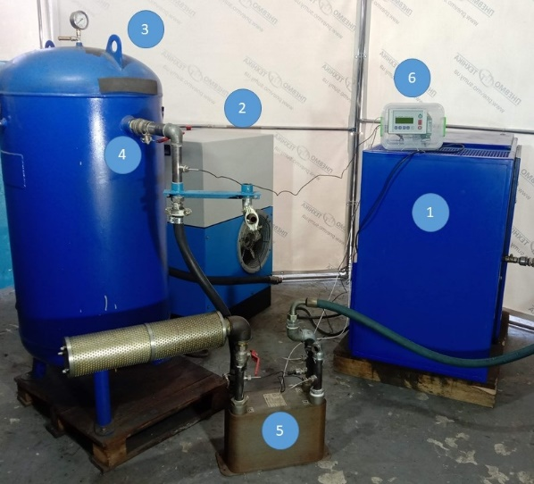
(a)
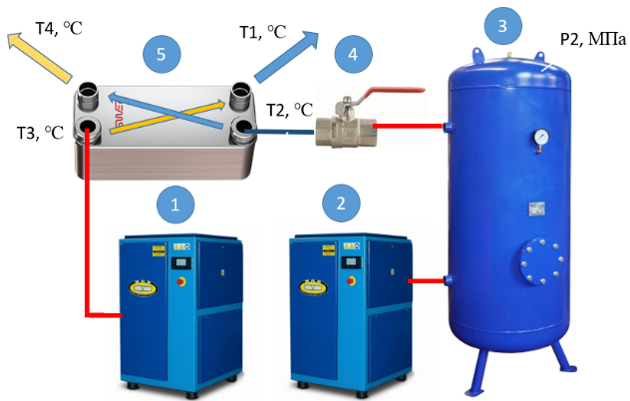
(b)
Fig.1. Scheme of the test bench (1—screw compressor WAN-NK60; 2—screw compressor CompAir START-031; 3—vertical receiver РВ 300.600; 4—ball valve 1 ½”; 5—plate heat exchanger FUNKE TPL 01-K-60-22); 6—microprocessor controller COMCONT-M.

The developed test bench is powered by two screw compressors. The first screw compressor WAN-NK60 (item 1, Fig. 1) is used as the main compressor to supply warm and humid compressed air with the parameters Q = 2.37 m3 /min, P = 6.2 bar, and T3 = 28.8 °C–29.4 °C to the plate heat exchanger (item 5, Fig. 1). The second CompAir START-031 screw compressor (item 2, Fig. 1) is used to fill the receiver (item 3, Fig. 1) with compressed air. The volume flow rate at which the receiver is filled is Q = 2.44 m3 /min. The receiver with a volume of V = 0.33 m3 is filled with compressed air to a pressure of P2 = 0.906 MPa, and the air temperature in the receivers is T = 26 °C.
After that, the ball valve is fully opened (item 4, Fig. 1) and the compressed air leaves the receiver, throttled and cooled to a temperature T2. In the heat exchanger, heat is exchanged between the compressed air T3 and the cooled air T2. At the outlet of the heat exchanger, the reduced temperature of the main compressed air stream T1 is obtained. All parameters of T1, T2, T3, T4, and P2 are recorded by the COMCONT-M microprocessor controller and stored in an Excel table [7].
The result of the experiment, on the above-described stand, was that it was possible to briefly reduce the temperature of the air after the throttle T2 to −18.8 °C, which in turn contributed to the decrease of the temperature T1 to +6.8 °C, this temperature was in temperature range of compressed air provided by refrigeration dryers with refrigerants R134 or R404. But such a result was achieved only due to the rapid reset of the entire volume of compressed air from the receiver and the drop in the air pressure P2 in the receiver to a value of 0.041 MPa.
Air expansion during the experiment was short-lived and depended on the volume of compressed air in the air receiver. After the air pressure in the receiver dropped to atmospheric pressure, the throttling process no longer occurred. Therefore, the presented method of cooling and drying compressed air needs improvement to achieve a stable heat exchange regime in a plate heat exchanger between two heat carriers.
The improvement of the test bench is offered by replacing the ball valve, which performs the function of a throttle expander, with a Rank-Hildsch vortex tube Fig. 2. A Rank-Hilsch vortex tube is a mechanical device that separates compressed gas into hot and cold streams. The gas exiting the hot end can reach temperatures of 200 °C (390 °F), while the gas exiting the cold end can reach −50 °C (−60 °F).
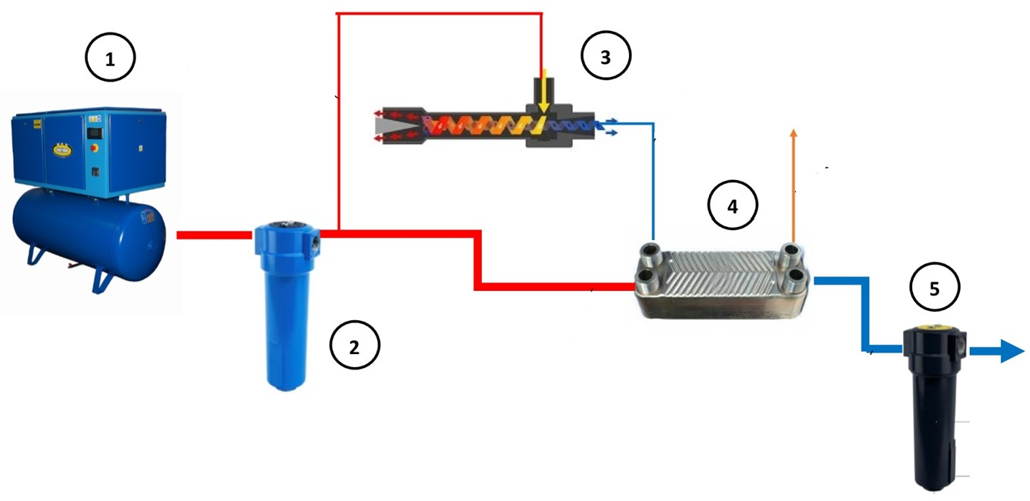
Fig.2. Scheme of the test bench with Ranque-Hilsch vortex tube (1—screw compressor with air receiver; 2— pre-cyclone moisture separator; 3— Ranque-Hilsch vortex tube; 4— plate heat exchanger; 5— final cyclone moisture separator.

As can be seen in Fig. 3, the operation of the vortex tube begins with the flow of high-pressure compressed air in a tangential line through the nozzle into the tube, which involves a strong circular motion at high speeds, as well as a centrifugal force. Consequently, there is an expansion of air inside the pipe, which causes a decrease in pressure. This results in a difference in air velocity in the center of the pipe, and the outer edge close to the pipe wall receives a transfer of kinetic energy from the air flow in the center of the pipe to the air flow along the pipe wall. The temperature is reduced by the air flow along the central axis, while the temperature of the air flow along the pipe wall increases, and a layer of thermal energy is separated inside the pipe. In addition, the tube design includes a central hole and a cone-shaped valve located at the outlet of the tube, where the hot air is released, causing flows of cooler air in the middle of the tube, which moves back to the central hole, and exits the vortex tube at the opposite end of the flow hot air [9].

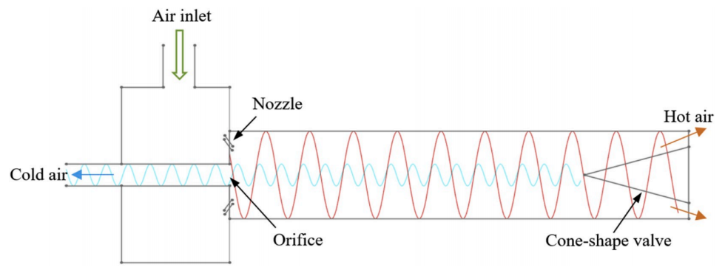
Fig.3. Working principle of a vortex tube.

The use of the Rank-Hildsch vortex tube in the test bench will allow to reach constant temperature regimes of the cooling air flow, and will also allow to stabilize the heat exchange process in the middle of the plate heat exchanger. Further experiments will consist in changing the parameters of the compressed air that will pass through the vortex tube, namely, the change in air flow per unit of time and the change in air pressure at the entrance to the vortex tube, as well as the adjustment of the cone-shaped valve of the vortex tube to change the temperature and air flow on the outlet side cold air. These actions will allow changing the temperature modes of heat exchange between the main flow of compressed air after the compressor and the flow of cooling air after the vortex tube. The result should be finding the optimal ratio of temperature, pressure and flow of compressed air after the compressor and air after the vortex tube to obtain a dew point temperature of compressed air at the level of +3°C, which will ensure the quality of compressed air at the level of the 4th class according to the DIN standard ISO 8573-1.
Acknowledgments
This research was partially realized within the project “Fulfillment of tasks of the perspective plan of development of a scientific direction“, Technical Sciences, Sumy State University, Ukraine, state reg. number 0121U112684.
Conclusion
This paper presents the concept of modernizing the compressed airdrying model using throttle expanders. The improvement of the test bench is offered by replacing the ball valve, which performs the function of a throttle expander, with a Rank-Hildsch vortex tube. It is expected that such refinement will allow reaching a stable mode of heat exchange in a plate heat exchanger between two heat carriers, and ultimately determine the optimal modes for obtaining the desired temperature of the dew point at the level of +3°C, which can ensure the quality of compressed air at the level of the 4th class according to ISO 8573-1:2010. The purpose of this article was to describe the further actions that will be taken to achieve the implementation of the compressed airdrying model based on the principle of a refrigeration dryer, but without the use of environmentally harmful gas refrigerants R134 or R404.
References
[1] Eras, J.J.C.; Gutiérrez, A.S.; Santos, V.S.; Ulloa, M.J.C. Energy management of compressed air systems. Assessing the production and use of compressed air in industry. Energy 2020, 213, 118662. https://doi.org/10.1016/j.energy.2020.118662.
[2] Hernandez-Herrera, H.; Silva-Ortega, J.I.; Diaz, V.L.M.; Sanchez, Z.G.; García, G.G.; Escorcia, S.M.; Zarate, H.E. Energy savings measures in compressed air systems. Int. J. Energy Econ. Policy 2020, 10, 414–422. https://doi.org/10.32479/ijeep.9059.
[3] Goodarzia, G.; Dehghani, S.; Akbarzadeh, A.; Date, A. Energy Saving Opportunities in air Drying Process in High-pressure Compressors. Energy Procedia 2017, 110, 428–433. https://doi.org/10.1016/j.egypro.2017.03.164.
[4] ISO 8573-1:2010; Compressed Air. Part 1: Contaminants and Purity Classes. ISO: Geneva, Switzerland, 2024.
[5] Yokoo, K.; Matsune, H.; Kishida, M.; Tatebayashi, J.; Yamamoto, T. Promoting effect of water vapor on particle matter combustion in a low-temperature continuous regeneration type PM removal device using a fluidized bed. Powder Technol. 2019, 355, 657–666. https://doi.org/10.1016/j.powtec.2019.07.080.
[6] Fedele, L.; Di Nicola, G.; Menegazzo, D.; Tomassetti, S.; Bobbo, S.; Quattrocchi, P.; Alemanno, L.; Catanzani, L.; Amato, S. pvTx properties for carbon dioxide (CO2)/difluoromethane (R32)/1,1,1,2-tetrafluoroethane (R134a) ternary mixture measured in the compressed liquid, superheated vapour, and two-phase regions. Int. J. Refrig. 2023, 151, 136–145. https://doi.org/10.1016/j.ijrefrig.2023.04.001.
[7] Liaposhchenko, O., Bondar, D., Ochowiak, M., Pavlenko, I., and Włodarczak, S., Modeling of Separation with Drying Processes for Compressed Air Using an Experimental Setup with Separation–Condensation and Throttling Devices, Energies (Basel), vol. 17, no. 13, p. 3129, Jun. 2024, doi: 10.3390/en17133129.
[8] Cartlidge, J.; Chowdhury, N.; Povey, T. Performance characteristics of a divergent vortex tube. Int. J. Heat Mass Transf. 2022, 186, 122497. https://doi.org/10.1016/j.ijheatmasstransfer.2021.122497
[9] Tempiam, A.; Kachapongkun, P.; Rattanadecho, P.; Prommas, R. Experimental investigation of vortex tube for reduction air inlet of a reciprocating air compressor. Case Stud. Therm. Eng. 2020, 19, 100617. https://doi.org/10.1016/j.csite.2020.100617.

