Analyzing Output Signal Processing Methods for Multimode Polymer Fiber Interferometers
Vasyl Varyshchuk
Department of Automation and Computer Integrated Technologies, Lviv Polytechnic National University, UKRAINE, Lviv, 12 S. Bandery St., E-mail: vasyl.i.varyshchuk@lpnu.ua
Abstract This research presents a comparative analysis of speckle pattern matching methods for multimode polymer fiber interferometers in deformation sensing. The study evaluates different performance metrics of investigated image matching techniques, highlighting phase-only correlation as an effective method, offering a balance between linearity, precision, and noise rejection.
Кеуwords fiber optic interferometer, multimode interference, image processing techniques.
Introduction
Fiber optic sensors, particularly interferometric sensing systems, have emerged as powerful tools in diverse fields such as structural health monitoring, biomedical diagnostics, and industrial automation due to their high sensitivity, immunity to electromagnetic interference, and compact size. Multimode polymer optical fibers (POFs) have gained increasing attention for their flexibility, low cost, and capacity to be embedded into complex structures. One of the key applications of POFs is in strain and deformation sensing, where multimode interference effects are utilized to detect small changes in the optical path length caused by external perturbations.
In multimode fiber interferometers, speckle patterns generated by the interference of guided modes are highly sensitive to external deformations [1, 2], making them an attractive option for sensing application. However, the challenge lies in the effective processing of these speckle patterns to reliably extract meaningful information about the applied deformation. Various signal processing methods have been employed to match and analyze speckle patterns. Each method offers distinct advantages and trade-offs in terms of accuracy, computational complexity, and robustness against noise.
This paper aims to conduct a comparative analysis of speckle pattern matching techniques for deformation sensing using multimode polymer fiber based interferometer. Presented study makes a contribution by providing a comparative evaluation of different methods, analyzing key performance metrics including linearity, precision, and signal-to-noise ratio (SNR). While individual methods have been studied extensively in isolation, to the best of our knowledge, a systematic comparison of these techniques applied to multimode polymer fiber interferometers has not been explored in existing literature. The analysis is based on experimental data collected under varying deformation conditions, enabling a comprehensive evaluation of each method's strengths and limitations. The findings of this study will guide the selection of the most suitable signal processing approach tailored to specific sensor requirements and applications.
Speckle Pattern Analysis Techniques
A simple approach for analyzing speckle patterns involves calculating the normalized average intensity (NI). While the NI metric effectively quantifies overall light attenuation, it falls short in detecting spatial variations in the speckle pattern intensity distribution [3]. Therefore, more advanced methods are necessary to fully characterize the fiber interferometer's performance. For speckle image matching and analysis, both image difference and image correlation features are usually used [1].
The sum of squared differences (SSD) is one of image matching techniques that based on computing the pixel-by-pixel difference between the reference image I₀(x, y) and the current image I(x, y). For each pixel (x, y), the difference between the intensities of the two images is squared, and these squared differences are summed across all pixels to obtain a single value, as follows [4]:
$$SSD=\sum_{x=1}^{M}{\sum_{y=1}^{N}{{(I\left(x,y\right)-I_{0}\left(x,y\right))}^{2}}}$$ | (1)
where M and N are the dimensions of the image. The SSD metric provides a measure of similarity between the two images, with lower values indicating greater similarity.
Another widely used technique for speckle patterns matching is zero mean normalized cross-correlation (ZNCC). It measures the similarity between two signals while normalizing for variations in intensity and offset. In comparison to the simple normalized correlation coefficient this method provides robustness against changes in amplitude and background noise [2, 4]. ZNCC value can be calculated using following equation:
$$ZNCC=\frac{\sum{{(I}_{0}-\overline{I_{0}})(I-\overline{I})}}{{\left[\sum{{\left(I_{0}-\overline{I_{0}}\right)}^{2}}\sum{{\left(I-\overline{I}\right)}^{2}}\right]}^{1/2}}$$ | (2)
Similar to the normalized correlation coefficient algorithm, when the reference speckle pattern image is the same as the measured speckle pattern, the value is equal to 1. When the speckle pattern deviates from the reference image, ZNCC will decrease accordingly.
The phase-only correlation (POC) is a technique used to measure the similarity between the phase components of two images. Given Y(ω_{x}, ω_{y}) and Y₀(ω_{x}, ω_{y}) as the Fourier transforms [5] of the images I(x,y) and I₀(x,y), respectively, the POC is computed as:
$$POC=IFFT\left[\frac{Y({}_{x},{}_{y}){ Y}_{0}^{*}({}_{x},{}_{y})}{\left|Y({}_{x},{}_{y}){ Y}_{0}^{*}({}_{x},{}_{y})\right|}\right]$$ | (3)
where IFFT denotes the inverse fast Fourier transform, and $Y_{0}^{*}({}_{x},{}_{y})$ is the complex conjugate of $Y_{0}({}_{x},{}_{y})$. This method evaluates the similarity of the phase information between two speckle fields, allowing precise detection of changes in the fiber's state. If the images are similar, the POC returns a surface with a sharp, single peak at the center, indicating zero phase difference. As the images become less correlated, this peak decreases and spreads out. For simplicity, instead of analyzing the entire surface, the POC result can be reduced to its maximum peak value, which can be referred to as the POC value. This peak amplitude serves as an efficient indicator of the degree of correlation between the two speckle images.
In conclusion, each of the presented speckle pattern matching methods offers distinct advantages and disadvantages depending on the specific performance criteria. The choice of method for implementing a fiber interferometric sensor should be guided by the system’s required characteristics, such as precision, sensitivity, or computational efficiency. By carefully considering these factors, the most suitable method can be selected to optimize the sensor's performance for the intended application.
Experimental Procedure and Results
The schematic of experimental setup depicted in Fig. 1 was utilized to analyze and compare different image matching techniques for multimode fiber interferometer. This configuration enabled a comprehensive evaluation of the interferometer performance under applied deformation, providing insights into the effectiveness of each method in detecting changes of the sensitive fiber status.
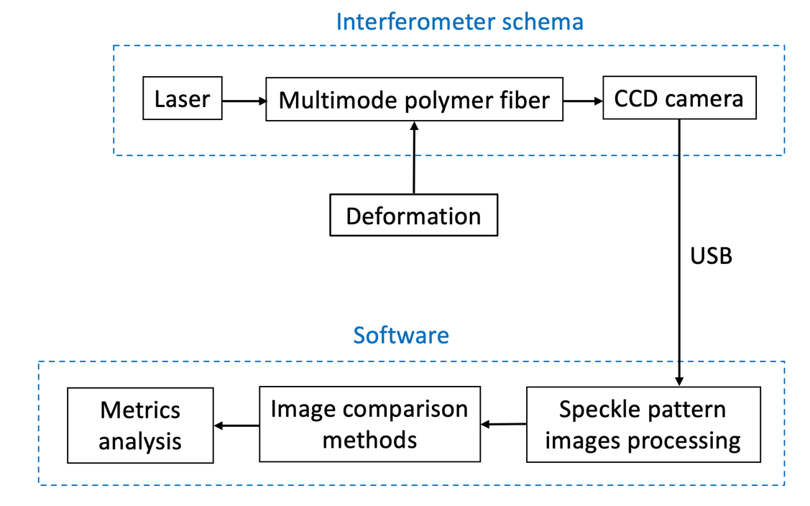
Fig.1. Schematic diagram of the experimental setup.
The light from a laser source is directly coupled into a 1 m section of standard polymer step-index fiber, featuring a 980/1000 μm core/cladding. The fiber was mounted at both ends using holders to provide tension and fixation. Axial deformation of the sensitive section of the fiber was induced by a micrometer translation stage, which applied small displacements along the fiber axis, causing elongations of the sensing fiber. To capture the resulting speckle intensity patterns, a CCD camera was used. Initially, the camera records a reference speckle pattern corresponding to the fiber's undeformed state. Any subsequent deformation due to external forces alters the spatial distribution of the speckles. Using custom-developed software implemented in Python programming language, three different matching techniques were applied to compare speckle patterns before and after deformation. Importantly, when tension is applied and then released, the speckle pattern returns to its original state, demonstrating the reproducibility of the measurement.
To evaluate the performance of each image comparison technique in fiber speckle images processing, the optical fiber was displaced incrementally from 0 to 200 μm, with step sizes of Δd = 10 caμm. At each displacement level, the setup was held steady for the acquisition of speckle image frames, allowing the speckle pattern to stabilize before further displacement. This approach ensured that any variations in the speckle patterns were consistent and attributable to the applied deformation, providing reliable data for comparison across different image matching techniques.
After establishing the reference speckle image I₀, the speckle pattern for the n-th frame I_{n} was used to calculate the relevant performance metrics. The experimental data are then fitted with linear functions to determine key parameters such as the linearity, precision, and signal-to-noise ratio associated with each signal processing method. This allows for a thorough evaluation of the interferometer’s performance characteristics.
The static responses of fiber interferometer evaluated for each method are illustrated in Fig. 2, where each data point corresponds to the average of 3 measurements.
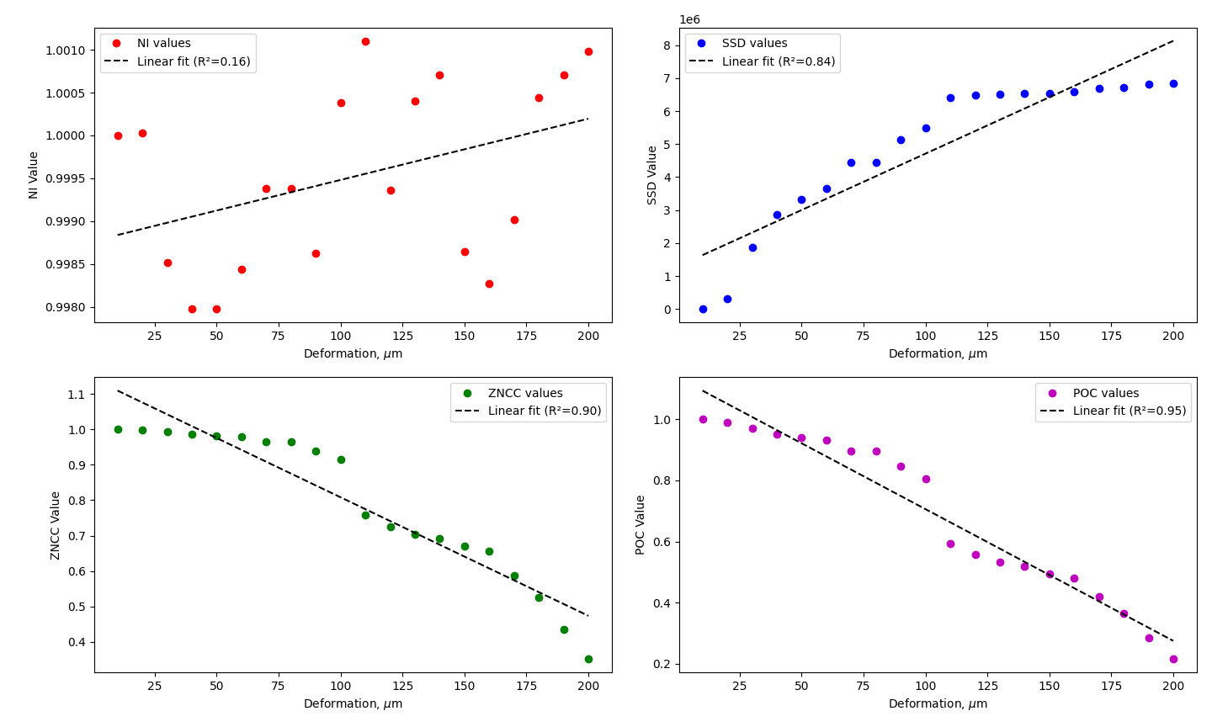
Fig. 2. Static calibration curves of the multimode fiber speckle interferometer for different image matching techniques.
The curves above illustrate the interferometer’s response under static conditions for each investigated image matching technique, highlighting the distinct behavior and sensitivity of each method in detecting speckle pattern changes induced by deformation. Linearity is a critical parameter that indicates how well the interferometer's output correlates with the applied deformation. Among the methods, POC demonstrates the highest linearity (R² = 0.948), closely followed by ZNCC (R² = 0.904), making these techniques highly suitable for applications requiring a strong linear response. SSD also performs well with R² = 0.838, while NI exhibits a much lower linearity (R² = 0.164), suggesting that it is not as effective in providing an accurate linear response so this method is not counted in further analysis. The performance analysis of the multimode polymer fiber interferometer demonstrates significant differences in terms of linearity, precision, and signal-to-noise ratio (SNR), as shown in Table 1.
Table 1
Comparison between diffrernt image matching techniques
Method | Linearity | Precision | SNR
SSD | 0.838496 | 0.441080 | 2.267165
ZNCC | 0.904068 | 0.256435 | 3.899623
POC | 0.948073 | 0.373408 | 2.678033

Precision metric, defined as the relative standard deviation, measures the consistency of the output signal. For precision metric, ZNCC (0.256) and POC (0.373) provide a more balanced trade-off between precision and sensitivity while SSD shows the least precision. SNR is a key factor in assessing the robustness of a method against noise. ZNCC and POC exhibit moderate SNR values of 3.90 and 2.68, respectively, which indicates balance between noise rejection and signal detection. SSD has the lowest SNR (2.27), indicating higher susceptibility to noise, which could negatively impact the interferometer's overall accuracy.
From the results, POC emerges as the most effective method, offering the balance of high linearity, moderate precision, and acceptable SNR, making it better for fiber interferometric sensors that require accurate and consistent response to applied deformations. ZNCC also shows good results, particularly in linearity, but its precision could be improved. SSD, despite its reasonably good linearity, suffers from lower precision and poor noise rejection.
Conclusion
In this study, it is conducted a comprehensive analysis of different image matching techniques applied to a multimode polymer fiber interferometer for deformation sensing. Among the evaluated methods, POC demonstrated the highest linearity (R² = 0.948) and balanced performance in terms of precision and signal-to-noise ratio (SNR). ZNCC method also performed well, especially in terms of linearity (R² = 0.904). Although the SSD showed reasonable linearity, it had lower precision and SNR, making it less robust. These findings provide valuable insights into the selection of signal processing methods for fiber optic interferometric sensors. Future research should focus on hybrid approaches that combine the strengths of these methods to enhance the performance of multimode polymer fiber based interferometric sensors and transducers across a broader range of applications.
References
[1] Fujiwara, E., Ri, Y., Wu, Y. T., Fujimoto, H., & Suzuki, C. K. (2018). Evaluation of image matching techniques for optical fiber specklegram sensor analysis. Applied optics, 57(33), 9845-9854. DOI: 10.1364/AO.57.009845 (Journal Article)
[2] Varyshchuk, V., & Bobitski, Y. (2015, July). Correlation processing of speckle pattern in multimode polymer optical fiber for deformation monitoring in nanometer range. In Nanoplasmonics, Nano-Optics, Nanocomposites, and Surface Studies: Selected Proceedings of the Second FP7 Conference and the Third International Summer School Nanotechnology: From Fundamental Research to Innovations, August 23-30, 2014, Yaremche-Lviv, Ukraine (pp. 329-338). DOI: 10.1007/978-3-319-18543-9_23
[3] Qian, S., Xu, Y., Zhong, L., & Su, L. (2016). Investigation on sensitivity enhancement for optical fiber speckle sensors. Optics express, 24(10), 10829-10840. DOI: 10.1364/OE.24.010829 (Journal Article)
[4] Xu, X., Ren, X., Zhong, F., Quan, C., & He, X. (2020). Optimization of speckle pattern based on integer programming method. Optics and Lasers in Engineering, 133, 106100. DOI: 10.1016/j.optlaseng.2020.106100 (Journal Article)
[5] Yamaki, S., Abe, M., & Kawamata, M. (2014). Statistical analysis of phase-only correlation functions based on directional statistics. IEICE Transactions on Fundamentals of Electronics, Communications and Computer Sciences, 97(12), 2601-2610. DOI: 10.1587/transfun.E97.A.2601 (Journal Article)

