Structure and Properties of Nanostructured Systems AgAu/Si
Mariana Shepida¹, Vitalii Tsybrivskyi², Yurii Sukhatskyi³,
Martyn Sozanskyi⁴, Vasyl Kordan⁵
1. Department of Civil Safety, Lviv Polytechnic National University,
UKRAINE, Lviv, S. Bandera Street 12, E-mail: mariana.a.shepida@lpnu.ua
2. Department of Hydraulic and Water Engineering, Lviv Polytechnic National University,
UKRAINE, Lviv, S. Bandera Street 12, E-mail: vitalii.tsybrivskyi.hb.2023@lpnu.ua
3. Department of Chemistry and Technology of Inorganic Substances, Lviv Polytechnic National University,
UKRAINE, Lviv, S. Bandera Street 12, E-mail: yurii.v.sukhatskyi@lpnu.ua
4. Department of Physical, Analytical and General Chemistry, Lviv Polytechnic National University,
UKRAINE, Lviv, S. Bandera Street 12, E-mail: martyn.a.sozanskyi@lpnu.ua
5. Ivan Franko National University of Lviv, 6, Kyryla i Mefodiya St.,
Lviv, 79005, Ukraine, E-mail: vasyl.kordan@lnu.edu.ua
Abstract – In aqueous solutions, a nanostructured AgAu bimetallic system is deposited by galvanic replacement on silicon. It was established that the coprecipitation of metals during galvanic replacement occurs somewhat ahead of the gold content in the AgAu/Si system. Thus, in aqueous solutions of [2mМАgNO₃]:[10mМHAuCl₄], nanoparticles with a ratio of Ag:Au = 2:10 are deposited on the silicon surface, respectively. The size of discrete bimetallic nanoparticles increases with increasing [AgNO₃]:[HAuCl₄] ratio. Therefore, at a close metal content, AgAu particles are the smallest. This is due to the factor of mutual influence of two metals during coprecipitation.
Кеуwords – AgAu/Si, nanostructured, galvanic replacement, polyvinylpyrrolidone, aqueous medium.
Introduction
Porous silicon and the modified surface of silicon, in particular porous, with nanoparticles and nanostructures of metals has attracted special attention in the last decade. This is due to the effective use of materials based on them in bisensory and biomedicine [1-3], catalysis [4], the production of porous silicon and silicon filaments [5, 6], for the cathodes of solar cells for the production of "green hydrogen" from water [7, 8 ] and other industries. The functional properties of silicon/nanometal systems depend on the geometry of the deposited metal nanoparticles and the overall surface architecture. Therefore, the choice of the method of their preparation is important in the aspect of maximum provision of the controlled formation of the given morphology of the metal deposit and manufacturability. Among the methods that meet such criteria is galvanic mixing, which is characterized by ease of implementation and does not require the use of complex equipment. Metal-activated chemical etching is promising for obtaining porous silicon. Bimetallic Au–Ag NPs offer the advantage of enhanced SERS signal broadband extinction of light [9]. Au–Ag NPs also have benefits in terms of chemical stability for long-term use. The flexible SERS sensor consisted of Ag and Au core-shell NPs on a PI substrate exhibited superior efficiency and durability after storage for 30 days and even after 500 cycles of mechanical stimuli (bending or torsion) [9]. Ag-based hybrid nanoprobes have shown their tremendous potential for SERS imaging of precise biological detection and mediated phototherapy. Therefore, the purpose of this work is to obtain nanostructured systems AgAu/Si and to study its catalytic properties.
Presenting main material
The process of galvanic replacement on the surface with silicon takes place by an electrochemical mechanism. In fluoride-containing solutions of precipitated metal ions, anodic and cathodic areas are formed, where the following main electrochemical reactions take place: electron generation and reduction of metal ions [10]. The values ​​of the standard electrode potentials of silver (E⁰Ag⁺/Ag = 0.80В), gold (E⁰[AuCl₄]⁻/Au = 1.00В) compared to silicon in fluoride solutions (Е⁰[SiF₆]^{2–}/Si = −1.2В) cause large values electromotive force ΔЕ⁰ ($E_{M(+n)/M}^{0}−E_{[{\text{SiF}}_{6}{]^{2−}}/{\text{Si}}}^{0}$≥ 1,9 В) of galvanic replacement processes, which gives grounds for their co-precipitation from aqueous solutions of AgNO₃, H[AuCl₄] by galvanic replacement on the silicon surface. This ensures high current densities in the cathode areas and, accordingly, a high rate of metal recovery, which contributes to the predominant nucleation. As a result, at low concentrations of the metal precursor in solutions, highly dispersed deposits are formed on the surface of silicon: nanostructures of silver, gold, spherical nanoparticles and their agglomerates, nanofilms.
A large content of HF in solutions ensures a high speed of the electron-generating reaction and, accordingly, a high speed of metal deposition, and also prevents the passivation of the silicon surface. However, the share of the side process, which causes etching of the substrate surface, increases. Therefore, in order to weaken the effects of these factors, in recent years, systematic research on the use of surface-active substances for the modification of the silicon surface has been started.
A problematic issue is the modification of porous silicon with metal nanoparticles by galvanic replacement. After all, diffusion limitations complicate the deposition of metal in pores of even submicron sizes. It was established that the coprecipitation of metals during galvanic replacement occurs somewhat ahead of the gold content in the AgAu/Si system. Thus, in aqueous solutions of [2mM AgNO₃]:[10mMHAuCl₄], nanoparticles with a ratio of Ag:Au = 2:10 are deposited on the silicon surface, respectively. At the same time, discrete bimetallic nanoparticles are formed (Fig. 1). The size of the latter increases with an increase in the [AgNO₃]:[HAuCl₄] ratio in the aqueous solution. Therefore, at a close metal content, AgAu particles are the smallest. This is due to the factor of mutual influence of two metals during coprecipitation.
During the process of galvanic replacement, uniform filling of the silicon surface with AgAu nanoparticles is observed up to the tendency of film formation. At the same time, their sizes practically do not increase. Therefore, nucleation takes place during long co-precipitation of metals.
As the temperature increases, a tendency to the formation of highly dispersed spongy sediments is observed. At low concentrations of recoverable metal ions, this causes cathodic polarization and, accordingly, the formation of a 3D precipitate.
Metal nanoparticles fixed on a silicon substrate exhibit plasmonic properties. Systems of this type are promising for creating highly sensitive sensors. Such sensors are easy to manufacture, compatible with silicon technology, which reduces the cost of final products. In addition, such plasmon-active surfaces can provide significant amplification of the Raman signal during the characterization and analysis of the composition of ultra-small amounts of amyloid proteins.

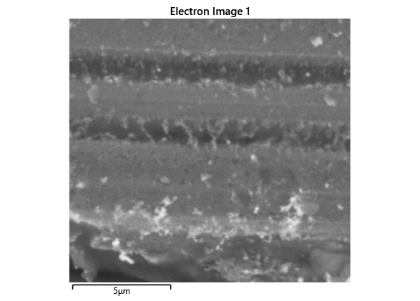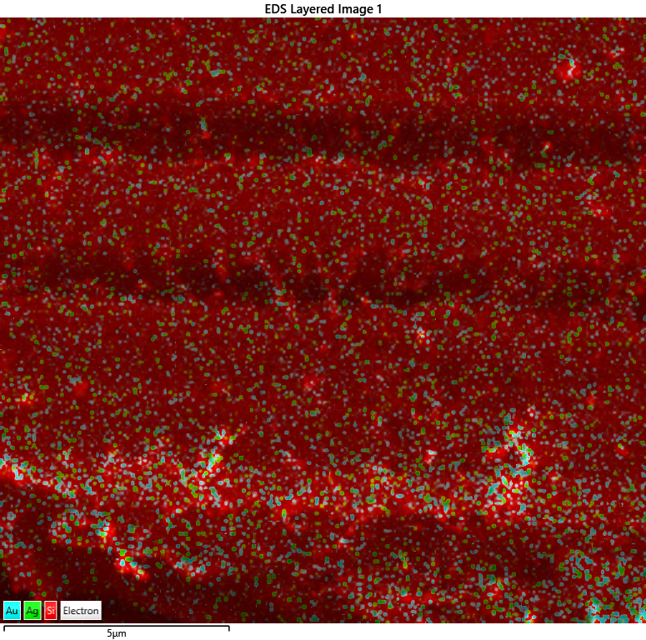
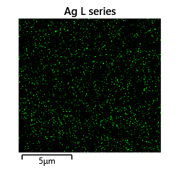
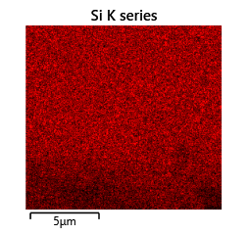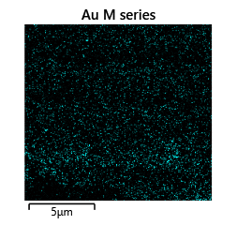
Fig.1. SEM image of AgAu/Si deposited from aqueous solutions of 2mM AgNO₃ + 10mM H[AuCl₄] (a) for 1 min at t = 40 ºС. Energy dispersive X-ray spectroscopy of the AgAu/Si surface (b).
Conclusion
The results of studies of the process of deposition of nanosized silver and gold particles on the surface of silicon by galvanic substitution in fluoride-containing solutions AgNO₃, H[AuCl₄] testify to the effectiveness of the deposition of discrete nanoparticles and nanofilms, which are characterized by density and high adhesion to the substrate. Based on the results of research on the surface of silicon modified with metal nanoparticles, an analysis of the morphology of AgAu/Si was carried out, and the influence of the duration of the galvanic replacement process on the size of the particles and their distribution was determined. The main kinetic parameters of the process are established.
Acknowledgments
This work was carried out with the support of the Ministry of Education and Science of Ukraine as part of the scientific work of the project for young scientists «Advanced oxidation processes, including nanocatalytic, based on cavitation technologies for purification of aqueous media from resistant N-substituted organic compounds» (state registration number 0122U000790).
References
[1] Peng F., Cao Z., Ji, X., Chu B., Su Y., He Y. Silicon nanostructures for cancer diagnosis and therapy // Nanomedicine. – 2015. – Vol. 10, No. 13. – P. 2109–2123.
[2] Tieu T., Alba M., Elnathan R., Cifuentes-Rius A., Voelcker N. H. Advances in Porous Silicon–Based Nanomaterials for Diagnostic and Therapeutic Applications // Advanced Theranostics. – 2019. – Vol. 2, No. 1. – P. 1800095.
[3] Grell M., Dincer C., Le T., Lauri A., Bajo E. N., Kasimatis M., Barandun G., Maier S. A., Cass A. E. G., Güder F. Autocatalytic Metallization of Fabrics Using Si Ink, for Biosensors, Batteries and Energy Harvesting // Advanced Functional Materials. – 2018. – Vol. 29, No. 1. – P. 1804798.
[4] Wei Q., Shi Y.-S., Sun K.-Q., Xu B.-Q. Pd-on-Si catalysts prepared via galvanic displacement for the selective hydrogenation of para-chloronitrobenzene // Chemistry Communication. – 2016. – Vol. 52. – P. 3026–3029.
[5] Arafat M. Y., Islam M. A., Bin Mahmood A. W., Abdullah F., Nur-E-Alam M., Kiong T. S., Amin N. Fabrication of Black Silicon via Metal-Assisted Chemical Etching—A Review // Sustainability. – 2021. – Vol. 13, No. 19. – Article ID 10766.
[6] Leonardi A. A., Faro M. J. L., Irrera A. Silicon Nanowires Synthesis by Metal-Assisted Chemical Etching: A Review // Nanomaterials. – 2021. – Vol. 11, No. 2. – Article ID 383.
[7] Kye J., Shin M., Lim B., Jang J-W., Oh I., Hwang S. Platinum Monolayer Electrocatalyst on Gold Nanostructures on Silicon for Photoelectrochemical Hydrogen Evolution // American Chemical Society. – 2013. – Vol. 7. – P. 6017–6023.
[8] Fabre B., Li G., Gouttefangeas F., Joanny L., Loget G. Tuning the Photoelectrocatalytic Hydrogen Evolution of Pt-Decorated Silicon Photocathodes by the Temperature and Time of Electroless Pt Deposition // Langmuir. – 2016. – Vol. 32. – P. 11728–11735.
[9] Huang, H.J.; Shiao, M.-H.; Lin, Y.-W.; Lin, B.-J.; Su, J.; Lin, Y.-S.; Chang, H.-W. Au@Ag Dendritic Nanoforests for Surface-Enhanced Raman Scattering Sensing. Nanomaterials 2021, 11, 1736. https://doi.org/10.3390/ nano11071736
[10] Shepida M., Kuntyi O., Sukhatskiy Y., Sozanskyi M., Holovchuk M. Deposition of PtPd nanoparticles on the silicon surface by galvanic replacement in DMSO medium // Applied Nanoscience (Switzerland). 2023. – Vol. 13(7). – P. 4719-4725. URL: https://doi.org/10.1007/s13204-022-02600-9

