Lighting level as a factor influencing the driver's functional state
Nazar Tiurdo¹, Taras Postranskyy²
1. Department of Transport Technologies, Lviv Polytechnic National University, UKRAINE, Lviv, 12 Stepan Bandery Str., E-mail: nazar.o.tiurdo@lpnu.ua
2. Department of Transport Technologies, Lviv Polytechnic National University, UKRAINE, Lviv, 12 Stepan Bandery Str., E-mail: taras.m.postranskyi@lpnu.ua
Abstract – Road safety is largely dependent on the driver's functional state. In turn, it is influenced by traffic conditions and, in particular, visibility and light levels. Given the connection between the efficiency of transport systems and the state of the driver's body, it is important to take into account the human factor in the transportation process.
Кеуwords – road safety, driver, functional state, lighting level, street and road network.
Introduction
Road safety is an important task of transport engineering and traffic management. At the same time, an important traffic management component is the performance design of the “driver-car-road-environment” system [1]. The driver is the least studied and predictable link, and his or her actions affect both his or her safety and the safety of other road users. Ensuring an adequate level of traffic safety reduces the probability of road accidents. One of the key indicators that should be considered to achieve this goal is visibility distance.
Visibility, from the transportation research point of view, should be understood as the minimum required distance at which a driver must see road elements and obstacles on the road and react to them in time. One of the factors that significantly affects the value of the visibility distance is the lighting level [2].
Thus, taking into account the above-mentioned importance of these indicators in ensuring the safety of road users, the paper sets out to study the impact of lighting on the functional state of the driver and the reliability of his or her work.

Research statement
The aim of the study is to identify patterns of changes in the drivers’ functional state at different levels of street and road network lighting. To achieve this goal, it is necessary to solve the following tasks:
- to analyze the parameters of the street and road network on which the research will be conducted;
- to conduct a field study of the drivers` functional state by recording heart rate variability;
- to analyze the obtained data and determine the values of the drivers' indicator of the activity of regulatory systems (IARS);
- to establish patterns of changes in the drivers` functional state at different lighting levels.

The driver`s functional state and lighting level in the dark period
A functional state is a complex of personal characteristics of those person’s functions and qualities that directly or indirectly determine the performance of work activities. In addition, the functional state of a human is considered as the reaction of the body's systems to external and internal influence factors, which is aimed at obtaining a useful result [1, 3].
It should be noted that the driver's functional state also affects the level of [1]:
- reaction time;
- compliance with traffic regimes;
- information processing;
- error-free decisions;
- adaptation to working conditions.
Today, a significant number of methods are used to study the driver's functional state. Most of them are based on the analysis of various physiological and psychological indicators. The same studies are often used in sports medicine and professional selection. That`s why a large number of them are quite developed and are being further improved. In this study, we used the method of recording electrocardiogram (ECG) parameters, in particular, heart rate variability (HRV). The analysis of HRV is based on the analysis of the R-R intervals of the ECG recording. Based on the indicators obtained from the HRV, the PARS value was calculated, the methodology for determining which is given in work [4].
The IARS value is analyzed on a ten-point scale:
- body tension is normal – 1-3 points;
- mild stress of the body – 4-5 points;
- expressed tension of the body – 6-7 points;
- state of overstrain – 8-10 points.
Road safety depends to a large extent on visibility, especially on the level of lighting in the dark. Last may have different levels on the street and road network at various times of the day, in particular [4]:
- natural lighting – provided by a natural light source;
- evening lighting – the mode of operation of outdoor lighting in the dark, when all the lamps of the lighting installation operate in nominal mode;
- night lighting – the mode of operation of outdoor lighting at night, when the brightness (illumination) of the road surface is reduced compared to the evening mode.
Also, the lighting level of the roadway depends on the street lamp system, particularly the layout of the luminaires. In turn, this scheme depends on the type and parameters of the street. The height of their placement also matters. It should be noted that in the evening and at night, drivers have a lot of difficulties performing their professional duties, including difficulty perceiving objects. This is due to insufficient lighting and, often, insufficient minimum difference between objects. At the same time, perception is possible when the brightness difference between the object and the background is equal to or greater than the threshold brightness difference [5].
Thus, given the trends in the development of dynamic parameters of cars and the increase in their speed characteristics, the issue of visibility distance is becoming more acute. As the lighting level decreases, the visibility distance also decreases. This poses a significant danger to vehicle control. Given the above, the issues of traffic safety and correct decision-making by the driver are becoming important, especially when driving at night.
Also, based on the above, it can be argued that with a decrease in lighting, not only does the range of visibility decrease, but the time for the driver's vision adaptation increases. All of this significantly affects and depends on the operator's functional state.

Results’ of the research and their analysis
The lighting level was measured using a luxmeter. The research was done at dusk (morning and evening) and at night. At the same time, were chosen days when there was no precipitation, and the roadway was clean and dry. This is due to the fact that additional factors affecting the experimental studies were avoided. At the same time, two typical sections of the road network were selected for research (Fig. 1).
a | b
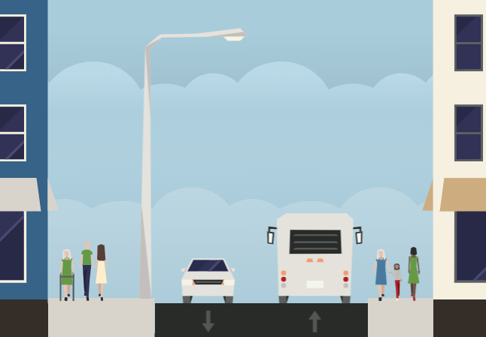 | 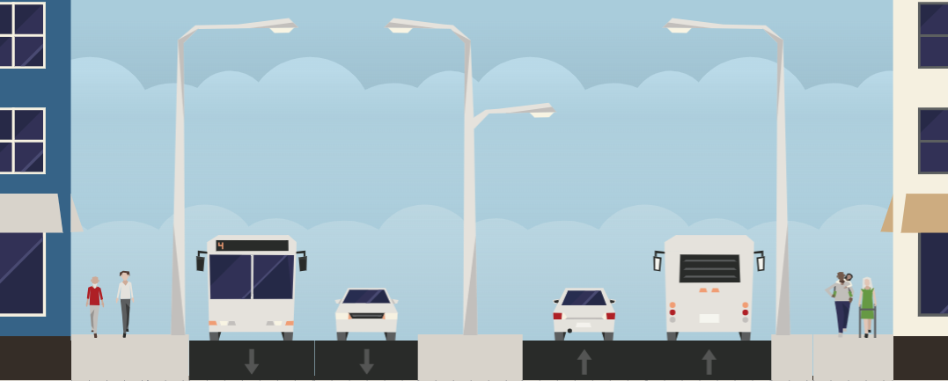
Fig. 1. Schematic representation of typical transverse profiles: a – roadway with 1x1 traffic lanes; b – multi-lane roadway with a dividing strip.
A study of changes in driver's functional state was carried out on the street and road network of Lviv. The HRV was measured with a “Polar H10” device and “KubiosHRV” software. At the same time, there was an observer in the vehicle who monitored the course of the study. This person recorded the relevant data on driving conditions. The vehicle was also equipped with a video recorder. The driver drove the car for one hour.
After exporting the received data, the driver's IARS value was determined. A graphical representation of the change in the average values of the driver's functional state at different times of the day is shown in Fig. 2.
Fig. 2. Graphical representation of the driver's IARS changes during the hour of the research
According to the results of studies, in the morning, the driver's IARS usually increases more slowly. This is due to the fact that during this period the body is at rest, and its reserves are not used. However, over time, the IARS can reach the value of 7-8 points, which indicates the transition of the body from a state of rest to the usual mode of functioning.
After analyzing all the data on the level of lighting and the driver's IARS, the dependence between these indicators was established. Having analyzed them, were created a graphical dependence, which is shown in Fig. 3.
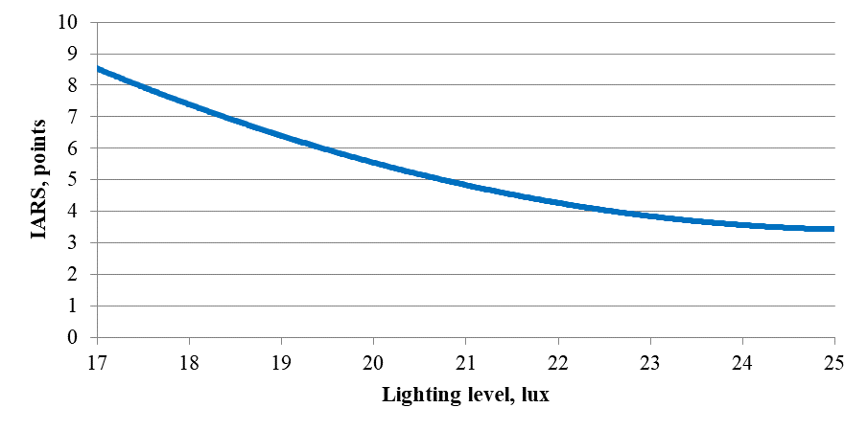
Fig. 2. Graphical representation of the driver's IARS changes during the hour of the research
Thus, it was found that the level of lighting affects the functional state of the driver. The identified dependence should be taken into account when creating new and improving existing artificial lighting of the street and road network
Conclusion
Based on the research results, we can conclude that the level of lighting on the road network affects the functional state of the driver. This, in turn, has a direct impact on road safety. It has also been established that the driver's working time should be reduced in case of poor visibility.
References
[1] Davidich, Y., Kush, Y., & Ponkratov, D. (2020). Change of car driver's stress index during different periods of the day in urban traffic conditions. Transport technologies, 1(2), 23-32. DOI: 10.23939/tt2020.02.023
[2] Gao, K., Tu, H., Sun, L., Sze, N. N., Song, Z., & Shi, H. (2020). Impacts of reduced visibility under hazy weather condition on collision risk and car-following behavior: Implications for traffic control and management. International journal of sustainable transportation, 14(8), 635-642. DOI: 10.1080/15568318.2019.1597226
[3] Lin Wang, Hong Wang, & Xin Jiang. (2017). A new method to detect driver fatigue based on EMG and ECG collected by portable non-contact sensors. Promet – Traffic&Transportation, 29, 479 – 488. DOI: 10.7307/ptt.v29i5.2244
[4] Boikiv M. V. (2016). Safe traffic modes in the night time taking into account the functional state of a driver. Candidate’s thesis. Lviv: LPNU
[5] Lee, M. L., Howard, M. E., Horrey, W. J., Liang, Y., Anderson, C., Shreeve, M. S., ... & Czeisler, C. A. (2016). High risk of near-crash driving events following night-shift work. Proceedings of the National Academy of Sciences, 113(1), 176-181. DOI: 10.1073/pnas.1510383112

