Determining The Influence Of The Public Transport Volume On The Dynamic Pricing Of Taxi Services
Maksym Afonin¹Kateryna Usachova²
1. Departament Of Transport Technologies, Lviv Polytechnic National UniversityUKRAINE, Lviv, St. Badery, 32
E-mail: maksym.o.afonin@lpnu.ua
1. Departament Of Transport Technologies, Lviv Polytechnic National UniversityUKRAINE, Lviv, St. Badery, 32
E-mail: kateryna.furman.mttop.2023@lpnu.ua
Abstract – In this paper, it is identified that when the transport connection of residential areas of the city is weakened, then the price of cab services doubles in bad weather conditions. This tendency indicates a relatively high demand for passengers, which is not satisfied by public transport operators.
Кеуwords – taxi, public transport, passenger demand, radial routes, schedule.
Research Statement
Taxi transportation has made a major breakthrough in Ukraine over the past 10 years, as online services have begun to develop that require only a mobile application. This has significantly increased the popularity of this type of transportation, giving users the opportunity to choose the class of vehicle, its capacity and level of comfort. It is also possible to make trips of different prices, as the price for the same route can vary during the day. It is also worth adding the safety and reliability of this particular level of travel compared to public transport [1-2].
Pricing for taxi transport is a separate topic for discussion, as different services have their own specific approach to this process. However, the main factor that affects the cost of a trip is customer demand in a particular area [3-4].
This paper considers the dependence of the price of taxi transportation on the level of provision of the direction of transportation by public transport at different times of the day. The main indicators that will be taken into account are the price of transportation by different taxi services, the number of public transport units on a particular route, as well as the intervals between them and the total time of door-to-door communication.
The expected results of the work are functional relationships between the number of rolling stock on public transport lines and the demand coefficient for taxi services. Based on such data, it will be possible to identify critical time periods in the day when the quality of transport services in certain transport directions will rapidly decline.
Given that the reputation of most public transport routes in Lviv is not the best, it is possible to quantify the shortage of vehicles, for example, in the evening after peak period. The impact of this phenomenon can be measured as the ratio of the actual fare at a certain hour of the day to the average price of taxi transportation during the day.
Study Results
The research was conducted in autumn 2024 in Lviv in rainy weather. The first direction of correspondence (Sykhiv - Center - Sykhiv), which was studied (Fig. 1a), was characterised by the presence of bus and tram connections, which can be defined as sustainable and saturated with transport. The second direction (Ryasne - Center - Ryasne) is much less saturated with transport and is served by only two bus routes (Fig. 1b), with the maximum saturation of this direction being 11 units of transport at a time, and the first direction - 17 units.

a)  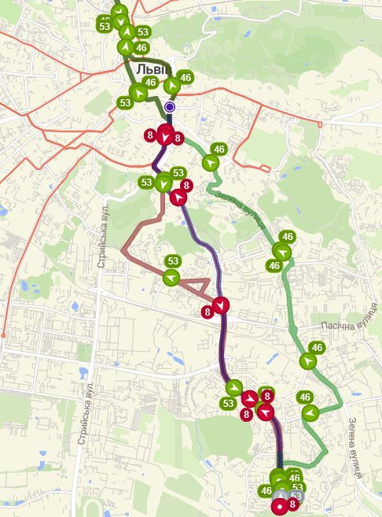 | b)  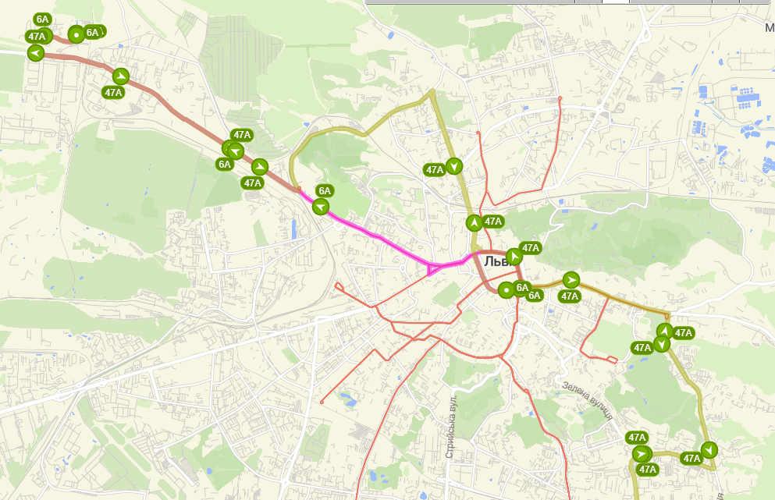
Fig. 1. Saturation of public transport: a) direction No. 1 «Sykhiv-Center-Sykhiv»;
b) direction No. 2 «Ryasne-Center-Ryasne»
It is also important to note that taxi prices were fixed in the direct direction (from the periphery to the centre) before lunch and vice versa for evening hours. Changes in the price of taxi transportation for both directions are shown in Fig. 2 and Fig. 3.
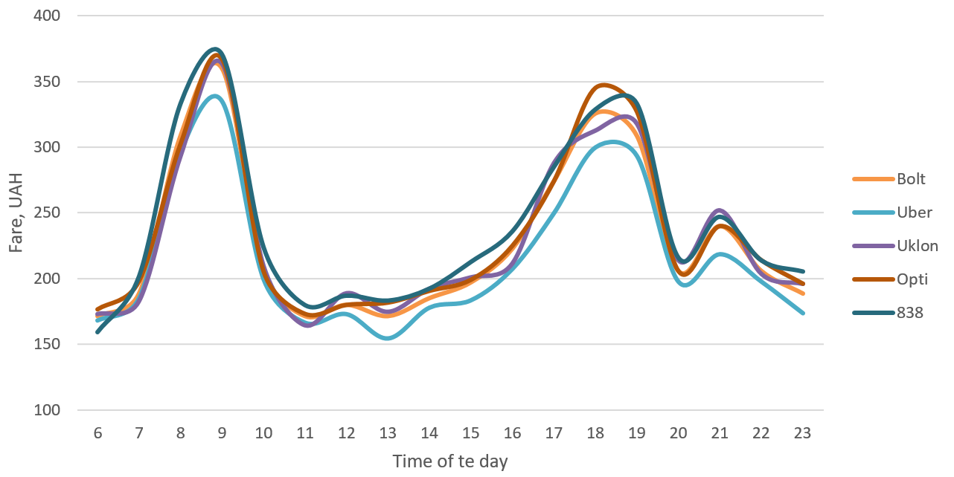
Fig. 2. Changes in the price of taxi services during the day in the direction No. 1 «Sykhiv- Center-Sykhiv»
This graph illustrates the variation in taxi fares across different ride-hailing services throughout the day, with the x-axis representing the time of day (from 6 AM to 11 PM) and the y-axis showing the fare in Ukrainian hryvnias (UAH), ranging from 100 to 400. The services compared include Bolt, Uber, Uklon, Opti, and 838, alongside an average fare line. The data reveals a distinct pattern, with two prominent peaks in fare prices: the first occurring just before 9 AM, where fares sharply rise to around 350 UAH, and the second peak appearing around 7-8 PM, with fares also reaching similar levels. Between these peaks, there is a significant dip in fares around midday, where prices stabilize and fall to their lowest point around noon, ranging between 150 and 200 UAH. After the evening peak, fares begin to drop steadily, decreasing throughout the late evening until the end of the day. While all services exhibit similar trends in fare fluctuation, there are minor variations in pricing, with some services slightly higher or lower at certain times of day. Overall, the fare structure is characterized by two rush hour periods with higher demand and prices, reflecting typical commuter patterns in urban settings.
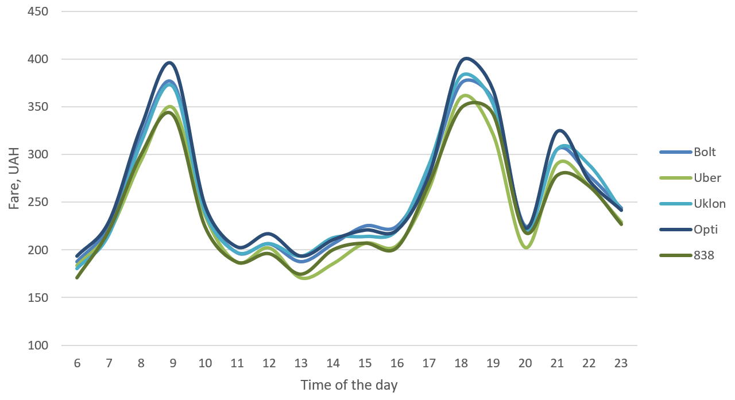
Fig. 3. Changes in the price of taxi services during the day in the direction No. 2 «Ryasne- Center- Ryasne»
This graph shows the variation in taxi fares throughout the day for different ride-hailing services, focusing on Route No. 2. The x-axis represents the hours of the day (from 6 AM to 11 PM), while the y-axis indicates the fare in Ukrainian hryvnias (UAH), ranging from 150 to 450. The services compared include Bolt, Uber, Uklon, Opti, and 838, along with an average fare line. Similar to previous patterns, there are two significant peaks in pricing: the first just before 9 AM, where fares rise sharply to nearly 400 UAH, and the second peak around 7-8 PM, with prices reaching slightly below 400 UAH. After the morning peak, fares decrease notably and stabilize around midday, hitting their lowest levels at about 1-2 PM, where they range between 200 and 250 UAH. After this midday dip, fares begin to increase again, peaking in the evening before sharply declining after 8 PM, continuing a downward trend throughout the late evening. As with the earlier analysis, all services follow similar fare trends, but there are minor differences in pricing for Route No. 2, with certain services showing slightly higher or lower fares at different times of the day. These results indicate that demand on this route mirrors typical commuting patterns, with high demand during morning and evening rush hours.
In general, the survey results show that in adverse weather conditions, the price of taxi services ranges from 150 to 350 UAH in direction 1 and from 200 to 400 UAH in direction 2. These results may indicate a certain quantitative difference between the quality of transport services in the neighbourhoods, especially if we note that residential areas in direction 1 are more populated and the distances from the start to the end point are the same - 8.5-8.7 km.
In addition to the classic morning and evening peak periods of demand (and price increases, respectively), the graph also shows another extreme between 21 and 22 hours of the day. This period corresponds to massive vehicle derailments, which in turn also affects mobility demand. Fig. 4 shows the dependence of the change in the taxi fare coefficient, which is determined by the ratio of the current price to the average daily price, on the number of vehicles on the line.
Fig. 4. Changes in the demand coefficient for taxi services depending on the number of public transport on the line
As can be seen from the dependence, a decrease in the number of active public transport units on the line in the evening after the peak period of the day causes a significant increase in the price of taxi services, which means that there is an unmet demand for mobility in the studied areas, which is neglected by urban passenger transport operators.
Conclusion
In this paper, the features of dynamic pricing for taxi services during the working day are studied. The results of the study show that there is a definite linear correlation between the number of vehicles on certain routes and the cost of a taxi ride. This conclusion can be drawn by analysing the change in demand coefficient during off-peak periods. Thus, there is a new opportunity to study the demand for transport based on the fare estimates set by the algorithms of different cab operators.
References
[1] Rodrigue J.-P. (2024). Geography of transport systems (6th Edition). Routledge.
DOI: 10.4324/9781003343196
[2] Cramer, J. and A.B. Krueger (2016). Disruptive Change in the Taxi Business: The Case of Uber. American Economic Review. 106. 177-182. DOI: 10.1257/aer.p20161002
[3] Zhuk, M. & Pivtorak, H. & Kovalyshyn, V. & Gits, I. (2024). Simulation of Transfer Probability in the City Route Network: Case Study of Lviv, Ukraine. Periodica Polytechnica Transportation Engineering. 52(3). 1-10. DOI: 10.3311/PPtr.22322.
[4] Zeng, C. & Oren, N.. (2014). Dynamic taxi pricing. Frontiers in Artificial Intelligence and Applications. 263. 1135-1136. DOI:10.3233/978-1-61499-419-0-1135

