Evaluation of inclinometer time series for detection of displacements caused by military explosions
Ivan Brusak ¹, Vladyslav Marchuk ², Ihor Savchyn ³
1. Department of Higher Geodesy and Astronomy, Lviv Polytechnic National University, UKRAINE, Lviv, Starosolskykh St.6, room 601b, E-mail: ivan.v.brusak@lpnu.ua
2. Department of Higher Geodesy and Astronomy, Lviv Polytechnic National University, UKRAINE, Lviv, Starosolskykh St.6, room 612, E-mail: vladyslav.marchuk.hd.2022@lpnu.ua
3. Department of Higher Geodesy and Astronomy, Lviv Polytechnic National University, UKRAINE, Lviv, Starosolskykh St.6, room 501, E-mail: ihor.r.savchyn@lpnu.ua
Abstract – The study is devoted to creating a semi-automated complex based on an inclinometer and Python code to determine anomalies in the inclinometer time series that may coincide with military explosions in the region. Based on the data, the exact time of the missile strike on the city of Lviv in July 2023 was determined and confirmed.
Кеуwords – inclinometer, military explosions, inclinometer time series analysis, Leica Nivel 210, Python, missile strike time determination.
Introduction
Various geotechnical sensors are often used for geodetic monitoring of buildings and structures [1], allowing prompt and real-time observation and analysis of the state of building deformation. The principle of operation of the inclinometer is the optoelectronic recording of signals inside the device that change in proportion to the angle of inclination. It should be noted that automated data collection from high-precision digital inclinometers requires the creation of special tilt stations with Internet access. Such stations consist of an inclinometer connected to a computer with specialised software. In particular, such inclinometer stations are located at hydroelectric power plants [2], complex engineering facilities, and high buildings [3], and to monitor architectural monuments. At the same time, using inclinometers allows for recording the locations of underground shocks and their power if the set of devices is considered similar to seismic stations [4].
In April 2023, a Leica Nivel 210 inclinometer was installed in room 704 of the 2nd academic building of Lviv Polytechnic National University to conduct various studies as part of the educational process. Nivel 210 inclinometer provides accurate information on changes in the inclination of buildings, structures or their parts to solve engineering problems. The inclinometer is biaxial inclination sensor. It is equipped with an RS232 interface to connect the sensor directly. The inclinometer is connected by a cable to a laptop, which records its data using the Nivel Data Collector software created by the institute's professors previously [4]. The software was developed in the Free Pascal programming language in the Lazaus visual programming environment (OpenSource environment).
Data is recorded every second through the software in binary format. It is then converted into a standard .txt file. To accurately determine the angle of inclination and direction of inclination, the inclinometer is installed in relation to the main axes of the building. Each of the high-precision sensors in each of the X and Y axes records signals with a resolution of 0.001 mrad (0.2").
The purpose of the research is to create a software code that would allow us to read the inclinometer data in .txt format, visualise time series and record the exact time of military explosions around and analyse the time series of inclinometer data.
Development of the programme for data analysis
We wrote a special Python code to analyse the data. The created program uses the following main Python libraries and functions: csv, plotly.express, numpy, datetime, scipy. Among them, csv is used to work with text data presented in a tabular format, plotly.express allows visualisation of time series, numpy - mathematical processing of large data sets, datetime - linking processing to time data, scipy - an open library of scientific materials containing tools for signal and image processing.
A fragment of the input data for the algorithm is shown in Table 1. The data includes the time characteristics of the measurement: Year, Month, Day, Hour, Min, Sec. Measurement along each of the InclX, InclY axes in angular measurement (mrad). The internal temperature (Temp) in ⁰C is also recorded.
Таble 1
A fragment of data from the inclinometer
Year | Month | Day | Hour | Min | Sec | InclX | InclY | Temp
2023 | 04 | 10 | 15 | 39 | 20 | -0.259 | -0.168 | 19.5
2023 | 04 | 10 | 15 | 39 | 21 | -0.258 | -0.163 | 19.5
2023 | 04 | 10 | 15 | 39 | 22 | -0.259 | -0.168 | 19.5
2023 | 04 | 10 | 15 | 39 | 23 | -0.258 | -0.174 | 19.5
2023 | 04 | 10 | 15 | 39 | 24 | -0.262 | -0.176 | 19.5
2023 | 04 | 10 | 15 | 39 | 25 | -0.261 | -0.181 | 19.5
2023 | 04 | 10 | 15 | 39 | 26 | -0.259 | -0.183 | 19.5
2023 | 04 | 10 | 15 | 39 | 27 | -0.264 | -0.174 | 19.5
2023 | 04 | 10 | 15 | 39 | 28 | -0.260 | -0.172 | 19.5
2023 | 04 | 10 | 15 | 39 | 29 | -0.262 | -0.174 | 19.5
The fragment shows that 1 measurement per second is recorded. Thus, the total file of collected data from the beginning of measurements contains more than 24 million measurements. Such a large amount of data in a month or year requires semi-automated or automated processing to use this data effectively.
The block diagram of the application code is shown in Fig. 1. It has 3 stages: Input .txt data, Program algorithm (file uploading, linear detrending, anomaly detection), and Output of graph data in .html format.
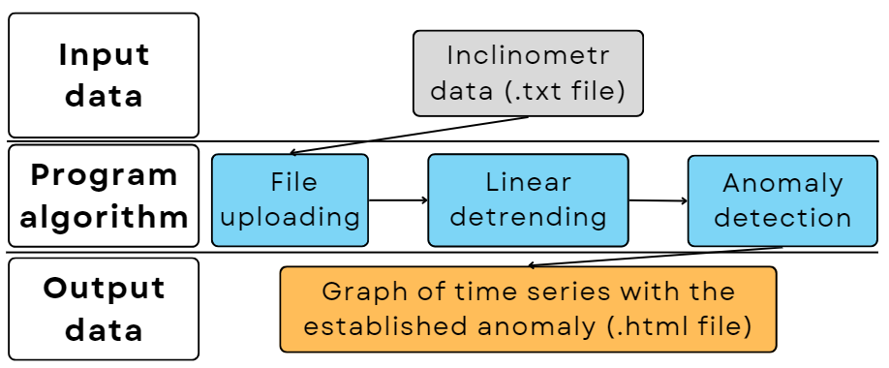
Fig.1. Block diagram of the developed program
Below we will briefly describe the sequence of code execution, taking into account the subroutines that are used for this purpose.
The input data is processed by the parse_inclinometr_file function, which opens the file and reads its contents, processes the header, converts the data into dictionaries with keys corresponding to the header and returns a list of dictionaries, where each dictionary contains data from a line.
The process_inclinometr function processes inclinometer data by performing the following steps: Initialises the lists for time, inclination, and X X, Y axes parse the data and create data time and X, Y axis values with temperature in the corresponding lists, performs detrending, finds anomalies using the function find_inclinometer_anomalies, which, in turn, calculates the absolute difference between inclX and inclY relative to the graph, determines the threshold for detecting anomalies based on the daily average value, which is filtered through a noise filter, then searches the difference values and adds an index to the anomaly list if the difference exceeds the threshold.
The final results are displayed by the plot_inclinometr_results function, which creates a graph using Plotly, adds lines for inclX and inclY, with the ability to visualise additional data on hover, displays anomalies and customises the legend.
Example of results
The available data from April 2023 was analysed for anomalies using a specially developed programme. It is worth noting that due to constant power outages, the time series had noticeable gaps. To evaluate the results, we considered the data aggregated by month. It should be noted that if the file includes all of the measurements, it contains 86,400 unique values per day.
Fig. 2 shows a fragment of the graph of the time series of the X component of the inclinometer with the identified anomaly.
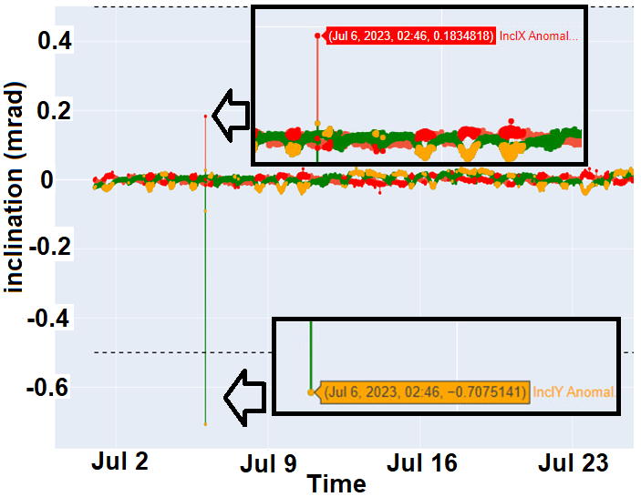
Fig.2. A fragment of the graph of the inclinometer time series (X component) with the identified anomaly corresponding to the military explosion on 6 July 2023.
The graph shows that the anomaly is sharply different from the general trend. The results are compared with open information on military explosions in the Lviv region. The open sources confirm that on 6 July, 10 residents were killed and at least 40 injured in a bombing that took place early in the morning in Lviv [5].
The maximum deviation of the X component was recorded at 02:46. The value is X=0.183 mrad, which differs by 0.210 mrad from the daily average value of X_{mean.day} =-0.030 mrad. The value for Y equals to -0.707 mrad, which is -0.407 mrad different from the daily average Y_{mean.day} =-0.300’. It should be noted, that the explosion site is located 1.5-2.0 km from the inclinometer installation site in a straight line.
Conclusions and discussion
As part of this study, the Nivel210 inclinometer has been installed on the campus of Lviv Polytechnic National University since April 2023. The obtained raw data was downloaded to a laptop using a pre-created Nivel Data Collector program [4]. In this study, we created a Python code that allows automated detrending and anomaly detection within the new program. It also allows data graph and anomaly visualisation.
The biaxial measurement graphs on 6 July 2023 show military explosions, which are confirmed to have occurred in Lviv, Ukraine. The detected explosions were clearly distinguished by time up to a second and occurred at a distance of 1.5-2.0 km. It is not yet clear how far explosions can be detected around the inclinometer.
The next steps in the study will be to compare the inclinometer series with GNSS results from the GTER station located on the roof of the building where the inclinometer is located. It would also be advisable to connect the inclinometer to a microcomputer with an autonomous power supply, as the laptop often does not record all the inclinometer data when the electricity in the building is turned off.
Acknowledgments
The authors would like to thank the Armed Forces of Ukraine because this paper has become possible only because of the resilience and courage of the Ukrainian Army.
References
[1] Vivat A., Nazarchuk N., Brusak I., Hrabovyi O. (2020) Research of motion fixing system based on micro electro mechanical systems In International Conference of Young Professionals «GeoTerrace-2020». European Association of Geoscientists & Engineers. 1-4. DOI: 10.3997/2214-4609.20205725
[2] Zyhar, A., Savchyn, I., Yushchenko, Y., & Pasichnyk, M. (2021). Analysis of inclinometric observations and prediction of soils deformations in the area of the Dnister PSPP. Geodynamics, 1 (30), 17-24. DOI: 10.23939/jgd2021.01.017
[3] Yigit, C., Li, X., Inal, C., Ge, L. & Yetkin, M. (2010). Preliminary evaluation of precise inclination sensor and GPS for monitoring full-scale dynamic response of a tall reinforced concrete building. Journal of Applied Geodesy, 4(2), 103-113. DOI: 10.1515/jag.2010.010
[4] Zaiats, O., Navodych, M., Petrov, S., & Tretyak, K. (2017). Precise tilt measurements for monitoring of mine fields at Stebnyk potassium deposit area, Geodynamics, 2 (23), 25–33. DOI: 10.23939/jgd2017.02.025
[5] Lviv strikes (2022–present). (2024, October 14). In Wikipedia. https://en.wikipedia.org/wiki/Lviv_strikes_(2022%E2%80%93present)#cite_note-46

