Mathematical model of a multi-winding synchronous machine with hybrid excitation
Andriy Lishchuk¹, Yury Pinchuk²
1. Institute of Power Engineering and Control System, L’viv Polytechnic National University, Ukraine, 12 Bandera St., E-mail: andrii.s.lishchuk@lpnu.ua;
2. Institute of Power Engineering and Control System, L’viv Polytechnic National University, Ukraine, 12 Bandera St., E-mail: yurii.m.pinchuk@lpnu.ua;
The paper proposes a new mathematical model of a multi-winding synchronous machine with hybrid excitation created using the method of average voltages in the integration step. The model of the synchronous machine is developed in phase coordinates and presented in the form of a multipole, which facilitates its use for modelling complex electromechanical systems.
Кеуwords – multi-winding synchronous machine, hybrid excitation, mathematical modelling, mathematical model of synchronous machine, average voltage method.
Introduction
Permanent magnet synchronous machines are widely used in power generation and consumption systems due to their well-known advantages: simple design, high torque values, and energy efficiency. At the same time, in many applications in which the speed of synchronous machines varies significantly, magnetic flux control is necessary. In particular, in electric drives, it is necessary to weaken the magnetic flux to increase the speed. In generators, magnetic flux control is also required to provide better voltage stabilization and compensate for armature response under conditions of speed and load changes [1, 2]. In this regard, it is interesting and promising to use synchronous machines with permanent magnet excitation in which an excitation winding is used along with permanent magnets [3-6]. Thus, an additional control channel for a synchronous machine appears, which expands its capabilities [5,6].
The use of multi-winding or multi-phase synchronous machines makes it possible to improve electromagnetic compatibility with the power supply, ensure better operation in the event of faults in individual power channels, and improve the quality of electromagnetic torque in systems with semiconductor converters [8, 9]. The use of multi-winding synchronous machines with hybrid excitation is a promising area of research. Conducting such studies requires the creation of appropriate mathematical models, including due to their absence in the standard libraries of popular computer simulation tools (in particular, Matlab/Simulink). It should be noted that simplified models in rectangular coordinate systems are often used for research and synthesis of control systems [9]. Such models provide high calculation speed, however, they do not allow modeling all operating modes, including asymmetric ones, with different winding connection schemes. Paper [10] shows the use of the method of average voltages in the integration step (AVIS) [11] to create a high-speed real-time model of a generator set with a classical three-phase synchronous generator with electromagnetic excitation for testing excitation systems. The use of the FEM method makes it possible to ensure high completeness of modeling of electrical machines in phase coordinates with consideration of nonlinearities, and, on the other hand, high calculation speed and numerical stability.
Therefore, the task of creating a mathematical model of a multi-winding synchronous machine with hybrid excitation with high calculation speed to analyze all possible operating modes, including asymmetric and emergency ones, as well as to synthesize control systems is relevant.
Mathematical model of a multi-winding synchronous machine
To create a mathematical model of a multi-winding synchronous machine with hybrid excitation, the method of average voltages in the integration step was used [11].
Papers [10, 12] describe the use of this method to create a mathematical model of a classical synchronous machine with electromagnetic excitation and one three-phase stator winding. In this paper, we propose to modify this model for a multi-winding synchronous machine containing n three-phase windings on the stator. The excitation of such a machine is realized in a hybrid way: by means of permanent magnets and an excitation winding. The calculated scheme of such a machine in the form of a multipole is shown in Fig. 1. Note that the stator windings are modeled in phase coordinates, and the damper winding is represented by short-circuited branches: along the d-axis and along the q-axis, respectively.
Fig.1. Calculated scheme of the SM
The general form of the equation of the AVIS method for synchronous machines is written as follows[11]:
(1)
,
where , – the current of the branch at the beginning and at the end of the integration step; , – the current coupling of the branch at the beginning and end of the step, m – the order of the polynomial that describes the current curve at the integration step (method order); – the integration step.
Using the 2nd-order AVIS method, based on (1), we derive the equation describing the phase A of the 1st stator winding shown in the design scheme (Fig. 1). Then we obtain:
, (2)
where - the average value of the voltage applied to the branch in the integration step (u_{A1} - the instantaneous value of the voltage applied to the branch); ψ_{А10}, ψ_{А11} - the values of the phase flux at the beginning and end of the integration step (hereinafter, the index 0 at the end indicates the value of the variable at the beginning of the step, and the index 1 indicates the value of the variable at the end of the step); і_{А10}, і_{А11} are the currents of the branch at the beginning and end of the integration step. Similar equations can be written for other branches of the сalculated scheme.
The phase flux coupling in equation (2) is determined on the basis of the currents of all phases and windings of the SM (including damping windings), own and mutual inductances, and flux coupling from permanent magnets:
, (3)
where ψ_{pmA1} = ψ_{pmax}cos(γ) - the flux flux component from permanent magnets, γ - the rotor rotation angle (in electric degrees). It should be noted that in the stator circuit equations, the flux linkage produced by the permanent magnets is represented in phase coordinates. This approach is commonly applied, as seen in works [13,14]. The flux linkage equations for other phases and windings will follow a similar form.
Let us introduce the following notations: - vector-column of external circuit currents; - vector-column of internal circuit currents (damper system); , - vectors-columns of electric potentials of external poles; , - vectors-columns of flux couplings of external and internal circuits;, - diagonal matrix of resistances of stator and excitation windings; ${\overset{˘}{R}}_{\text{ii}}=\text{diag}(r_{D},r_{Q})$ - diagonal matrix of resistances of damper windings.
Then, taking into account equation (2), we can write the vector equation for the external circuits (stator windings and excitation).
(4)
For the internal contours of the rotor (damper system), the vector equation will be:
(5)
Index 0 denotes the value of the vector at the beginning of the integration step, and index 1 denotes the value of the vector at the end of the step
The change in the fluxes of the external circuits of the synchronous machine will be equal per step:
, (6)
where ${\vec{L}}_{\text{ee}}$ - a matrix of dimension (3n+1) × (3n+1) of intrinsic and mutual inductances of the stator and field windings, in which the diagonal elements are intrinsic inductances of the stator and field windings, and all other elements are mutual inductances between these windings (these inductances are calculated according to the known electromagnetic parameters of the synchronous machine and the rotor angle); ${\vec{L}}_{\text{ei}},{\vec{L}}_{\text{ie}}$ - matrices of mutual inductances between the external and internal circuits; ${\overset{˘}{L}}_{\text{ii}}=\text{diag}\left(L_{\text{DD}},L_{\text{QQ}}\right)$ - matrix of inductances of the internal circuits (rotor damping winding); permanent magnet flux vector specified in phase coordinates of the external circuits (stator and field winding phases):
, (7)
α₁…α_{1n} – the offset angle in the space between the stator windings..
A change in the permanent magnet flux cohesion in phase coordinates at a step will be caused by a change in the rotor rotation angle at the step.
The change in the fluxes of the internal circuits of the synchronous machine will be equal per step:
${\vec{ψ}}_{\text{ii}1}−{\vec{ψ}}_{\text{ii}0}={\overset{˘}{L}}_{\text{ii}}⋅{\vec{i}}_{\text{ii}1}+{\overset{˘}{L}}_{\text{ie}1}⋅{\vec{i}}_{\text{ee}1}−{\overset{˘}{L}}_{\text{ii}}⋅{\vec{i}}_{\text{ii}0}−{\overset{˘}{L}}_{\text{ie}0}⋅{\vec{i}}_{\text{ee}0}$, (8)
Substituting into equations (4), (5) the increments of flow coefficients from expressions (6), (8), we obtain the equations:
(9)
(10)
Determining from equation (10) the current vector of the internal circuits at the end of the step and substituting it into equation (9), we obtain:
$\frac{1}{Δt}\int_{t_{0}}^{t_{0}+Δt}{{\vec{ϕ}}^{I}\text{dt}}−\frac{1}{Δt}\int_{t_{0}}^{t_{0}+Δt}{{\vec{ϕ}}^{\text{II}}\text{dt}}−\overset{˘}{R}{\vec{i}}_{\text{ee}1}−E=0$, (11)
where: $\overset{˘}{R}={\overset{˘}{R}}_{\text{ee}1}^{}−{\overset{˘}{R}}_{\text{ii}1}^{−1}\frac{{\overset{˘}{L}}_{\text{ie}1}{\overset{˘}{L}}_{\text{ei}1}}{{Δt}^{2}}$, − the matrix of step resistances of internal,
, − the step impedance matrices of the external circuits at the beginning and end of the step,
− step electromotive force, which is determined by the values of the variables at the beginning of the step, as well as by the increase in the flux cohesion of permanent magnets in the phase coordinates of the stator windings.
Equation (11) is an algebraic equation from which we determine the stator and excitation winding currents at the end of the integration step. The input information for this is the values of the winding currents at the beginning of the step (${\vec{i}}_{\text{ee}0}$та ${\vec{i}}_{\text{ii}0}$), the average values of the outer pole potentials at the step, and the electromagnetic parameters of the synchronous machine windings. The currents of the damping winding at the end of the step are determined from equation (10).
The rotational speed and rotor angle are determined from the equations: mechanical state:
(12)
(13)
where M_{n} - the external torque applied to the synchronous machine shaft, M - the electromagnetic torque of the synchronous machine; J - the rotor moment of inertia.
The vector equation of a synchronous machine in the form of a multipole is obtained from equation (11):
${\vec{i}}_{\text{SCM}}+{\overset{˘}{G}}_{\text{SCM}}\frac{1}{Δt}\int_{t_{0}}^{t_{0}+Δt}{{\vec{ϕ}}_{\text{см}}\text{dt}}+{\overset{˘}{C}}_{\text{SCM}}=0$, (14)
where: - vector of currents of external branches, ${\vec{ϕ}}_{\text{CM}}={\left({\vec{ϕ}}^{I},{\vec{ϕ}}^{\text{II}}\right)}^{T}$ − vector of potentials of external poles; ${\vec{G}}_{\text{SCM}}=\begin{aligned}\left(\begin{matrix}{\overset{˘}{R}}^{\text{-1}} & −{\overset{˘}{R}}^{\text{-1}}\end{matrix} | \right) \\ \end{aligned}$ $C_{\text{SCM}}=\begin{aligned}\left({\overset{˘}{R}}^{\text{-1}} | \right) \\ \end{aligned}$ − matrix of coefficients and vector of free terms.
The external integral vector equation (13), the internal equation (10), and the mechanical state equation (12) form the mathematical model of the synchronous machine.
Verification of mathematical model of multi-winding synchronous machine
The described mathematical model was verified by means of a physical experiment, in which a synchronous generator with two stator windings, an excitation winding, and small permanent magnets on the rotor was used (the function of permanent magnets is to ensure reliable self-excitation). A schematic diagram of the experimental setup is shown in Fig. 2. The field winding of the synchronous machine (SM) is powered from one of the stator windings using a self-excitation scheme through a diode rectifier. The stator winding from which the excitation is carried out is located at an angle of α=90⁰ with respect to the main winding to which the load is connected. Additionally, a circuit with resistance _{RK} is introduced into the generator circuit. This generator circuit provides compensation for the armature reaction and makes it possible to stabilise the generator voltage with sufficient accuracy when the load changes. Parameters of the synchronous machine: rated power P_{n} = 2 kW, rated voltage and current U_{n} = 220 V, І_{n} = 11 A, number of pairs of poles р₀= 1.
The comparison of the experimental and mathematical modelling results was carried out for the modes of initial excitation of the generator at idle and change (inrush and offrush) of the active-inductive load. These modes are characterised by a significant range of changes in the main coordinates.
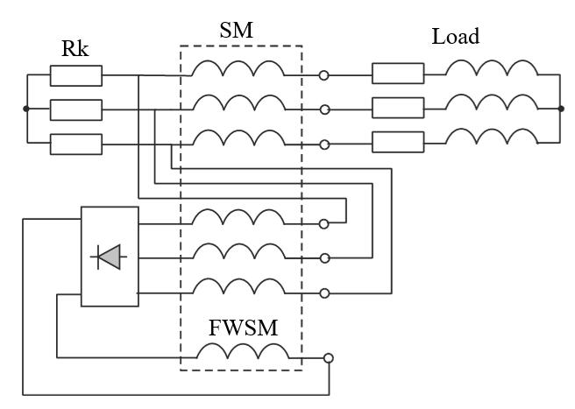
Fig. 2. Schematic of the experimental setup
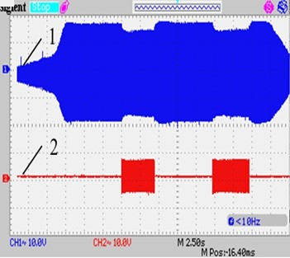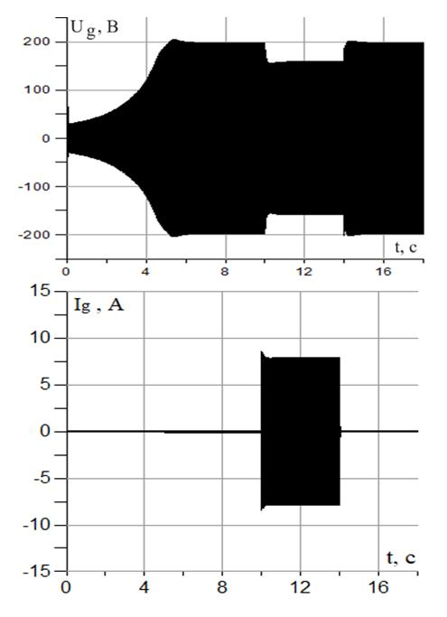
a) b)
Fig.3. Voltage (curve 1) and stator current (curve 2) of the generator in the modes of initial excitation at idle and load changes: a - experimentally recorded oscillogram (scale for voltage 100 V/unit, for current 10 A/unit), b - simulation results
Comparison of the simulation results with the experimental results gives grounds to assert that the nature of the change in the main coordinates coincides. In particular:
- in both cases, there is an initial voltage in the SM stator in the absence of excitation current caused by the action of permanent magnets (the difference between its values in the experimental and calculated oscillograms is about 7%);
- in both cases, a slight overshoot of the generator voltage in the process of self-excitation is noticeable (the difference between its value on the experimental and calculated oscillograms is about 5%);
- a similar process of voltage change during load shedding and load shedding.
Thus, we can state the adequacy of the developed model.
Conclusion
Representing the mathematical model of a multi-winding synchronous machine in phase coordinates greatly expands the modelling capabilities. This is especially important for analysing asymmetric operating modes and multi-channel configurations where loads are connected to windings in different ways. Representing the design model in the form of a multipole greatly simplifies its integration into the modelling of complex electromechanical systems, providing greater flexibility and accuracy in solving real-world engineering problems.
The use of the method of average voltages in the integration step to create a mathematical model allows to effectively use the advantages of this method, in particular, to ensure high stability of the calculation and speed.
References
- J. K. Nøland, S. Nuzzo, A. Tessarolo and E. F. Alves, "Excitation System Technologies for Wound-Field Synchronous Machines: Survey of Solutions and Evolving Trends," in IEEE Access, vol. 7, pp. 109699-109718, 2019, doi: 10.1109/ACCESS.2019.2933493.
- J. K. NØland, M. Giset and E. F. Alves, "Continuous Evolution and Modern Approaches of Excitation Systems for Synchronous Machines," 2018 XIII International Conference on Electrical Machines (ICEM), Alexandroupoli, Greece, 2018, pp. 104-110, doi: 10.1109/ICELMACH.2018.8507212.
- S. Wang, S. Ni, Y. Xia, X. Wang, P. Su and S. Huang, "Hybrid excitation permanent magnet synchronous machines and their structures — Combination art of elements of machines," 2014 International Conference on Electrical Machines (ICEM), Berlin, Germany, 2014, pp. 2618-2624, doi: 10.1109/ICELMACH.2014.6960557.
- F. Giulii Capponi, G. Borocci, G. De Donato and F. Caricchi, "Flux Regulation Strategies for Hybrid Excitation Synchronous Machines," in IEEE Transactions on Industry Applications, vol. 51, no. 5, pp. 3838-3847, Sept.-Oct. 2015, doi: 10.1109/TIA.2015.2417120.
- B. Nedjar, S. Hlioui, M. Lecrivain et al., “Study of a new hybrid excitation synchronous machine”, Electrical Machines (ICEM), 2012 XXth International Conference on Electrical Machines, pp. 2927-2932.
- P. Paplicki, M. Wardach, M. Bonisáawski, R. Paáka, “Simulation and experimental results of hybrid electric machine with a novel flux control strategy”, Archives of Electrical Engineering, Vol. 64(1), 2015, pp. 37-51
- H. May, R. Paáka, P. Paplicki, S. Szkolny, and W.-R. Canders, “Modified concept of permanent magnet excited synchronous machines with improved high-speed features”, Arch. Electr. Eng., Jan. 2011, vol. 60, no. 4, pp. 531–540,
- R. Cousseau, R. Romary, R. Pusca and E. Semail, "Two-Slot Coil Pitch For Five-Phase Integrated Permanent Magnet Synchronous Machine," 2020 International Conference on Electrical Machines (ICEM), Gothenburg, Sweden, 2020, pp. 1615-1620, doi: 10.1109/ICEM49940.2020.9271037.
- B. Sen and J. Wang, “Stationary Frame Fault-Tolerant Current Control of Polyphase Permanent-Magnet Machines Under,” vol. 31, no. 7, 2016, pp.4684–4696.
- Kutsyk, A.; Semeniuk, M.; Korkosz, M.; Podskarbi, G. Diagnosis of the Static Excitation Systems of Synchronous Generators with the Use of Hardware-In-the-Loop Technologies. Energies 2021, 14, 6937. https://doi.org/10.3390/en14216937
- O. Plakhtyna, A. Kutsyk, M. Semeniuk, "Real-Time Models of Electromechanical Power Systems, Based on the Method of Average Voltages in Integration Step and Their Computer Application",. Energies, Vol.13, 2263, 2020. https://doi.org/10.3390/en13092263
- Куцик А.С., Семенюк М.Б., Йовбак В.Д. Застосування методу середньокрокових напруг для математичного моделювання електромеханічних ситстем з синхронною машиною. Вісник НУ «Львівська політехніка» «Електроенергетичні та електромеханічні системи», №671, 2010, с. 45-50.
- L. Romeral, J. C. Urresty, J. -R. Riba Ruiz and A. Garcia Espinosa, "Modeling of Surface-Mounted Permanent Magnet Synchronous Motors With Stator Winding Interturn Faults," in IEEE Transactions on Industrial Electronics, vol. 58, no. 5, pp. 1576-1585, May 2011, doi: 10.1109/TIE.2010.2062480.
- S. Alves de Souza and W. Issamu Suemitsu, "Five-Phase Permanent-Magnet Synchronous Motor," in IEEE Latin America Transactions, vol. 15, no. 4, pp. 639-645, April 2017, doi: 10.1109/TLA.2017.7896349.

