Evaluation of photosensitivity of materials with photocatalytic activity

L. Odosii, ¹ M. Mikhalieva,² L. Parashchyk,³ L. Kropuvnutcka,⁴ Yu. Shelekh⁵
1.Department of Electromechanics and Electronics Hetman Petro Sahaidachnyi National Army Academy, UKRAINE, Lviv, Heroes of Maidan str., 32, e-mail: odosiu@ukr.net
2. Department of Electromechanics and Electronics Hetman Petro Sahaidachnyi National Army Academy, UKRAINE, Lviv, Heroes of Maidan str., 32, e-mail: galmih@ukr.net

3. Department of Electromechanics and Electronics Hetman Petro Sahaidachnyi National Army Academy, UKRAINE, Lviv, Heroes of Maidan str., 32, e-mail: lidadmy@ukr.net

4.Faculty of Human Health and Natural Science, Drohobych Ivan Franko State Prdagogical Universiti, UKRAINE, Drohobych,. Stryyska, str 3, e-mail: liliyakrop@dspu.edu.ua
5. Department of electric power engineering and control system, Lviv Polytechnic National University, UKRAINE, Lviv, Stepan Bandera str. 12, e-mail: yurii.l.shelekh@lpnu.ua

Abstract - The spectral, electrochemical and energy characteristics of dyes are investigated to predict their sensitisation properties and the possibility of their use for the creation of photonanomaterials that are sensitive to a wide spectral range in the near-infrared and visible regions of the spectrum. By measuring the photocurrent of films containing pure TiO₂ modified with a dye, the prospect of using polymethine dyes as sensitizers of semiconductor materials used in photovoltaics to convert solar radiation into electrical energy has been proved.

Keywords - photocatalitic activity, light-sensitive materials, sensitizers, semiconductors, nanosystems.

Introduction

The prospect of using sunlight as a source of inexhaustible, environmentally friendly, renewable energy that can be used for the needs of mankind for millions of years has led to rapid development and research in the field of photochemistry, photocatalysis and photoelectrochemistry of semiconductor materials. These scientific areas study the principles of photochemical processes of solar energy conversion and focus on the search for nanophotomaterials with improved absorption properties. With the development of infrastructure and technological progress in ensuring global energy consumption, photovoltaics uses various methods, both classical and nanocatalysis, which involves the design and production of photocatalytic systems involving semiconductor materials with improved light-absorbing properties.

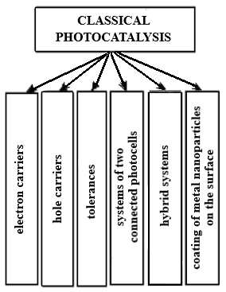
Fig. 1. Methods of designing photocatalytic systems involving semiconductor photocatalysts by classical catalysis

According to [1], the methods of classical photo catalysis include (Fig. 1), and nanocatalysis includes the methods shown in Fig. 2.
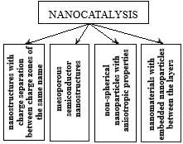

Fig. 2. Methods of designing photocatalytic systems involving semiconductor photocatalysts by nanocatalysis

It has been found that the most effective systems are those related to nanocatalysis: layered materials [2], in the gaps of which semiconductor nanoparticles are introduced, nonspherical semiconductor nanoparticles and mesoporous nanostructured materials [3], which are constructed on the basis of microcrystalline semiconductors and significantly increase photoactivity. Hybrid systems combining semiconductor and metal-complex catalysts [4] and systems constructed by depositing metal nanoparticles (Pt, Pd) on the surface of semiconductors have similar properties. The latter are capable of capturing photogenerated electrons, inhibiting recombination processes, and can also be used in dark processes.
High efficiency of the photocatalytic process is provided by materials synthesised by the method of doping semiconducting TiO₂, the design features of which are based on the introduction of photocatalytic blocks. However, their efficiency depends on the method of dopant introduction [5].
One of the most promising methods of nanocatalysis is the creation of a heterostructure based on Titanium (IV) sensitised with organic dyes [6-9]. This approach allows to increase the photocatalytic activity and extend the spectral range of light absorption and light conversion due to the separation of photogenerated charges, which leads to a decrease in recombination processes [3].
For the successful functioning of photocatalysts-heterostructures, it is necessary to select their components with certain optical, electrophysical and electrochemical characteristics that provide a thermodynamic gain of all electronic processes leading to photocatalytic conversion.
To determine the aspects of ensuring the proper functioning of oxide semiconductor systems, which should contain in their composition in certain proportions a semiconductor-photocatalyst, a dye-sensitizer and possibly some other substances. An analysis of scientific publications on the main research areas of the school of academician A.I. Kipriyanov in the field of photonics of organic dyes sensitive to infrared light was carried out. The direction of this activity was continued by the Ukrainian scientist, academician of the National Academy of Sciences of Ukraine O.O. Ishchenko, who made a scientific breakthrough in the study of polymethine dyes, which have the widest range of photophysical and photochemical properties compared to other types of dyes [10]. Researchers have established a correlation between the structure and spectral characteristics of dyes. The method of selecting heterocyclic compounds of different types allowed them to synthesise dyes with predetermined absorption selectivity and spectral band shapes (state-of-the-art research in the field of polymethine dyes). This, in turn, resolved the issues related to the conversion of light energy of a wide spectral range and the possibility of their practical use as sensitizers.

Experimental part

Employees of the Department of Colour and Structure of Organic Compounds of the Institute of the National Academy of Sciences of Ukraine synthesised and sent us polymethine dyes with different types of heterocyclic groups of symmetrical and asymmetrical structure for research.
Symmetrical cyanine cationic dyes D1-3, with extended polymethine bonds were studied.
To determine the sensitisation properties, spectral data and half-wave redox potentials were obtained and analysed (Table 1).
The spectral characteristics of the dyes were measured in dimethylformamide, and the electrochemical parameters were obtained with the addition of an electrolyte that promotes intermolecular interaction.
It was found that lengthening the polymethine chain in the investigated cationic symmetric dyes B1–B3 by one vinylene group leads to a regular linear bathochromic shift of the maximum of the absorption band to 110 and 117 nm, respectively.

Table 1
Spectral and electrochemical results (half-wave redox potentials)
of polymethine dyes

Code | Spectral datas |  | Electrochemical datas |  | Energy of HOMO  and LUMO, еV |  | Energy difference ∆E,  eV | Е_{g},  еV
Code | λ_{max,}  нм | E_{hν},  eВ | E_{ox} | E_{red} | E_{HOMO} | E_{LUMO} | Energy difference ∆E,  eV | Е_{g},  еV
Code | λ_{max,}  нм | E_{hν},  eВ | relative to a s.h.e.
D1 | 766 | 1,62 | 0,985 | -0,397 | -5,40 | -3,85 | 0,24 | 1,55
D2 | 876 | 1,42 | 0,730 | -0,366 | -5,14 | -3,79 | 0,32 | 1,35
D3 | 993 | 1,25 | 0,588 | -0,316 | -5,01 | -3,79 | 0,35 | 1,22

* λ_{max} – maximum absorption band, E_{hν} –the band gap calculated from the spectral characteristics, E_{ox} і E_{red} – oxidation and reduction potentials, ∆E – difference between the light absorption energy (1240/hν) and oxidation and reduction potentials, Е_{g} – band gap calculated from electrochemical data

The obtained electrochemical data were used to determine the HOMO and LUMO energies of the dyes and to calculate the values of their energy gaps (E_{g}), which provide a correct explanation of the electronic spectra of molecular systems. Diagrams of the location of the oxidation potentials of dyes relative to the conduction band of titanium (IV) oxide were constructed. (Fig. 3) A thermodynamic analysis of the energy characteristics of dyes in the electronically excited state was carried out. It was found that the processes of electron injection into the conduction band of TiO2 are thermodynamically allowed, since in all cases the LUMO energy level is higher than the potential of the TiO₂ conduction band. Such an analysis served as a prerequisite for the design of semiconductor HS with photocatalytic activity provided by the sensitisation properties of dyes.

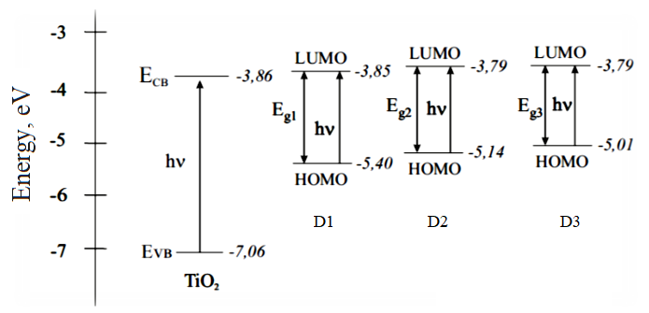
Fig. 3. Diagram of the location of the HOMO and LUMO energy levels of dyes D1-D3 and TiO₂

The photosensitive heterostructures were constructed on the basis of a semiconductor titanium dioxide photocatalyst (Degussa) P25 with a dye (D) deposited on the surface, which is fixed on the surface with an electronically conductive polymeric material, polypoxylpropylcarbazole (PEPK). The design methodology is described in [11].
Photometric studies of films containing pure (unmodified) TiO₂ (Fig. 4) and modified with D1-3 dyes-sensitizers (Figs. 5, 6, 7) were carried out.

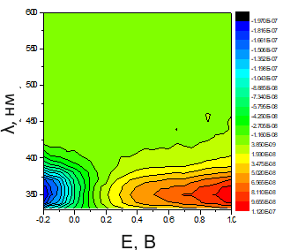
Fig. 4. Measurement of the photocurrent of
unmodified TiO_{2.}

Such a comparison makes it possible to assert the course of electronic transfer processes between the dye and titanium (IV) oxide. The light falling on the surface of TiO₂ modified with the dye causes the injection of electrons, which leads to the photocurrent. A positive overcharge is likely to be created on the surface of the semiconductor, which leads to a potential difference.
The analysis of the results shows that for pure (unmodified) TiO₂ (Fig. 4), the photocurrent is observed in the wavelength range from 330 to 430 nm.
The addition of a dye to TiO₂ leads to a broadening of the absorption band to the long-wavelength region,
Figs. 5-7 show the results of photocurrent measurements for heterostructures containing D1-3 dyes. It can be seen that the addition of D1 covers the range from 375 to 597 nm (Fig. 5).

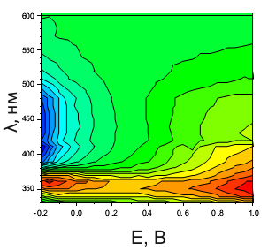
Fig. 5. Photocurrent measurements of the investigated materials: TiO₂ modified with dye B1

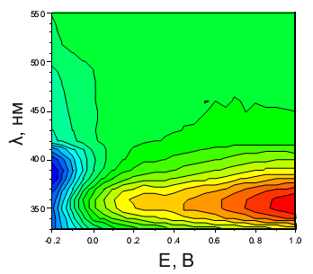
Fig. 6. Photocurrent measurements of the investigated materials: TiO₂ modified with dye D2

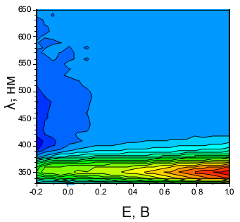
Fig. 7. Photocurrent measurements of the investigated materials: TiO₂ modified with dye D3

As a result of modification of TiO₂/D2, with a longer polymethine chain length and higher spectral values, the range of photosensitivity expands both in the UV and IR zones.
In the case of the introduction of D3 with a triple bond, a similar process is observed, but no further expansion occurred.
Thus, the presence of photocurrent in the visible region of the spectrum for D/TiO₂ is evidence that the addition of a dye to the heterostructure leads to the sensitisation of TiO₂ by the dye under study.
From the patterns discussed above, it can be seen that deep-colored dyes have a significant effect on expanding photosensitivity and increasing the efficiency of the photocatalyst and play a decisive role in the widespread implementation of this type of photocatalysis in practice. However, it was established that the initial increase in photocatalytic activity caused by the presence of dye molecules in the HS, which absorb visible and IR light, changes to a decline. Perhaps this is related to the concentration content of the dye, since it is known that with an increase in the amount of dye, polymolecular layers are formed, which impair the process of light transmission, and the dye under conditions of photoexcitation cannot enter into electronic interaction with the photocatalyst, which can lead to inhibition of the reaction at the boundary phase separation and, accordingly, to a decrease in photoactivity.
In order to check the influence of the concentration content of the dye on photoelectric transformations, it is planned to carry out a study of heterostructures by the method of immittance spectroscopy. [12-20]. Research of immittance on modern RLC-meters makes it possible to establish the dependence of physical properties (complex conductivity of the measuring system) on the composition of the investigated substance.

Conclusion

The regularities that relate the spectral, electrochemical and energy characteristics of polymethine dyes to the length of the polymethine chain have been established. It is shown that with the growth of its length, the energy losses during electronic excitation, which are distributed among a large number of π-bonds, decrease, which leads to a more complete use of light quanta.
The thermodynamic analysis of the energy characteristics of heterostructures based on titanium (IV) oxide and polymethine dye was carried out. The ways of purposeful design of photosensitive materials with photocatalytic activity based on ensuring full compliance of the physical and chemical parameters of the components, in which electronic processes are allowed and are characterised by a significant driving force, have been developed and substantiated.
It has been found that when a polymethine dye is applied to the surface of titanium (IV) oxide, the ratio of intensities of the short- and long-wave absorption bands changes, indicating a change in the angle between the directions of the chromophores.

Acknowledgments

We are sincerely grateful to I.M. Kobasa, Doctor of Chemical Sciences, Professor of the Department of Chemistry and Food Product Examination of the Chernivtsi National University named after Y. Fedbkovich, for his help in conducting research.

References

[1] Kryukov, A.I., Stroyuk, A.L., Kuchmiy, S.Ya., Pokhodenko, V.D. (2013). Nanophotocatalysis, Akademperiodika, 618, P. 12.
[2] Yeredla R.R. (2008). Incorporating strong polarity minerals of tourmaline with semiconductor titania to improve the photosplitting of water. Journal of Physical Chemistry, 2 (112), P. 532–539.
[3] Pokhodenko V.D. [et all]. (1992). Aromatic amines – electron carriers increasing the efficiency of photocatalytic redox reactions. Theoretical and experimental chemistry, 5/6 (28), P. 411–415.
[4] Kryukov A.I. (2000). Energetics of electron processes in semiconductor photocatalytic systems. Theoretical and experimental chemistry, 2 (36), P. 69–89.
[5] Hoffmann, M.R., Martin, S. T., Choi, W. (1995). Environmental applications of semiconductor photocatalysis. Chemical. Review, 1(95), Р.69–96.
[6] Kobasa, I., Odosiy, L., Kurdyukova, I., Ishchenko, O., Kurek, S. (2015). Electrochemical and energetic characteristics of new dye-sensitizers for photovoltaic cells. Functional Materials Letters, 8(5), 1550067
[7] Kobasa, I.M., Kondratyeva, I.V., Odosiy, L.I., Kropelnytska, Y.V. (2019). Sensitization of TiO₂ by a symmetric anionic polymethine dye with three conjugated chromophores. Research on Chemical Intermediates, 45(8), PP. 4043–4052.
[8] Kobasa, I.M., Gusyak, N.B., Odosii, L.I. (2015). Titanium dioxide sensitization with a biscyanine dye in the photocatalytic reduction of methylene blue. Kinetics and Catalysis, 56(2), PP. 158–163.
[9] Kobasa, I., Kondratyeva, I., Odosii, L. (2010). TiO₂/biscyanine and CdS/biscyanine heterostructures - Influence of the structural composition on the photocatalytic activity. Canadian Journal of Chemistry, 88(7), PP. 659–666.
[10] Ishchenko, O.О., Slominsky, Yu. L., Tolmachov, O. I. (2009). Modern achievements in the field of polymethine dyes of the Kipriyanov school. Journal of Organic and the Farmchemistry, 3(27), PP. 3–24.
[11] Kondratieva, I. V. Systems of TiO₂-based oxides and heterostructures of semiconductors with bis-quinocyanine dyes as photocatalyst and catalysts of redox transformations of N₂, CO and methylene blue. Chernivtsi National University. un them Yu Fedkovych - Chernivtsi 2009 - 186 pp.
[12] Grigorchak, I., Monday, G. Impedance Spectroscopy. Publishing House of Lviv Polytechnic, 352 p.
[13] Mikhalieva, M., Odosii, L., Shabatura, Yu., Lunkova, H., Hots, N., Przystupa, K., Atamaniuk, V. (2019) Electrical method for the cyberphysical control system of non-Electrical objects. Przeglad Electrotechniczny, 11, PP. 200–203.
[14] Mikhaleva, M., Odosij, L., Zalypka, V., Seredyuk, B., Paraschuk, L., Lunkova, H. (2020). Electrical method for inteligent cooling liquid control system. Acta Imeko, 9(1), PP. 56 - 60.
[15] Parashchuk, L.Ya., Kochubey, V.V., Odosiy, L.I., Korolko, S.V. (2019). Research into the protective characteristics of special-purpose cement-based concretes. Voprosy Khimii i Khimicheskoi Tekhnologii, 3, pp. 139–144.
[16] Mikhalieva, M., Paracuda, V., Shabatura, Yu., Przystupa, K., Odosii, L. (2021). Electrical method for the control water after osmosis process for the standard unit of ultrasound power in water environment. Przegląd Elektrotechniczny, Vol. 1, pp.104–106.
[17] Mikhalieva, M., Odosii, L., Przystupa, K., Shabatura, Yu., Hrubel, M., Hots, N. (2023). Improvement of electrical methods of control and evaluation of impact of military activity on surface waters. Przegląd Elektrotechniczny, 99, (2), PP. 230-234.
[18] Parashchuk, L., Shelekh, Y., Sabat, M., Odosii, L. (2023). Electromechanical System of control and determination of strength of concrete by non-destructive method. IEEE 4th KhPI Week on Advanced Technology, Vol. 2023. PP.1-4.
[19] Mikhalieva, M., Odosii, L., Przystupa, K., Shabatura, Yu., Romanchuk, V., Parashchuk, L. Opportunities of electrical technologies for control of the quality paramaters of light sensitive materials. Przeglad elektrotechniczny, 100(3), − PР. 285-288.

