Assessment of recent geodynamics of the Ukrainian Carpathians based on data of GNSS stations
Ivan Brusak
Department of Higher Geodesy and Astronomy, Lviv Polytechnic National University, UKRAINE, Lviv, Starosolskykh St.6, room 601b, E-mail: ivan.v.brusak@lpnu.ua
Abstract – The study analyses the recent horizontal and vertical geodynamics of the Ukrainian Carpathians. Using RINEX files from the continuously operating GNSS network Geoterrace, daily coordinates, annual velocities, and territory's deformation parameters were calculated. New maps of recent special deformations of the Ukrainian Carpathians were created for further use by geoscientists.
Кеуwords – recent geodynamics, GNSS stations, Geoterrace GNSS network, Ukrainian Carpathians, Earth surface deformations, horizontal deformations, vertical deformations.
Introduction
The Ukrainian Carpathians are located between the Western (Slovak and Polish) and Eastern (Romanian) Carpathians, forming a fragment of the northern branch of the alpine Mediterranean belt. It includes the Pre-Carpathian Highlands, the Carpathian Mountains, and the Transcarpathian Lowlands. The Ukrainian Carpathians consist of various structural blocks, which has led to an intense interest in studying the tectonics and recent deformations of the region [1]. Nowadays GNSS data from continuous operating stations are widely used to study the geodynamic deformations [2, 3, 4]. The new permanent GNSS stations have been installed in western Ukraine over the last decade by employees of Institute of Geodesy, Lviv Polytechnic National University. Such a continuously operating GNSS network in the region is called Geoterrace. The distance between neighbouring GNSS stations is on average 70 km, which is effective for the recent geodynamics study of the Ukrainian Carpathians [4].
The purpose of the research is to analyze the horizontal and vertical deformations of the Ukrainian Carpathian region according to the data of GNSS stations and build special maps of deformations for further use by geoscientists.
Data
To study the geodynamics of the Ukrainian Carpathians, daily RINEX-files from 22 GNSS stations were used. Figure 1 shows the location of GNSS stations.
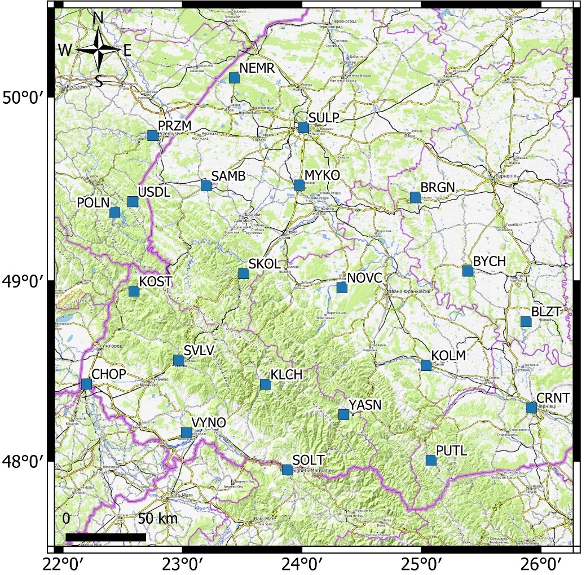
Fig.1. Location of 22 GNSS stations in Ukrainian Carpathians
As shown in Figure 1, several GNSS stations are located in Poland, outside the Ukrainian Carpathians. However, their inclusion enhances the network's geometric accuracy. These GNSS stations operated simultaneously from 2018 to 2022. The selection criteria required each station to have a continuous operation period of at least three years, with a minimum of 200 daily solutions per year.
Method
Daily coordinates for GNSS stations were derived using the Bernese GNSS Software [5]. Reference stations were selected from IGS stations distributed across the region. The calculations produced a network solution utilizing Double Difference strategy. The geocentric coordinates X, Y, Z of the continuous GNSS stations were specified in the ITRF-2014 system. The GNSS displacements of the stations ΔX, ΔY, ΔZ are determined by subtracting the coordinates of the station for the current epoch from the coordinates for the first epoch. The determination of the relative velocity vectors, associated with the motion of the Eurasian tectonic plate, involves recalculating the displacements ΔX, ΔY, and ΔZ from the geocentric system (ITRF-2014) into the ETRF-2000 system, followed by a transformation into the topocentric coordinate system. After this conversion, North, East and Up components were calculated as the annual velocities, representing the average trend from the time series data. It is important to highlight that the transition to the ETRF-2000 coordinate system was essential for evaluating the geodynamics of the Ukrainian Carpathians, as it excludes the influence of the European tectonic plate and focuses on local deformations.
According to the calculated results, the map of vertical and horizontal displacements of the Ukrainian Carpathian region according to GNSS data from 2018 to 2022 was built. The map is shown in Figure 2.
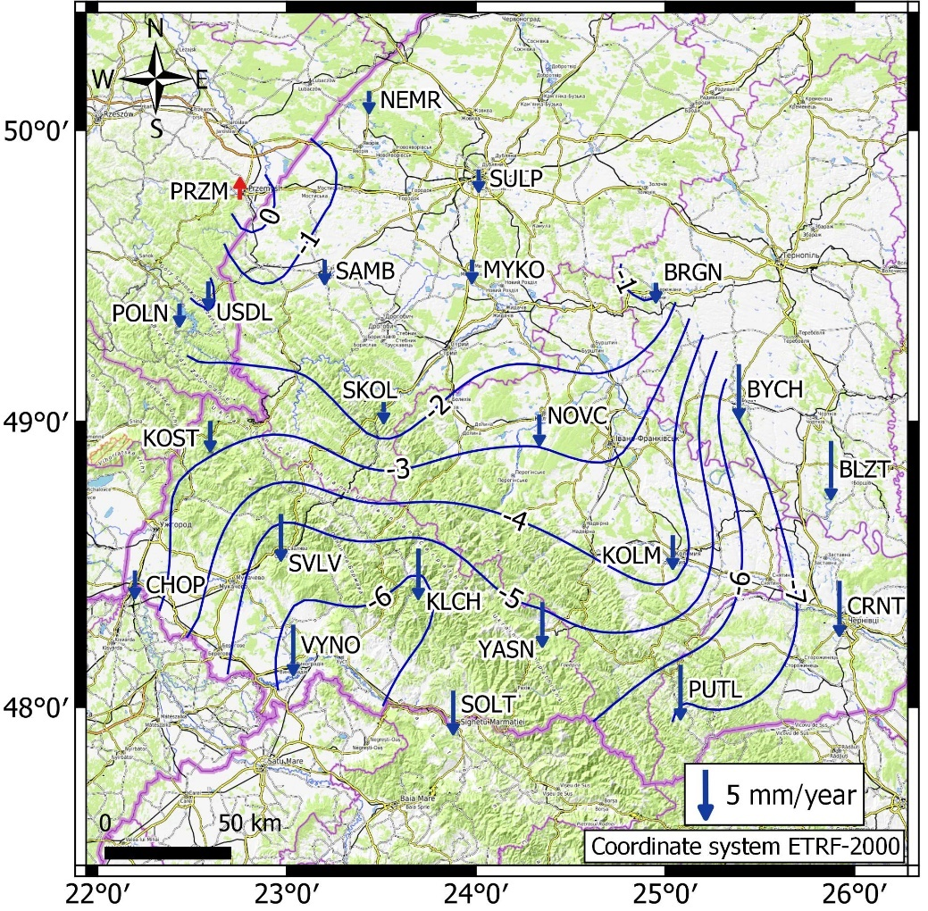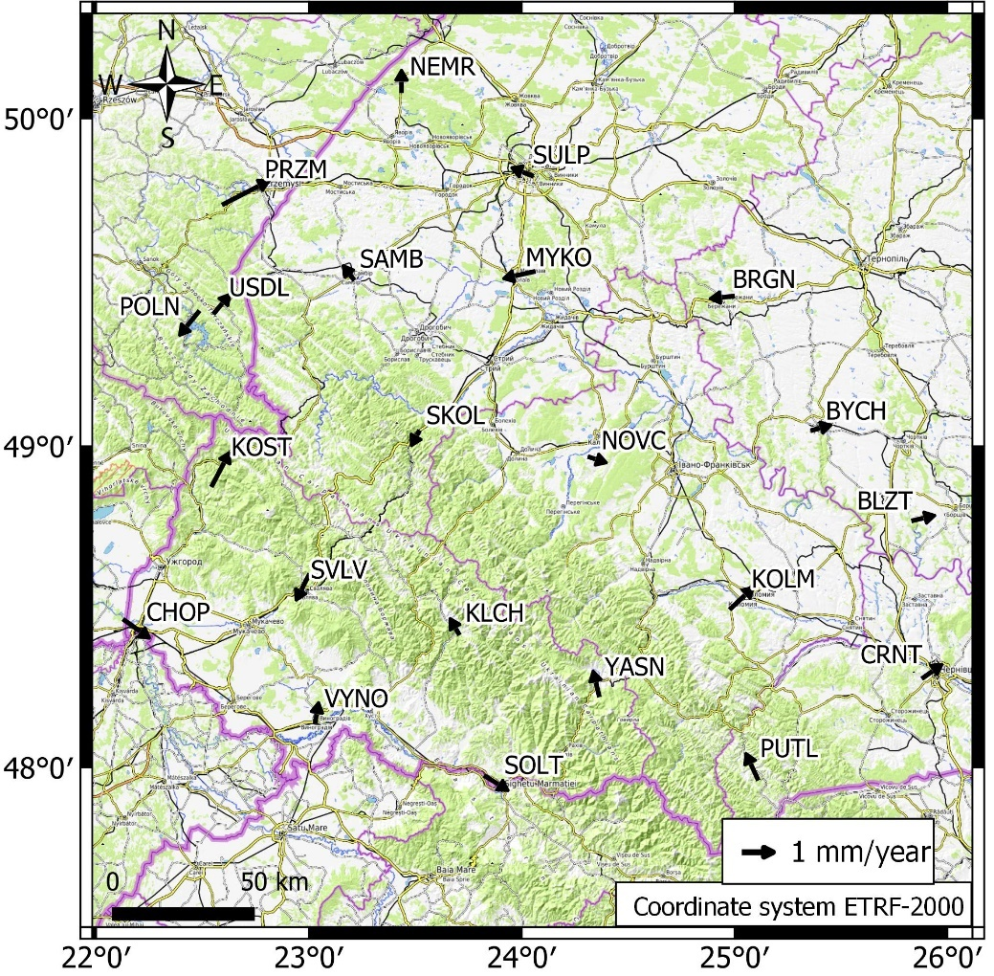
Fig.2. Vertical (left) and horizontal (right) displacements of the Ukrainian Carpathians based on GNSS data in the coordinate system ETRF-2000 from 2018 to 2021
The analysis of GNSS data reveals that subsidence in the Ukrainian Carpathians is not uniform across the territory. The vertical velocity field shows negative values between -1 and -7 mm/year. GNSS stations located in the northern areas, outside the mountain massifs, exhibit the least subsidence. In contrast, subsidence is more pronounced in the mountainous sections of the studied region.
The horizontal displacements observed in the Ukrainian Carpathian region, as shown in the figure, exhibit a rather chaotic pattern according to GNSS data. To clarify these displacements, a condensed vector model of the horizontal movements of the Earth's crust within the ETRF-2000 coordinate system is presented. This model provides a detailed analysis of the horizontal movements of the of the Earth's crust in the Ukrainian Carpathians.
According to strain rates analysis and homogeneity of GNSS stations along the Ukrainian Carpathian region, the irregular grid in the form of a triangle net based on Delaunay algorithm [6] was used, where continuous GNSS stations are triangle vertices. For a detailed analysis of geodynamic processes, the 2-dimensional strain rate tensor has been determined for each triangle. Compression and extension of the Earth crust were established for each triangle and then converted to a regular grid.
Densed vector model of horizontal displacements (compression and extension) of the Earth crust of the territory of the Ukrainian Carpathians based on GNSS data from 2018 to 2022 is shown on the Figure 3.
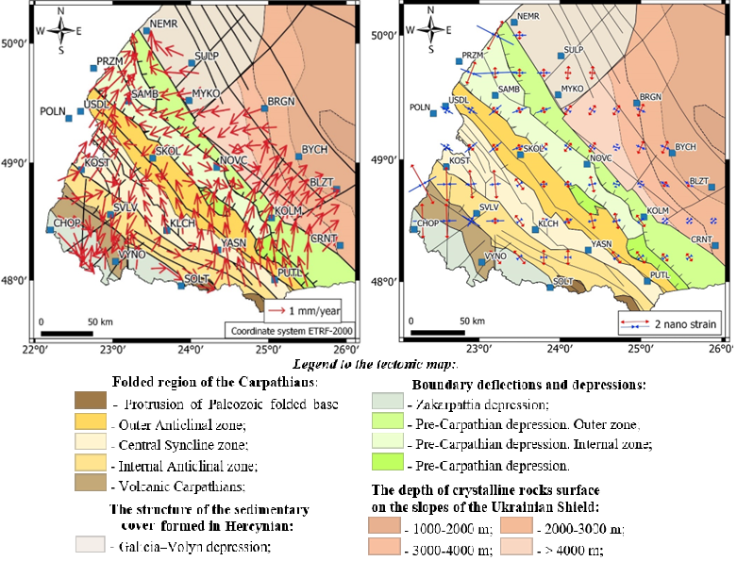
Fig.3. Densed vector model of horizontal displacements and deformations of the Earth crust of territory of the Ukrainian Carpathians based on GNSS data from 2018 to 2022
The geodynamics of the Ukrainian Carpathians is quite complex. Based on the densed vector model it is not clear to distinguish the classical tectonic zoning of the Ukrainian Carpathians.
From the map of compression and tension of parts of the crust of the Ukrainian Carpathians according to the GNSS stations, it is clear that the area of compression observed in Zakarpattia corresponds between the SVLV and VYNO stations, which coincides with the Transcarpathian fault and the zone of increased seismicity.
Conclusions
Data from 22 GNSS stations on the territory were used to study the geodynamic features of the Ukrainian Carpathian region. Daily coordinates, annual velocities, and deformation parameters of the territory are calculated from RINEX files of the continuously operating GNSS network Geoterrace.
A map of vertical deformations of the territory of the Ukrainian Carpathians was constructed. In general, all stations on the territory of Ukraine experience subsidence from 1 to 7 mm per year. This may reflect denudation processes in the region. Subsidence is more pronounced in the mountainous part of the studied region, while stations in the northern regions, outside the mountain massifs, associated with the Lviv regional magnetic anomaly, exhibit the least subsidence.
Maps of horizontal deformations of the territory of the Ukrainian Carpathians were constructed. To generalize the connection with tectonics, the map of horizontal deformations is superimposed on the tectonic structure of the region with recorded tectonic faults. Horizontal annual rates of the stations reach values of 1-3 mm in different directions, which may be caused by a large number of ancient faults. A compression-tension map of the territory of the Ukrainian Carpathians was constructed, which quite clearly demonstrates the compression zone in Transcarpathia, which corresponds to the SVLV and VYNO stations and coincides with the Transcarpathian fault and the zone of increased seismicity.
To enhance the analysis of the identified deformation zones, it is advisable to incorporate more detailed geological and geophysical survey data, as well as to increase the number of analyzed GNSS stations.
Acknowledgements
The author would like to thank the Armed Forces of Ukraine because this paper has become possible only because of the resilience and courage of the Ukrainian Army
References
[1] Kruglov S. (1998) Tectonics and geodynamics of the Ukrainian Carpathians. Geodynamics, 1(98), 82-91. URL: https://science.lpnu.ua/uk/jgd/vsi-vypusky/11998/tektonika-ta-geodynamika-ukrayinskyh-karpat
[2] Doskich, S., Savchuk, S., Dzhuman, B. (2023). Determination of horizontal deformation of the Earth`s crust on the territory of Ukraine based on GNSS measurements Geodynamics, 2(35), 89-98. DOI: https://doi.org/10.23939/jgd2023.02.089
[3] Doskich, S. (2021). Deformations of the land crust of the Carpathian region according to the data of GNSS observation. Geodesy, Cartography, and Aerial Photography, 93(1), 35–41. https://doi.org/ 10.23939/istcgcap2021.93.035
[4] Tretyak, K., & Brusak, І. (2022). Modern deformations of Earth crust of territory of Western Ukraine based on “GEOTERRACE” GNSS network data. Geodynamics, 1(32), 16-25. DOI: https://doi.org/10.23939/jgd2022.02.016
[5] Dach, R., Lutz, S., Walser, P., & Fridez, P. (2015). Bernese GNSS software version 5.2. DOI: 10.7892/boris.72297
[6] Tretyak, K., & Brusak, І. (2020). The research of interrelation between seismic activity and modern horisontal movements of the Сarpathian-Balkan region based on the data from permanent GNSS stations. Geodynamics, 1(28), 5-18. https://doi.org/10.23939/jgd2020.01.005

