Computer modeling of drums of lifting machines and mechanisms

Taratuta Kostyantin1, Ph.D., Associate Professor;

Vostotskyi Serhii1, Researcher

1 Zaporizhzhia National University, str. Zhukovsky, 66, Zaporizhzhia, 69600, Ukraine

taratutazp@gmail.com

**Abstract.** The work deals with modeling of drums of skip winch-dock blast furnaces. The stages of modeling and calculations with the use of automated design programs are shown. The optimal structural parameters of the drums are shown.

**Keywords:** modeling, drum, designing.

1. Introduction

Skip winches have large dimensions and a significant number of transmission elements. At the moment, modernization of automatic control systems for skip winches of blast furnaces is widely carried out by using modern converting units and non-contact displacement sensors, but the designs themselves have remained unchanged. The main trends in the design of modern lifting mechanisms are the desire to reduce the size and increase productivity.

1. Simulation results

In the course of the current study, the load capacity of the proposed structure was determined under the action of a non-linear load. In the course of studying the drum of the skip winch, we will determine ways to improve the design.

Cylindrical drums, which are smooth or grooved, have become the most common. Drums with grooves are used on the skip winch. The design sequence of the drum includes several stages: selection of the nominal diameter and length, determination of the depth and length of the threaded section, determination of other geometric parameters (thickness of the cylindrical part, diameter of the axis, etc.). The specified parameters are selected according to recommendations, taking into account the largest static tension of the rope. Further calculation is carried out in order to check the strength of the drum and axle. The stability of the cylindrical wall of the drum is also determined, the axis is checked for bending, and the calculation of the knot for attaching the rope to the drum is carried out.

Also, when designing the drum, the angles of the rope exit from the drum should be taken into account. The angles of the rope must be minimal. The angles of the rope can be reduced, for example, by reducing the length and increasing the diameter of the drum or by increasing the distance between the blocks and the drum. In case of multi-layer winding, the angles of descent of the rope near the rim of the drum should be more than 0.5° to prevent tangling of the rope turns (see Fig. 1).

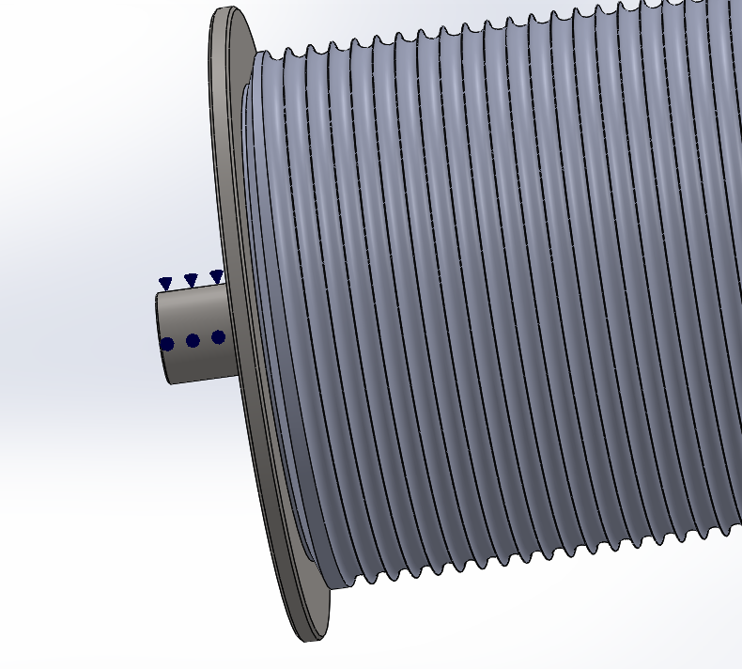 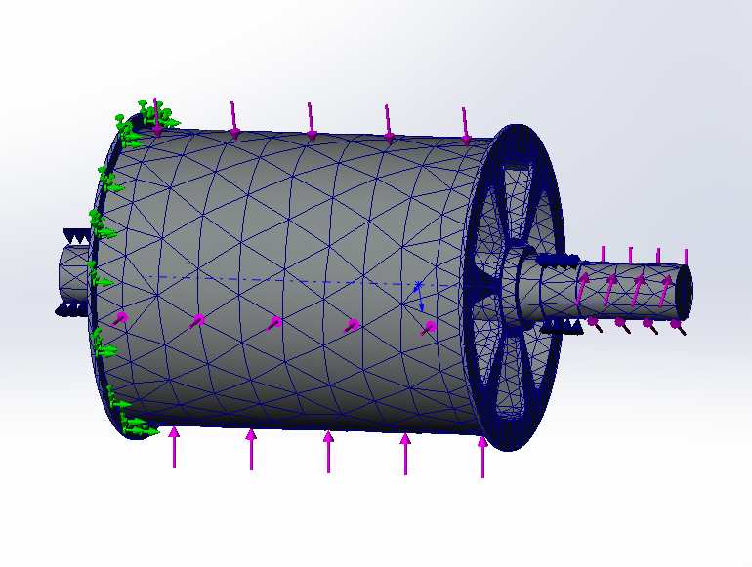

**Fig. 1.** Spatial 3D model of the skip winch drum

The design was carried out in the SolidWorks system. This CAD system makes it possible to carry out static stress analysis, dynamic analysis, thermal analysis, and optimize the design parameters of the model. The analysis of the obtained graphs shows the presence of a significant margin of strength and the distribution of Von Mises stresses in the drum at nominal loads within the limits of permissible values. The analysis of the obtained results shows that the proposed design of the drum and the parameters of the axis correspond to the permissible values of stresses (see Fig. 2).

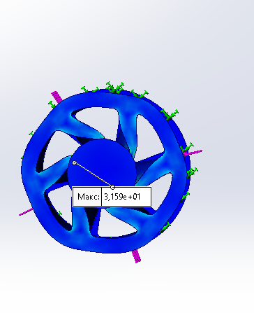 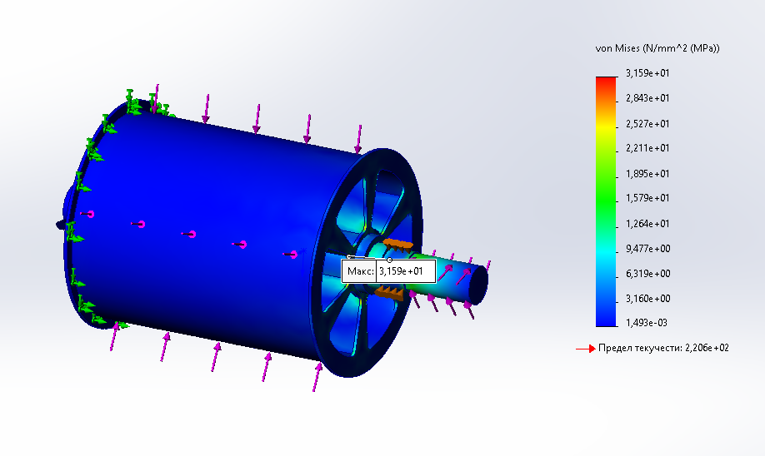

**Fig. 2.** Conditional view of the 3D model of the drum and stress distribution diagrams under the action of critical loads

1. Conclusions

Compared to traditional methods, computer-aided design has the following advantages: fast model creation and editing; the use of various materials, sizes and configurations without the need to manufacture physical prototypes; identifying problems in the early stages; time reduction Also, computer design systems allow the integration of developed models into the automated system of technological preparation for production.

References

1. Design, modification and analysis of 3 ton electrical overhead travelling crane rope drum. February 2021. IOP Conference Series Materials Science and Engineering 1057(1):012025. DOI: [10.1088/1757-899X/1057/1/012025](http://dx.doi.org/10.1088/1757-899X/1057/1/012025)