Effect of temperature and time parameters of aluminium-silicate melts on the elastic modulus of fibres

Diduk І.¹, Ph.D.

¹ Institute for Problems of Materials Science, National Academy of Science,
3, Akademika Krzhizhanovskoho Str., Kyiv, 03142, Ukraine
ididuk2@gmail.com
Keywords: alumina-silicate melts, fibres, modulus of elasticity
- Introduction
Expansion of the range of composite materials with fibre fillers, especially for structural purposes, requires high strength and modulus of elasticity. Production of fibres with specified properties remains an important scientific and technical task. Basalt continuous fibres (BCF) produced from rocks occupy an intermediate postion in these parameters and are between alumina-magnesia high-modulus and glass fbres of type E [1-2].

The study purpose is to determine the dependence of elastic properties of fibres from temperature and time of melt production, which directly affect their properties [3], in particular the homogeneity of melts and homogeneity of glasses and fibres produced from them [4-5], which further have an influence on the structure and physical and mechanical properties of fibres [6].

- Materials and methods
Aluminosilicate fibres of various chemical compositions produced from melts of natural raw materials, rocks, and nonmetallic minerals were used as materials for the study, both in a single component form and in certain ratios in accordance with the requirements for chemical and mineralogical composition presented in [7-9], such that the resulting melt had a viscosity in the range of 50-200 dPa. s at a temperature of 1450 oC, crystallisation ability and fibre formation interval, which allows producing continuous and coarse fibres by forming a fibre filament from a melt stream. Fibres were produced on a single-filament laboratory stand, the scheme of which is shown in Fig. 1.
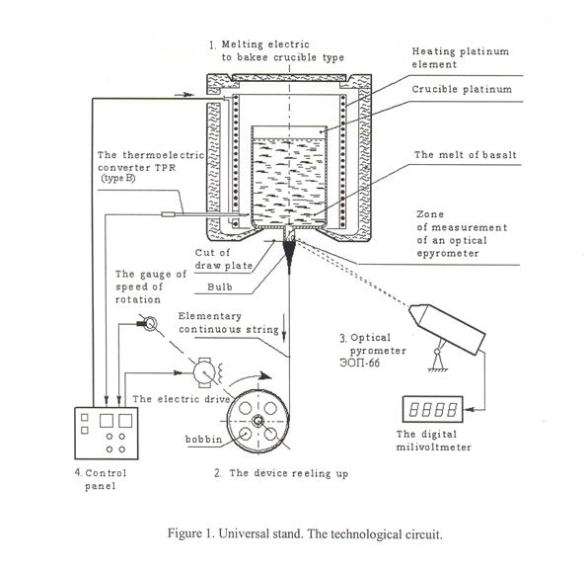
Fig. 1 - Technological scheme of the universal stand

The universal stand is a laboratory system for studying fibre formation in the process of continuous drawing of fibres from basalt or aluminosilicate melts and provides for the maintenance of the set temperature from 100 to 1500 °C with an accuracy of + 1 °C, the melt level from 10 to 60 mm and the device rotation speed from 1 to 1000 m/min for winding single fibres with a diameter of 5 to 300 µm. The temperature of the melt in the high-temperature furnace was controlled by means of a TPR (B), which is located at the lower edge of the crucible with the melt, in the air space of the furnace without contact with the melt and crucible. The diameter of the fibre of a given size was produced by changing the speed of rotation of the device for winding and, accordingly, drawing the fibre. The diameter of the die ranged from 1.6 to 2.4 mm, depending on the viscosity characteristics of the aluminosilicate melt.
The modulus of elasticity was determined by two methods, the absolute elongation method and the ultrasonic wave transmission method. The first method was used to study the dependence of the elastic properties of the fibre on its diameter. After determining the optimal fibre diameter, the second method was used to determine the dependence of the fibre elastic modulus on the temperature and holding time of the melt during their production. The non-destructive testing method was used to determine the sound propagation velocity C in fibres with a diameter of 30+1.0 μm using an acoustic installation. To calculate the elastic modulus, the density of the fibres was also determined by the weight method. The modulus of elasticity E was calculated by the formula:
Е=ρС², (1)
where ρ − the fibre density, kg/m3;
С – sound transmission speed, m/s.

- Resalts and discussion
To determine the dependence of the elastic modulus on the fibre diameter, aluminosilicate fibres from rocks of different compositions and synthesised from a mixture of natural non-metallic minerals with the amount of SiO₂ ranging from 46 to 58 % (wt. %) were used. The results are shown in Fig. 2-3.
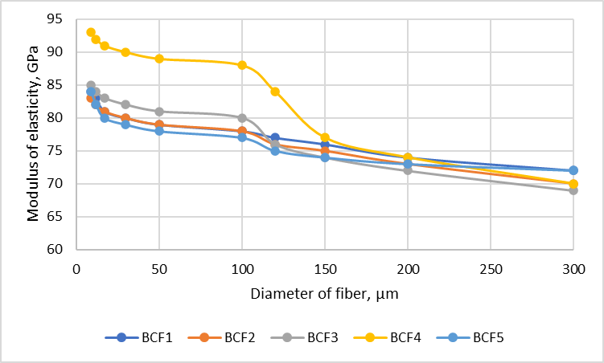
Fig.2 - Dependence of elastic modulus on fibre (continuous and coarse) diameter in the range from 9 to 300 µm
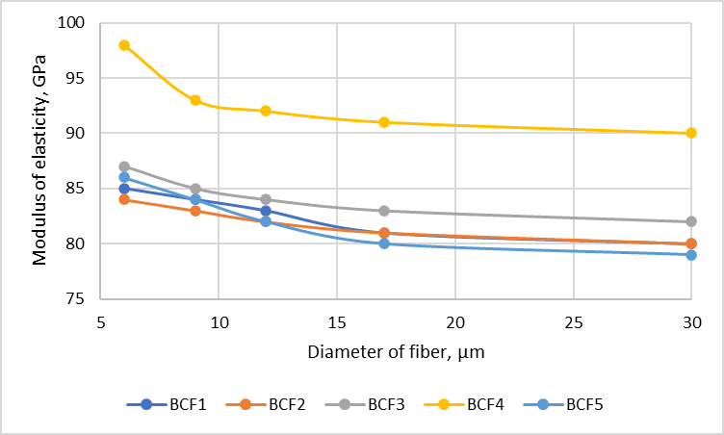
Fig.3 - Dependence of elastic modulus on continuous fibre diameter in the range from 6 to 30 µm

When determining the dependence of the elastic modulus on the diameter for five samples of fibres of different compositions obtained from basalt and similar rocks, it was found that there is a tendency to increase it with a decrease in diameter up to 25 %, but for fibres with a diameter of 9 to 30 µm, the absolute values have a deviation of no more than 2-3 %. Based on the results of the obtained dependence of the elastic modulus on the diameter, to determine the effect of temperature and melt holding time, laboratory samples of aluminosilicate fibres of 15 different compositions with a diameter of 30+1 µm were made and the absolute values of the elastic modulus were determined. When determining the effect of temperature, it was found that the discrepancy between the data, both in one and the other direction, is insignificant, mainly 1-2 %, for some fibre samples up to 6 %. However, with an increase in the melt holding time, an increase in the elastic modulus by 5-6 % is observed.
- Conclusion

The modulus of elasticity of aluminium-silicate fibres depends on the chemical composition and diameter of the fibres. With an increase in diameter from 6 µm to 300 µm, the elastic modulus decreases by up to 25 %. For fibres with a diameter of 9 to 30 microns, this decrease is insignificant and is within 2-3 %. The temperature at which fibres are produced within the fibre formation interval for different compositions is characterised by both an increase and a decrease in the elastic modulus, and no clear dependence was found. The melt holding time affects the melt homogeneity and texture of the fibres, which improves the elastic modulus, but only slightly, by 2-3 %. Thus, in order to obtain fibres with higher elastic properties, it is necessary to use fibres of smaller diameter and hold the melt until it reaches a homogeneous condition.

Список посилань
[1] Dzhigiris D.D. Basics of production of basalt fibres and products / D.D. Dzhigiris, M.F. Makhova. М: Teploenergetik, 2002.- 411 p.
[2] Lazoryak B.I. Glass fibres / B.I. Lazoryak, S.I. Gutnikov, A.N. Seleznev.
[3] Chuvashov Y.M., Yashchenko O.M., Trofimova T.P., Diduk I.I., Rybalka E.O., Koshelenko N.I., Bozhko V.I. On some properties of melts and glasses of basic igneous rocks of basalt-like composition / Scientific notes: LSTU.-2009.- No. 2.-Vol. 24.- P.342-346.
[4] Diduk I.I., Chuvashov Y.M., Yashchenko O.M., Skoryk M.A. Investigation of the surface structure of fibres from rocks of basic glasses of basalt type and silicate systems / Modern problems of physical material science: edited by academician V.V. Skorokhod.- 2012.- P.180-185.
[5] Diduk I. The effect of chemical composition on properties of rock melts / I.Diduk, G.A. Bagliuk // Machines, Technologies, Materials. – 2/2016.- P.15-18.
[6] S.G.Ivanitsky, Yu. Koshelenko Influence of conditions and parameters of basalt non-permeable fibres formation on their strength and surface condition / "Uspihi Materialoznavstvo" 2021, No. 3, 86-92.
[7] Bocharova, I.N. Rocks as one-component raw materials for the production of basalt fibres / Bocharova, I.N., Gorbachev, G.F., Gritsak, A.S., Mironenko, N.P. // Rocks as one-component raw materials for the production of basalt fibres / Collection of reports of the International scientific and technical seminar "New materials and tools" - Kiev, 2005.- P.3-8.
[8] [Electronic resource]. Access mode: http://www.bavoma.com.
[9] Gorbachev G.F., Bocharova I.N., Diduk I.I., Ivanitsky S.G., Koshelenko N.I. Features of formation of continuous basalt fibres and their properties / Collection of reports of the International scientific and technical seminar "New materials and tools".- Kiev, 2005.- P.8-19.

