Ti-Ni Shape Memory Alloy by Magnetically Controlled Electroslag Melting
Igor Protokovilov, Doctor of Engineering, Senior Researcher;
Vitalii Porokhonko, PhD, Senior Researcher
The E.O. Paton Electric Welding Institute of the NAS of Ukraine, 11 Kazymyr Malevych Str., Kyiv, 03150, Ukraine
Key words: Ti-Ni, shape memory alloy, electroslag melting, magnetic field, ingot.
- Introduction
Alloys based on the Ti-53.5÷57.0 Ni wt.% system (nickel titanium, nitinol) are functional materials with unique properties - shape memory effect and superelasticity. These properties, combined with high strength and corrosion resistance characteristics, low density, high biocompatibility and low elastic modulus, determine the effectiveness of their use for the manufacture of medical instruments and implants, temperature sensors, thermo-mechanical devices, connecting couplings, etc.
In the production of Ti-Ni based alloys, there is an acute problem of ensuring a strictly specified chemical composition of the metal with high homogeneity. This is due to the fact that the complex of nitinol characteristics, primarily the transition temperatures, strongly depends on the chemical and phase composition of the alloy. Therefore, Ti-Ni alloys are subject to high requirements for the accuracy of the chemical composition (deviation in component content up to 0.2÷0.3%). This requires the need to use a complex technological process to produce Ti-Ni ingots with repeated, in some cases up to 3- or 4-fold, remelting.
Despite intensive work in this area, the task of ensuring chemical and structural homogeneity in the production of Ti-Ni system alloys remains relevant.
- Magnetically-controlled Electroslag Melting
The new magnetically-controlled electroslag melting (MEM) process is carried out in a chamber-type electroslag furnace in an inert gas atmosphere, which minimizes the interaction of the metal with air gases (Fig. 1). Melting is carried out in a copper water-cooled crystallizer. As a consumable electrode, an electrode pressed from the charge mixture (titanium sponge and alloying components) is used.
The main distinguishing feature of the MEM process is the electromagnetic effect on the liquid metal pool, which makes it possible to obtain alloys with high chemical homogeneity of the metal and a fine-grained structure.
Ingots of Ti-55Ni (wt.%) alloy with a diameter of 65 and 100 mm were melted using the MEM method. The initial components were sponge titanium grade TG-90 and nickel grade NP-2. Consumable electrodes were manufactured by pressing. Oxygen-free flux AN-T4 was used. The resulting ingots were subjected to re-melting, which is due to the peculiarities of melting of the pressed electrode, characterized by instability of the melting current.
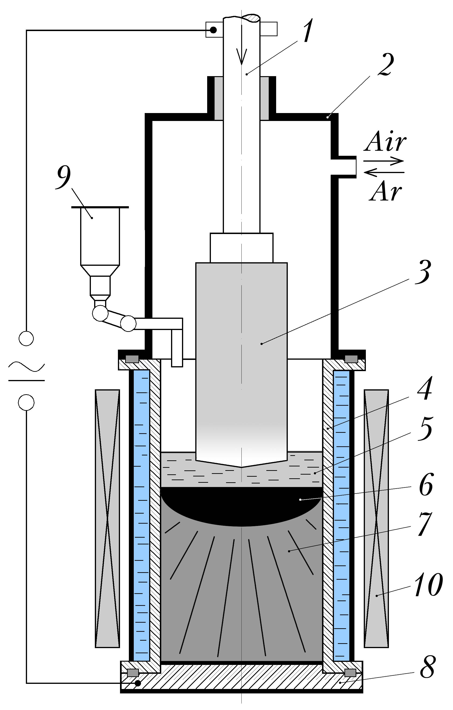 | Fig.1. Schematic diagram of MEM process: 1 - electrode feed rod; 2 - furnace chamber; 3 - consumable electrode; 4 - water cooled mold; 5 - slag pool; 6 - metal pool; 7 - ingot; 8 - bottom plate; 9 - bulk feed hopper, 10 – electromagnetic system.
- Results and discussion
The resulting ingots are characterized by high quality of side surface formation (Fig. 2a). The macrostructure of the metal is dense, without pores, cracks, slag inclusions and other defects of metallurgical origin (Fig. 3a). It is uniform across the entire section and consisting of globular equiaxed grains.
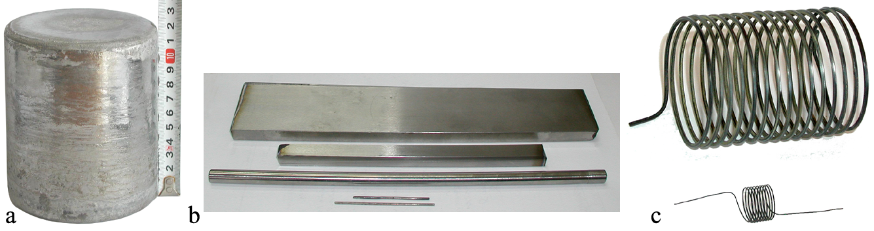
Fig. 2. Ti-55Ni ingot (a) and plates and wire made from it (b, c)
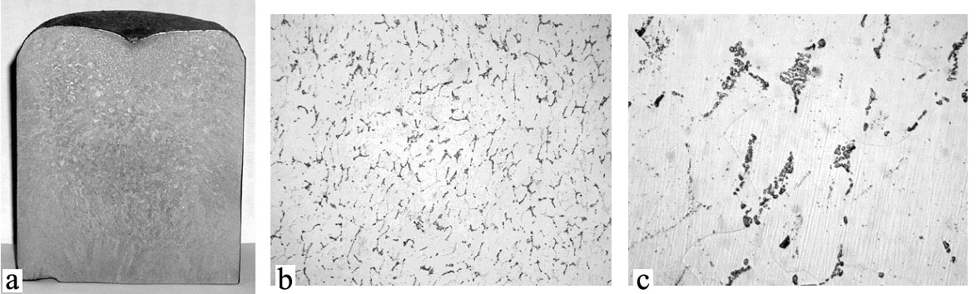
Fig. 3. Macrostructure of the longitudinal section of a Ti-55Ni ingot (a) and microstructure after deformation and heat treatment (b, c)
The results of the chemical analysis of the smelted metal are shown in Table 1. The deviation of the titanium and nickel content across the section of the ingot does not exceed 0.2%, which indicates the high chemical homogeneity of the cast metal.
Table 1. Chemical composition of Ti-55Ni ingot by MEM technology.
Location |  | Content, weight %
 |  | Ti | Ni | Al | Fe | Si | Cu | O | N | H
Top | Centre | 44,68 | 54,72 | 0,12 | 0,035 | 0,020 | 0,032 | not determined
Top | 1/2R | 44,75 | 54,67 | 0,14 | 0,024 | 0,015 | 0,030
Top | Edge | 44,78 | 54,54 | 0,14 | 0,042 | 0,028 | 0,030
Middle | Centre | 44,80 | 54,64 | 0,14 | 0,032 | 0,032 | 0,056
Middle | 1/2R | 44,80 | 54,53 | 0,12 | 0,030 | 0,050 | 0,028 | 0,09 | 0,016 | 0,002
Middle | Edge | 44,62 | 54,78 | 0,12 | 0,030 | 0,032 | 0,040
Bottom | Centre | 44,63 | 54,78 | 0,12 | 0,067 | 0,026 | 0,046 | not determined
Bottom | 1/2R | 44,70 | 54,72 | 0,12 | 0,100 | 0,040 | 0,052
Bottom | Edge | 44,65 | 54,78 | 0,12 | 0,095 | 0,035 | 0,030
Plates with a thickness of 0.5...15 mm and wire with a diameter of 0.3...1.2 mm were made from the molten ingots (Fig. 2 b,c). Optical metallography of the deformed metal showed the absence of internal defects (Fig. 3 b,c). The microstructure of the metal is finely dispersed, which is caused by a large degree of deformation. Grains have a globular shape with a typical size of 5...8 μm.
Studies of the functional properties of the resulting wire showed a pronounced shape memory effect. Dilatometric studies have made it possible to identify the characteristic points of martensite and austenite start temperatures, which are M_{s}=55⁰С, A_{s}=85⁰С. These data correlate well with literature data for an alloy of this chemical composition.
Thus, the conducted studies showed the high effectiveness of using the developed MEM technology to obtain ingots of Ti-Ni alloy with a shape memory effect.

